Rabbits Home Learning

Monday 4th January



Hello Rabbits Class!

Did you have a good Christmas? What did Father Christmas bring for you?

Can you draw me a picture of your favourite Christmas present and colour it in?

Read, Write, Inc (RWI)

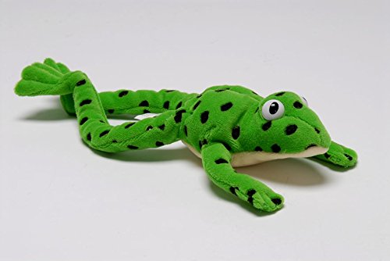 Can you help Fred? Remember he can only fred talk, he can’t say the words properly! Look at the words below. Say it like Fred then say the word. Ask a grown up to help you.

b a g cot dad bin dog nut lip red

Can you remember the sounds we learned at school?

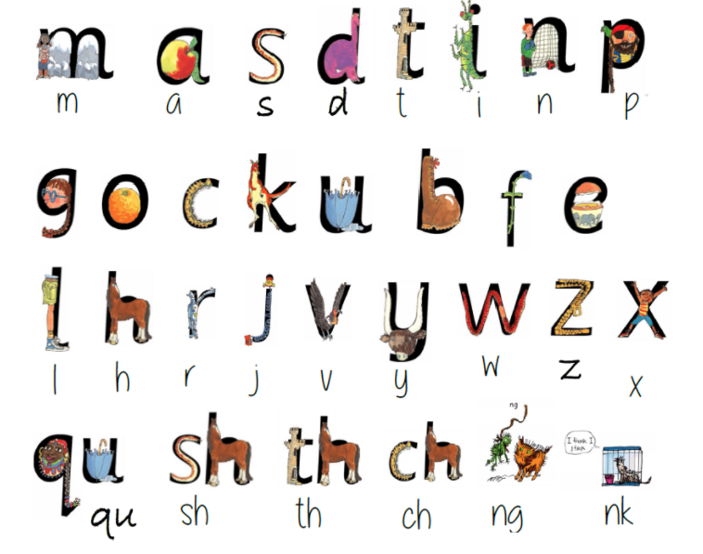

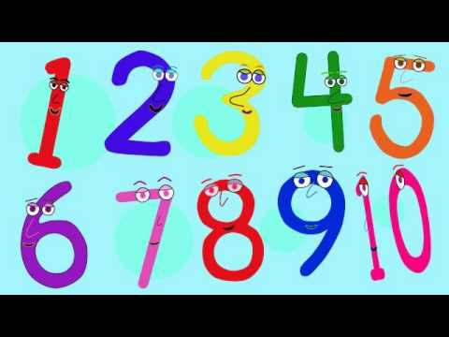

Maths

Watch this number song on you tube.

<https://www.youtube.com/watch?v=dk9Yt1PqQiw>

Try making your own numbers 1-10 using coloured pens, don’t forget to give them funny faces too.

Please send me photos of the children’s Christmas present pictures and number pictures. I look forward to catching up with you all during the week.

[rgolden@charing.kent.sch.uk](mailto:rgolden@charing.kent.sch.uk)