Rabbits Home Learning
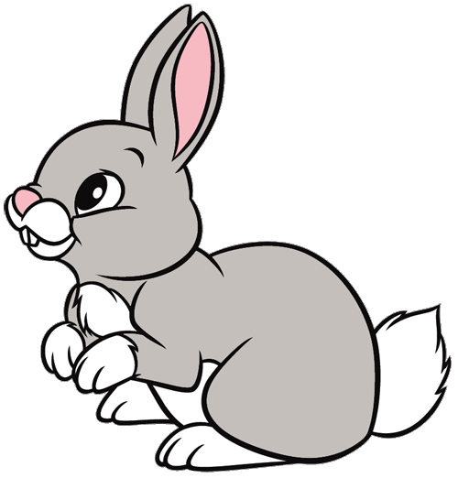
Wednesday 6th January

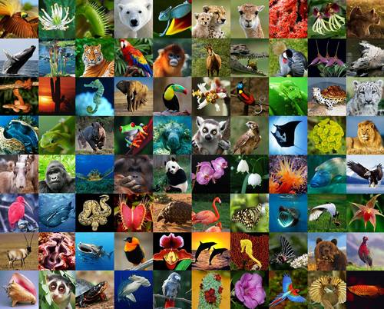
This term we are finding out all about amazing animals.
Have a look at the pictures above. Can you find all the animals? How many can you name? Ask a grown up to count how many and let me know!
Which animal is your favourite?

https://www.bbc.co.uk/iplayer/episode/b0834qf7/andys-baby-animals-7-hitching-a-ride
Please watch this episode about baby animals.
RWI
Please practice forming this letter correctly.
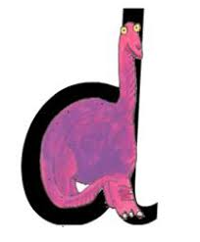
Remember….. go round his bottom, up his tall neck and down to his feet.
Fred talk these words. Remember……. Say it like Fred then say the word.

dig dog dot den
dip doll sad nod

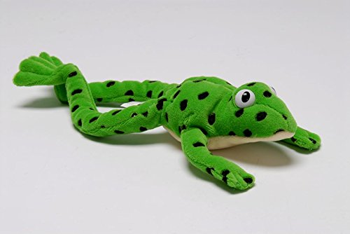

Maths
All these numbers are mixed up! Starting with 0, can you say your numbers to 10 in order and point to the correct number?

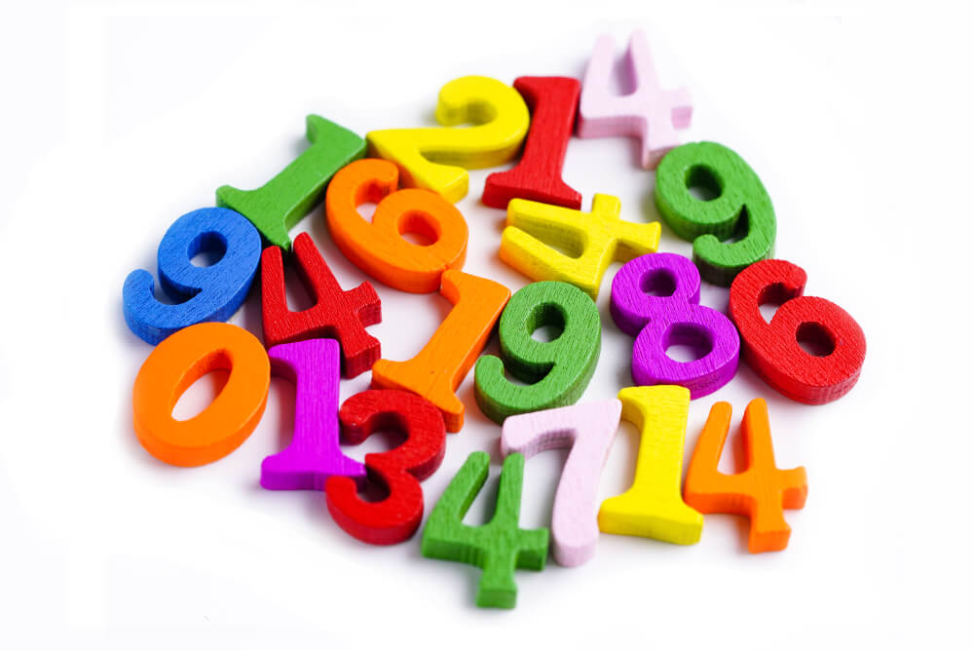
If you have a printer, print out the attached worksheet and cut and stick the numbers in the correct order.
If you don’t please write numbers to 10 out of order for your child to cut up and stick in the correct order.
https://www.youtube.com/watch?v=6RfIKqkvHTY
Here’s a count to 10 song your child will be familiar with.
Please send me photos and updates to my email. Thank you if you sent me an email yesterday.
rgolden@charing.kent.sch.uk

