Rabbits Home Learning
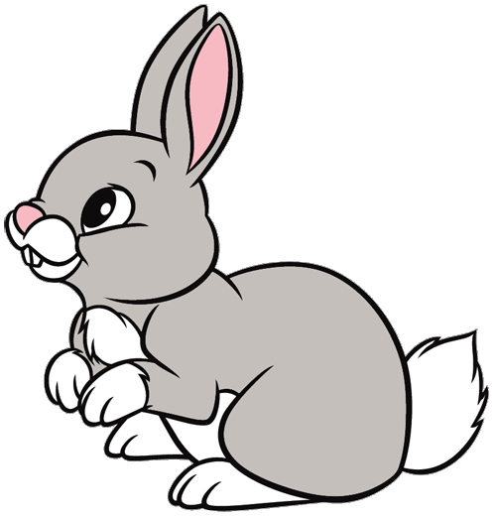
Thursday 7th January

This work for today is to go alongside our online meeting this morning. Some of it I will have explained but this is for everyone to access in case you weren’t able to make the ‘teams’ meeting.

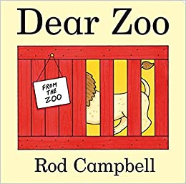
This is the story I read today.
If you would like to hear it again or weren’t able to join us this morning, please click on the link below.

https://www.youtube.com/watch?v=ZqGYWRHOV6E

Can you remember all the animals from the story?

Draw a picture of 3 animals and have a go at writing their names.

Parents… please encourage your child to identify the sound they can hear rather than copying your writing.
If your child is trying to write ‘snake’, they may only be able (with your help), to hear the ‘s’ and the ‘k’ sound. If they write ‘sk’, ‘sc’, ‘snk’ or ‘snc’, that is absolutely fine. The purpose is for them to independently use the sounds they know to begin to do developmental writing.
For an extra challenge have a go at writing…
I can see a ….. (and add the animal name).
I have attached the sounds chart we use at school.

RWI
Please practice forming this letter correctly.
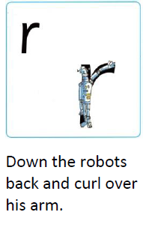
Practise writing the letter as many times as you can. Try using different pens, pencils, crayons, felt tips, chalk, whatever you have at home!
You could even make the letter shape using pieces of pasta… as long as it’s not for dinner!
Fred needs help! Fred talk and then say the word!
run red rip rap rub rug
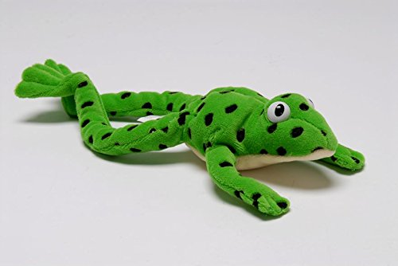
Maths
Which animal from the story is the tallest?
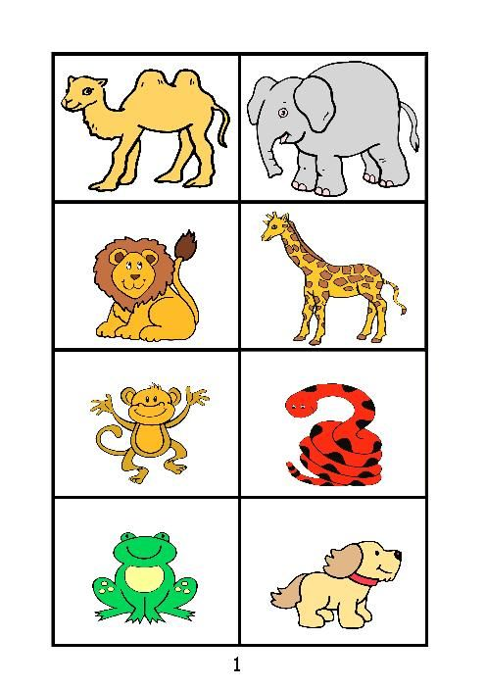
Who is the tallest in your house? Who is the shortest?
Can you find some toys and order them from tallest to shortest?
Watch this funny song and join in….
https://www.youtube.com/watch?v=Na9YR73Tma8
Please send me photos and updates to my email. Keep in touch.
rgolden@charing.kent.sch.uk

