Rabbits Home Learning
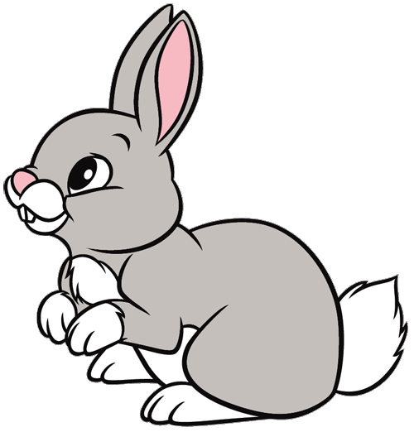
Friday 8th January

This work for today is to go alongside our online meeting this morning. Some of it I will have explained but this is for everyone to access in case you weren’t able to make the ‘teams’ meeting.

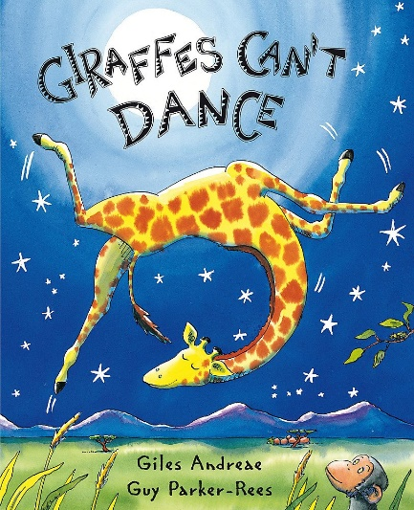
https://www.youtube.com/watch?v=4UNRduYI_04
Here’s a read aloud version if you want to hear the story again or you couldn’t join us today on Teams.
RWI
Please practice forming this letter correctly.

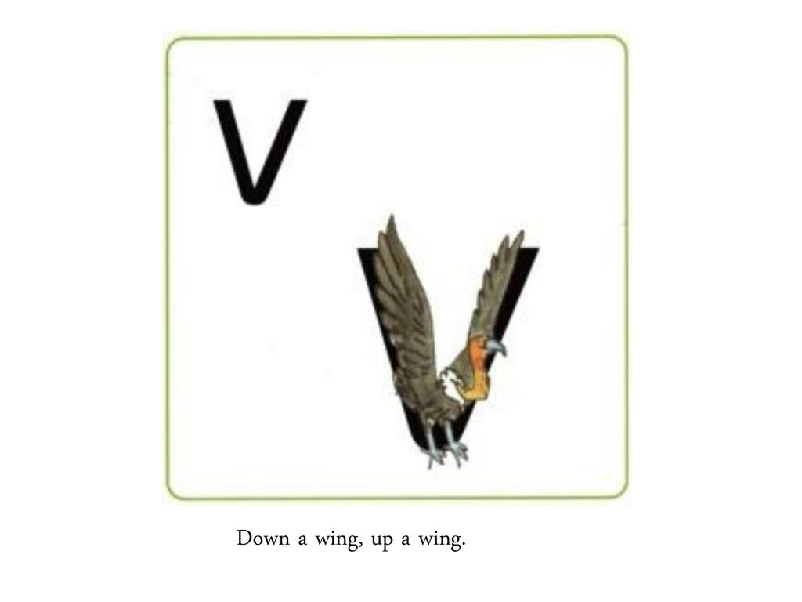
Don’t forget to say…
“Down a wing, up a wing.” ….as you write the letter.
Fred needs help! Fred talk and then say the word!
vet van 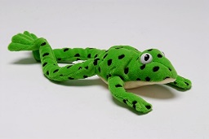
Creative activity
Can you make a giraffe? Here are some ideas for you to try.
Or simply draw and colour a giraffe with a very long neck!
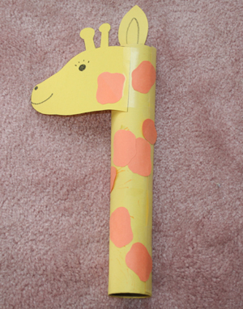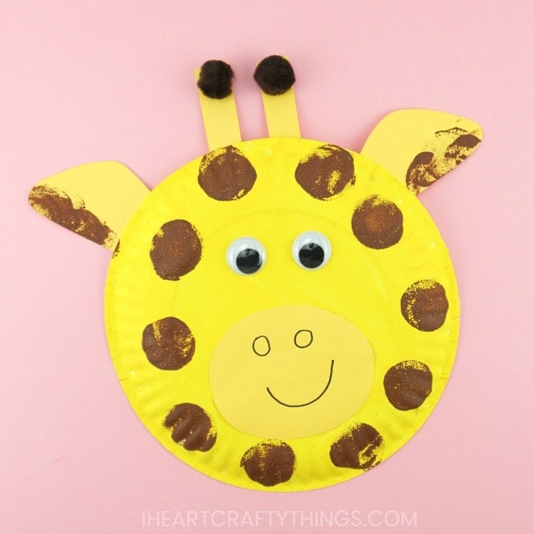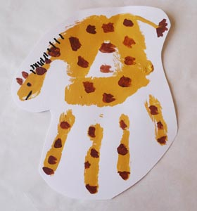

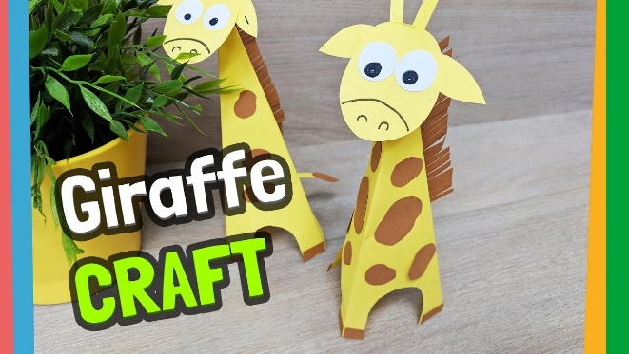.
This one is very cute but you’ll need lots of help with the cutting! There are youtube instructions in the link below.
https://www.youtube.com/watch?app=desktop&v=rJIT6wmnuMA

Please bring your giraffes to our Teams meeting on Monday.
Please send me photos and updates to my email. Keep in touch.
rgolden@charing.kent.sch.uk

