Science 18.1
Go to the following web page: What are the parts of a plant? - BBC Bitesize
Learn about the different parts of a plant and what the function of each plant is.

Activity 1

Label the different parts of this plant.
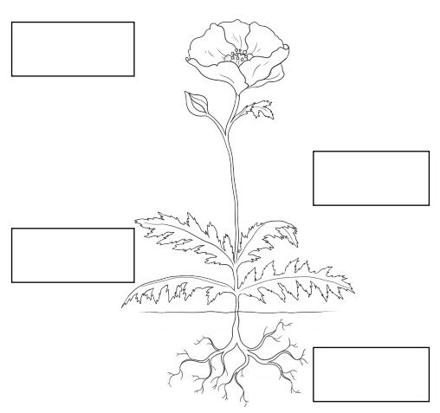

Activity 2

Match each picture to the correct statement

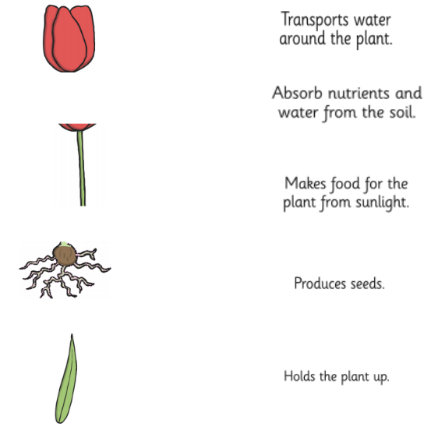

Activity 3
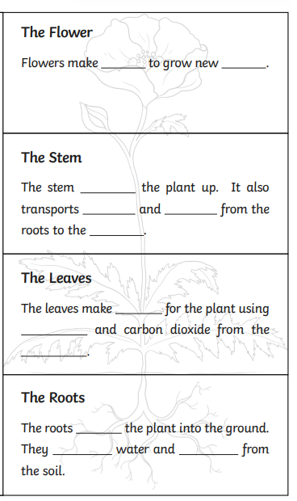
Use the words below to help you.

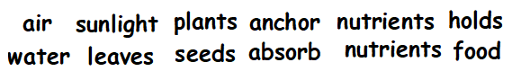

Activity 4 – Challenge
What is photosynthesis? Do your own research and find out. Write a few sentences to explain what you have found out.

Photosynthesis is …__________________________________
_____________________________________________________________________________________________________________________________________________________

