Science 25.1.21
Parts of a flower
Watch the video on parts of a flower. BBC Bitesize - Reproduction in Flowering Plants - Bing video
Activity 1
Use the paper flower sheet a). If you can print it out, dissect it (cut it out with scissors) and place each part on the dissection mat sheet b) below. If you can’t print it out, then draw each part of the flower in the correct section.
a)
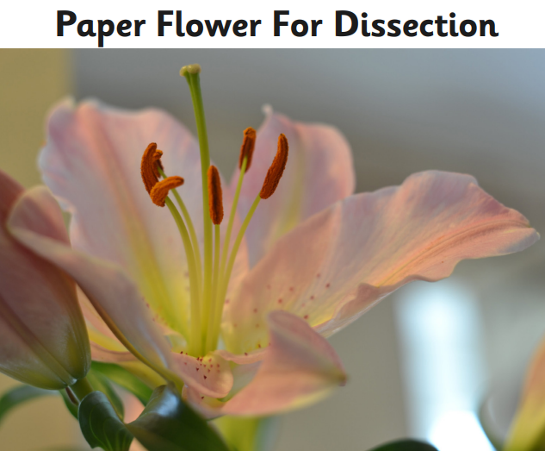

b)
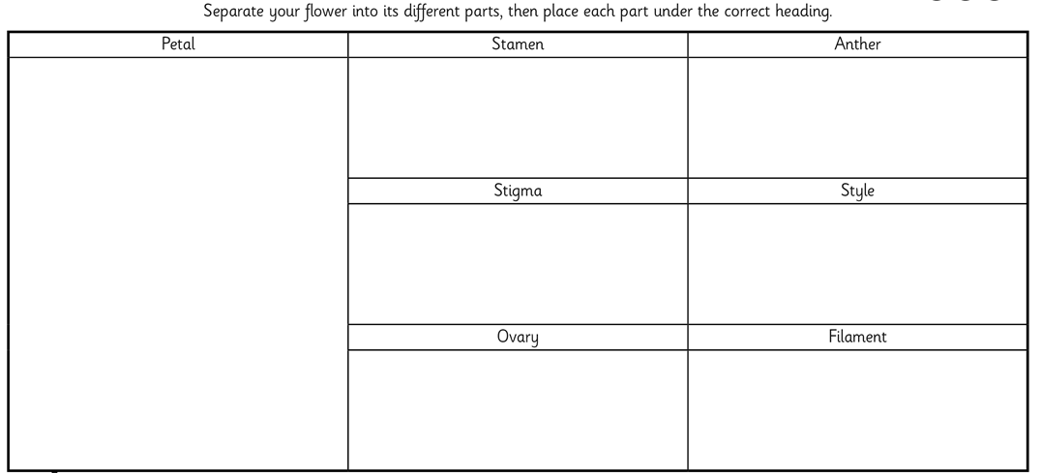

Use the diagram below to help you.
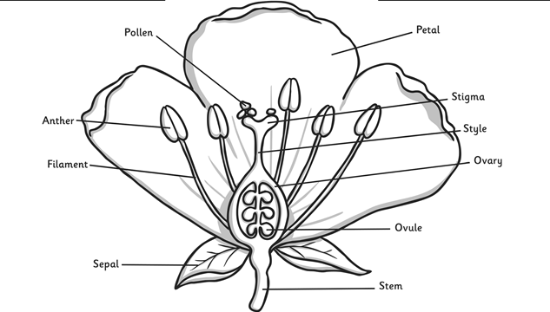

Activity 2
