Science 1.2.21
Go to the following web page: www.bing.com/videos/search?q=life+cycle+of+a+flower+for+kids&&view=detail&mid=97A10F756C4A495E068C97A10F756C4A495E068C&&FORM=VRDGAR&ru=%2Fvideos%2Fsearch%3Fq%3Dlife%2Bcycle%2Bof%2Ba%2Bflower%2Bfor%2Bkids%26FORM%3DHDRSC4
Answer the following questions.
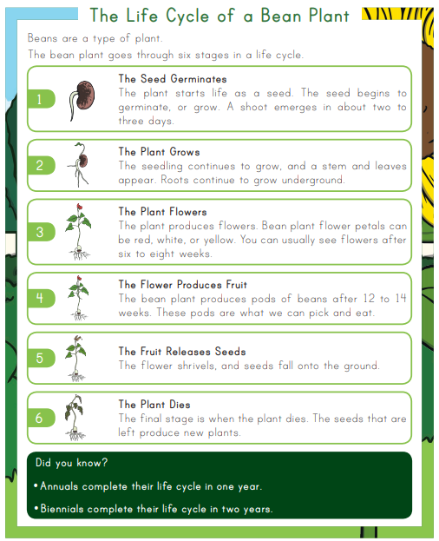
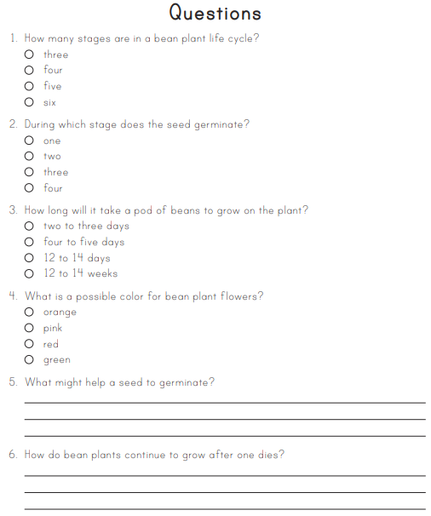

Find the answers below – Don’t peek until you have attempted to answer these.

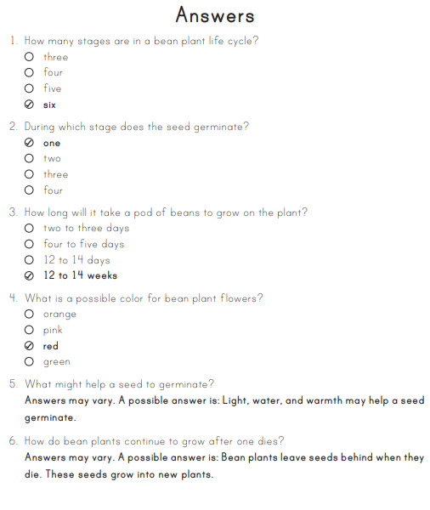

Activity 2
Research and draw the lifecycle of a plant of your choice. Remember to include all the different stages. Look at the examples below to inspire you.
