Spellings 18.1.21
How many of these can you learn?
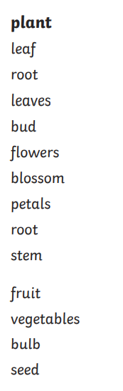
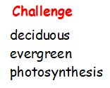
Can you use these in a sentence?

