Home learning
Art - Year 1
Over the next two weeks we are going to be making our own pirate ships out of junk model materials and resources.
This week we are going to design our ships and collect items we need to make the ships.
What I would like you to do is to draw a design of your pirate ship. Once you have designed it, I want you to label the different parts of the ship with what you are going to use to make it.
Remember: You are going to be making it next week, so when you are designing the ship, you will need to think about what items you will have available to build the ship with. You may need to ask your adult to help you with what items will be available.
As well as labelling your design, you need to write a list of items you will need to build it, under the heading “What do I need?” which will include the items you plan to collect this week, as well as any other resources to build it, such as glue or tape.
- Please use the template below to help you with this.
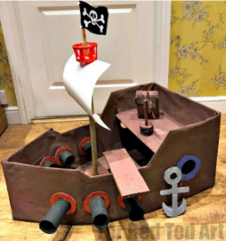
Here are some pictures to help you with ideas of what you can use.
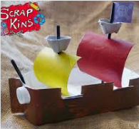

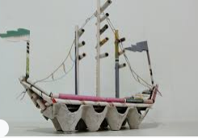

Please draw your ‘Pirate Ship’ Design here:

What do I need to build my Pirate Ship? - Please bullet point what materials you are using.
_______________________________________________________________________________________________________________________________________________________________________________________________________________________________________________________________________________________________________________________________________________________________________________________________________________________________________________________________________
Home learning
Art – Year 2
Over the next two weeks we are going to be making our own pirate ships out of junk model materials and resources.
This week we are going to design our ships and collect items we need to make the ships.
What I would you to do is to draw a design of your pirate ship. Once you have designed it, I want you to label the different parts of the ship with what you are going to use to make it.
Remember: You are going to be making it next week, so when you are designing the ship, you will need to think about what items you will have available to build the ship with. You may need to ask your grownup to help you with what items will be available.
Once you have drawn and labelled your design, you will need to write a list of items you will need for construction next week, as well as an explanation of why you have chosen those materials.
- Please use the template below to help you with this.
Here are some pictures to help you with ideas of what you can use.

Please draw your ‘Pirate Ship’ Design here:

What do I need to build my Pirate Ship? – Please explain why you are using these materials.
______________________________________________________________________________________________________________________________________________________________________________________________________________________________________________________________________________________________________________________________________________________________________________________________________

