Home learning
Art
Hello Squirrels,
Thank you for your amazing pirate ship designs last week!
This week, you are going to be making them.
What I want you to do it make your pirate ship based on your plans from last week.
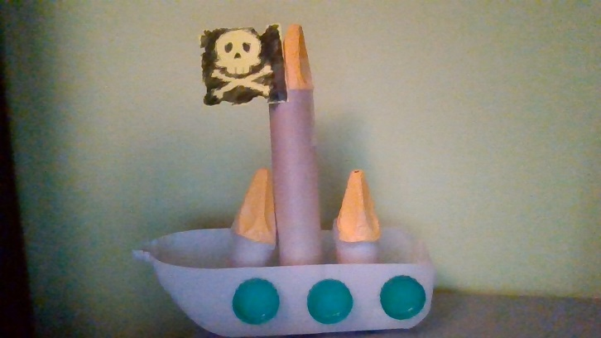
Here is a picture of my pirate ship.

If you did not get round to doing the plan last week do not worry, you can still make the pirate ship this week.
Once you have made it, either send a picture of your ship by email or upload onto teams. On the next page there are some questions I would like you to think about and answer.

Year 1 – speak to an adult about these questions.

Year 2 – answer these questions in the space below.

We are looking forward to seeing your fantastic pieces of work!

What do you think went well?
________________________________________________________________________________________________________
What would you do differently?
________________________________________________________________________________________________________
Did you change anything from your plan?
________________________________________________________________________________________________________

