Home Learning
English
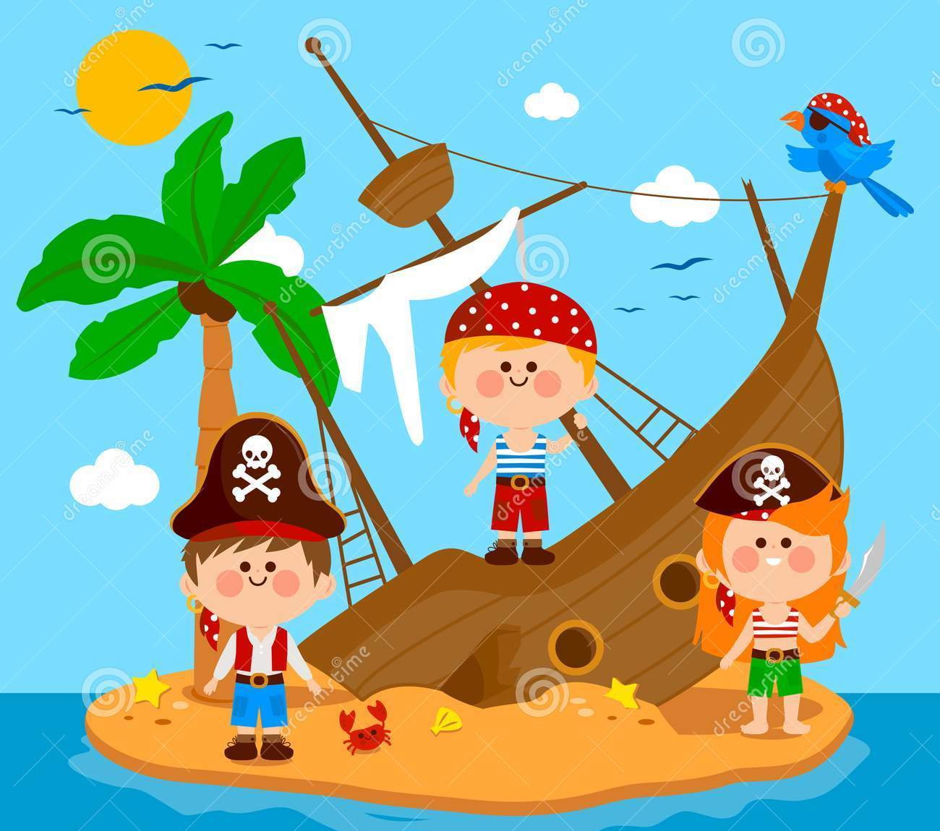
Our topic for this term is ‘Pirates!’ The pictures below need your help! We need to send a message in a bottle to set them free!
How could we help them?
What has happened?
How do you think they feel?

In your message, you need to include:
- What they look like.
- What has happened to them.

Year 1:
Please write 3 sentences for your message in a bottle. There is a template below if you would like to print it, or you can write your message on paper.

Year 2:
Please write 6 sentences for your message in a bottle. There is a template below if you would like to print it, or you can write your message on paper.

Message in a bottle Template:

