Home Learning
English
Today we are going to be learning about ‘Prepositions.’
Let’s remind ourselves about what one is: https://www.bbc.co.uk/bitesize/topics/zwwp8mn/articles/zw38srd#:~:text=Introduction%20to%20prepositions-,Prepositions,%2C%20under%2C%20inside%20and%20outside.
A preposition tells you where an object is in relation to something else.
- Look at the questions below and fill in the missing word with a preposition from the box. The first one is done for you.
in on next to behind
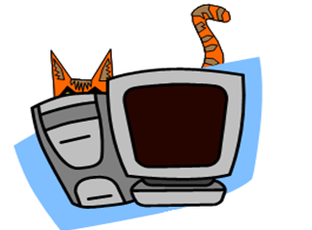
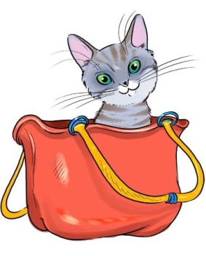
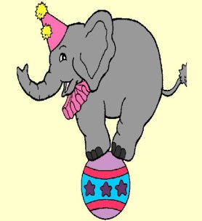
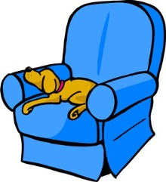
3. The cat is _______ the computer.
2. The cat is ______ the bag.
4. The elephant is ______ the bal.
1. The dog is on the sofa.

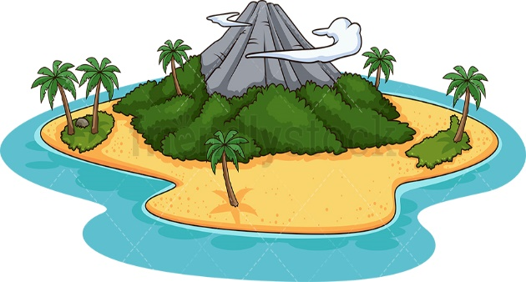
Year 1: Once you have completed the questions above, please look at the treasure map below. It is your job to fill in the sentences to show how the pirate got to the hidden treasure!
2. The Pirate climbs ____________ the mountain.

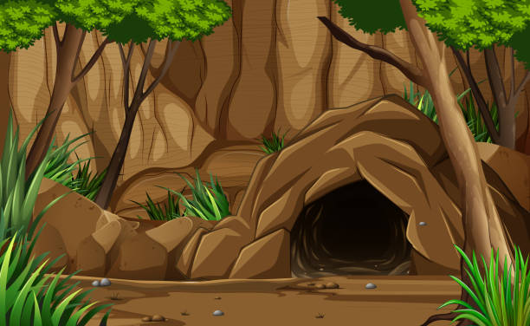
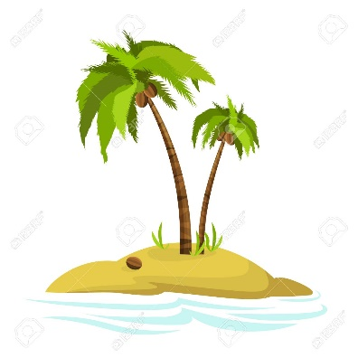
3. The Pirate is hiding ____________ the ___________.
3. The Pirate is standing ____________ the palm tree.
1. The Pirate jumps ____________ the sea.

Year 2: Once you have completed the questions above, please look at the treasure map below. It is your job to fill in the sentences to show how the pirate got to the hidden treasure!
2. The Pirate climbs ____________ the __________mountain.
Challenge: Can you add an adjective to describe the objects?

1. The Pirate jumps ____________ the cold sea.
3. The Pirate is standing ____________ the ___________palm tree.

3. The Pirate is hiding ____________ the ___________ _______.

Year 1 Answers:
- The Pirate jumps into the sea.
- The pirate climbs up the mountain.
- The pirate is standing next to the palm tree.
- The pirate is hiding inside the cave.

Year 2 Answers – I have written suggestions for adjectives. Any that the children have suggested is fantastic.
- The Pirate jumps into the cold/rough/wavey sea.
- The pirate climbs up the rocky/steep mountain.
- The pirate is standing next to the green/beautiful/swaying palm tree.
- The pirate is hiding inside the dark/damp/scary cave.

