Home Learning
English
Good Morning Squirrels. As you know our topic is ‘Pirates’ for this term. We are going to be starting a book today called ‘Pirates love Underpants.’
Please watch the story: https://www.youtube.com/watch?v=Vd8_Y1bEzA8

Please talk to your adult about these questions:
- What do the pirates love?
- How did they get the golden underpants?
- What was your favourite part?

Activity:
Year 1: Please draw a picture of your favourite part of the story. Then write 4 sentences about why you like this part of the story.
You could start like this:
I like this because…
I find this part good because…

Look at my example below for some help (underneath the Year 2 Work)

Year 2: Please draw a picture of your favourite part of the story. Then write a paragraph (6 sentences) about why you like this part of the story.
You could start like this:
I like this because…
I find this part good because…

Look at my example below for some help.
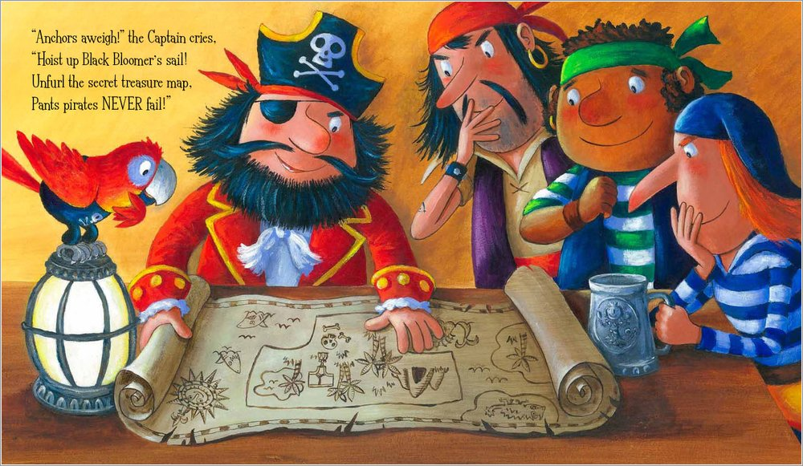
I like this part because they are making a plan.
I like this because the parrot is helping to.
I like this because the island on the map looks like underpants.
I like this because they look excited and happy.

