Home Learning
English
Happy Monday Squirrels. This week you will be doing a series of activities that will help you with next weeks learning. Today we are going to be learning about Nouns.
Please watch this video: https://www.bbc.co.uk/bitesize/topics/zrqqtfr/articles/zpd8ng8

There are 2 types of noun:
- Common nouns
These are the names of things (places or objects).
- Proper nouns
These are the names of a particular person, place or thing. They always begin with a capital letter.

Year 1
Activity: Please look at the pirate below and write in the nouns for each part of the pirate. I have given you the first letter of each word. I have done 2 for you. You can print or edit this document.
h
Pirate

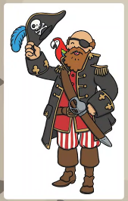
eye-patch
b
p
j

s
t
b

Challenge:
Can you write 3 sentences using 2 of the nouns you have found on the pirate?
I have used 2 nouns in my sentence.
I have given you an example:
The pirate has an eye-patch.

Remember:
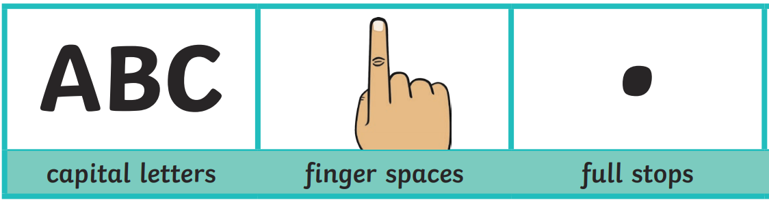
1. _________________________________________________________________________________________________________________________________________________________

2. _________________________________________________________________________________________________________________________________________________________

3. _________________________________________________________________________________________________________________________________________________________

Year 2:
Activity: Please look at the pirate below and write in the nouns for each part of the pirate. I have done 2 for you. You can print or edit this document.

Pirate

eye-patch

Challenge:
Can you write 2 sentences using 2 of the nouns you have found on the pirate?
I have used 2 nouns in my sentence.
I have given you an example:
The pirate has an eye-patch.
Remember:
1.________________________________________________________________________________________________________________________________________________________

2.________________________________________________________________________________________________________________________________________________________

3.________________________________________________________________________________________________________________________________________________________

4.________________________________________________________________________________________________________________________________________________________

