Home Learning
English
Year 1 and 2:
Yesterday, you learnt about nouns and today we are going to learn about verbs.
Please watch this video about verbs: https://www.bbc.co.uk/bitesize/topics/zrqqtfr/articles/zpxhdxs

Activity 1: Please highlight (on the document) or colour in the verbs in the sentences below.

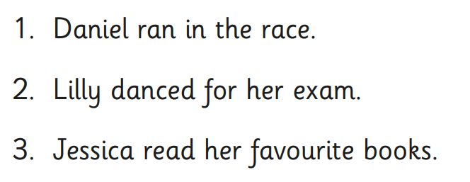

Activity 2: Please look at the pictures of the pirates. They are ‘doing’ different activities. Can you match the verbs to the actions in the picture?
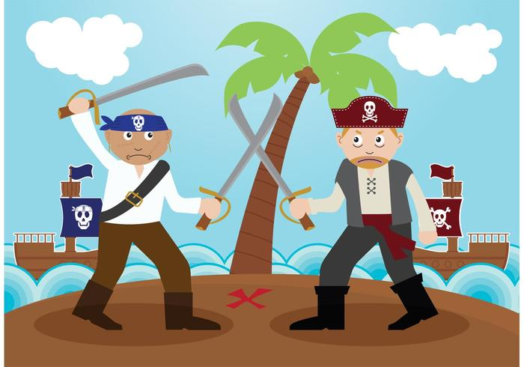
2.
1.
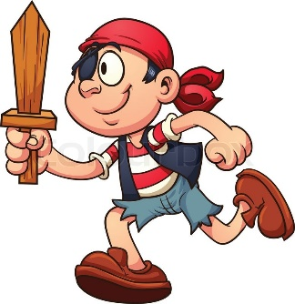

3.
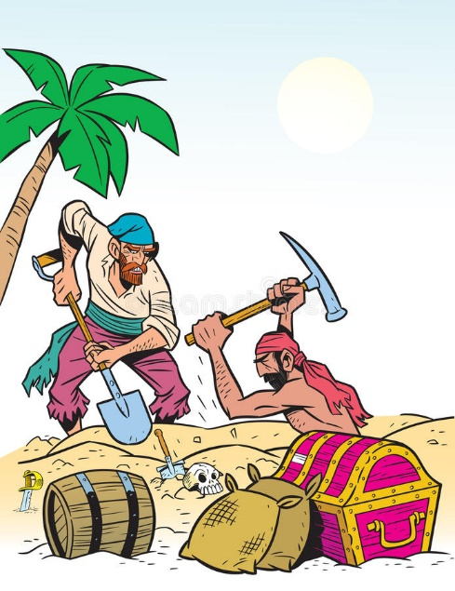
4.

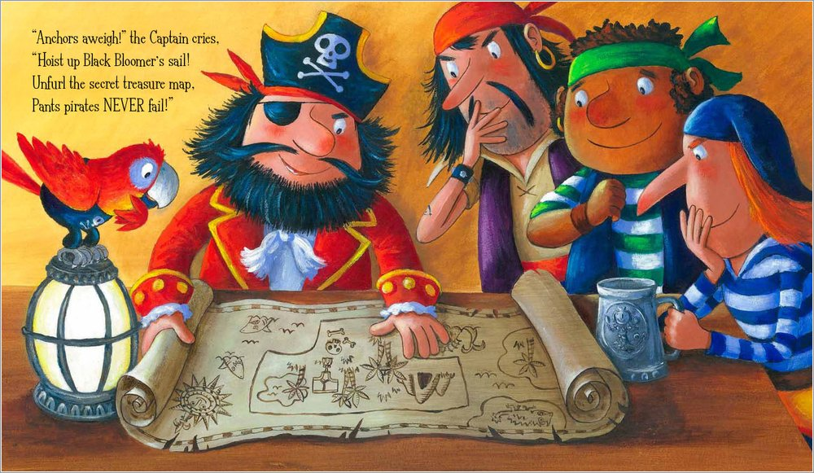
5.

Year 1:  Please look at the pictures above and write 3 sentences which include a verb. I have done the first one for you. | Year 2:  Please look at the pictures above and write 5 sentences which include a verb. I have done the first one for you.

1. The pirate is running.

2._____________________________________________________________________________

3. _____________________________________
_______________________________________

4. ______________________________________
_______________________________________

5. _____________________________________
_______________________________________

6. ______________________________________
_______________________________________

