**Home Learning**

**English**

Today we are going to be focusing more on the book that we started this term ‘Pirate’s love underpants.’

Please watch this recording of the book to remind yourselves of the story: <https://www.youtube.com/watch?v=Vd8_Y1bEzA8>

Year 1:

Please look below at the sentences. These are sentences from the story ‘Pirates love underpants.’

In each sentence, I have highlighted the verb and left a space next to it.

This is for you think of an adverb.

Please watch this video: <https://www.bbc.co.uk/bitesize/topics/zwwp8mn/articles/zgsgxfr>

An Adverb describes the verb.

* Use the adverb word mat on the next page to help you describe the verb.
* Please re-write the full sentence underneath with your new adverb.

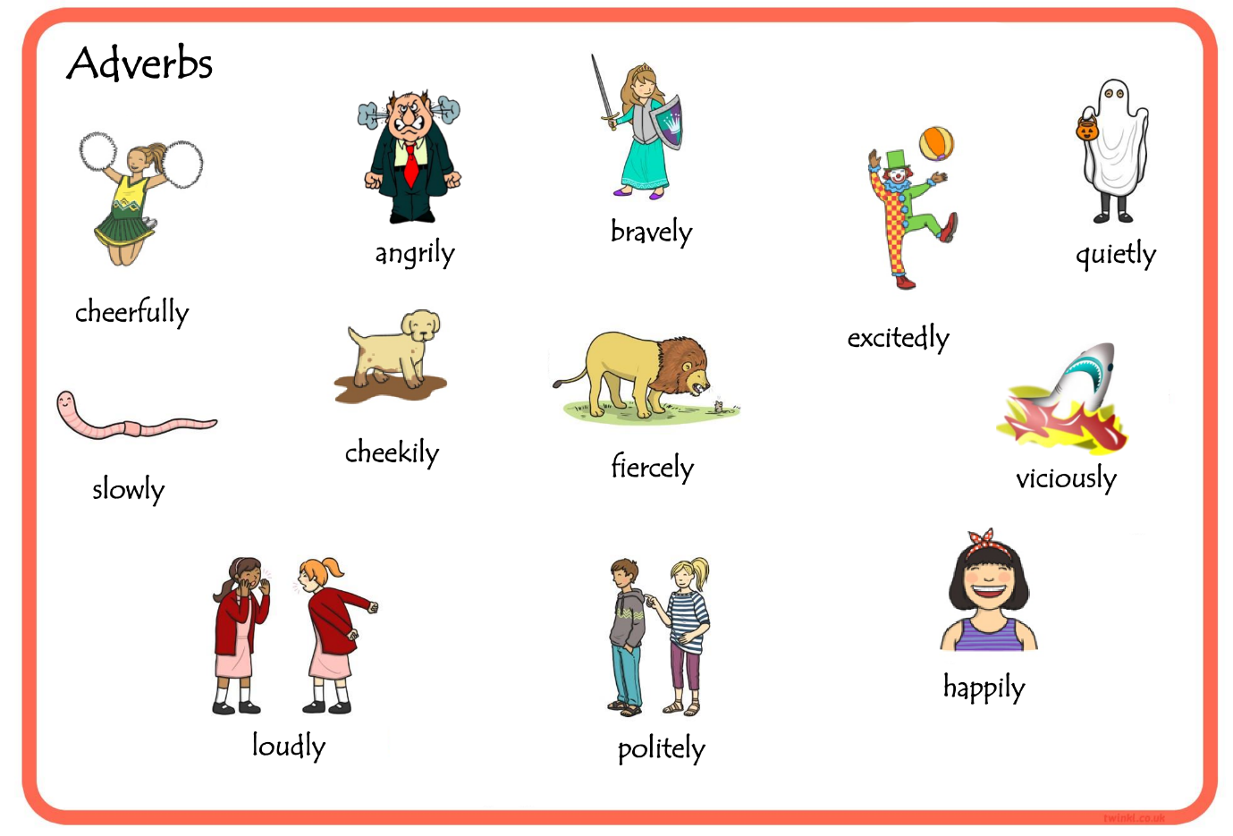

How does the boat bob?

verb

1. Black Bloomer bobs ________________upon the waves.

___________________________________________________________________________________________________________________________________________________________________________________________________

In this sentence, I have put the line for the adverb later on so the sentence will make sense.

How do they grab the cutlasses?

How do they row the boats?

2. The pirates grab their cutlasses _____________, and row their boats __________ to shore.

___________________________________________________________________________________________________________________________________________________________________________________________________

3. The pirates wade _________________ through the gurgling swamps.

___________________________________________________________________________________________________________________________________________________________________________________________________

4. They trek ______________through prickly undergrowth.

___________________________________________________________________________________________________________________________________________________________________________________________________

Year 2:

Please look below at the sentences. These are sentences from the story ‘Pirates love underpants.’

In each sentence, I have highlighted the verb and left a space next to it.

This is for you think of an adverb.

Please watch this video: <https://www.bbc.co.uk/bitesize/topics/zwwp8mn/articles/zgsgxfr>

An Adverb describes the verb.

* Use the adverb word mat on the next page to help you describe the verb and write it in the space provided.
* Then, have a think of another word for the verb (highlighted in green).
* You can use this link to a thesaurus to help you find some different words for the verb: <https://www.thesaurus.com/>
* Once you have got a different verb and an adverb, please re-write your sentence underneath.



How do they row the boats?

How does the boat bob?

How do they grab the cutlasses?

verb

1. Black Bloomer bobs ________________upon the waves.

___________________________________________________________________________________________________________________________________________________________________________________________________

In this sentence, I have put the line for the adverb later on so the sentence will make sense.

2. The pirates grab their cutlasses _____________, and row their boats __________ to shore.

___________________________________________________________________________________________________________________________________________________________________________________________________

3. The pirates wade _________________ through the gurgling swamps.

___________________________________________________________________________________________________________________________________________________________________________________________________

4. They trek ______________through prickly undergrowth.

___________________________________________________________________________________________________________________________________________________________________________________________________