Home Learning
English
Year 1 and 2:
This week we have been focusing on Nouns, Verbs, Adjectives and Adverbs.
Our final lesson for this week will be focusing on all of these aspects.
We are going to do a Wanted Poster.

Remember:
Noun: a person, place or thing.
Verb: a doing word.
Adjective: a describing word.

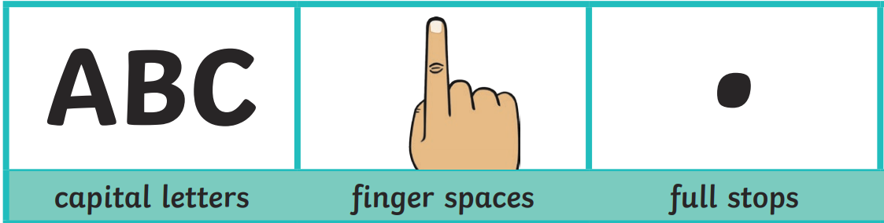
Make sure you have these in your writing:

Activity:
- Draw a picture of a pirate either in the space below or on plain paper.
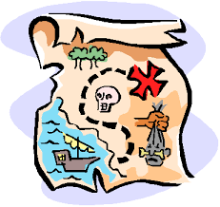
- Try and make this pirate colourful and with lots of accessories. Here are some examples:
map
eye-patch
parrot
sword
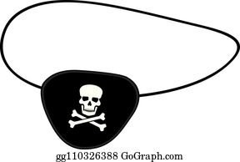
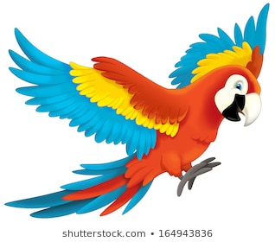
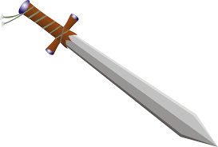
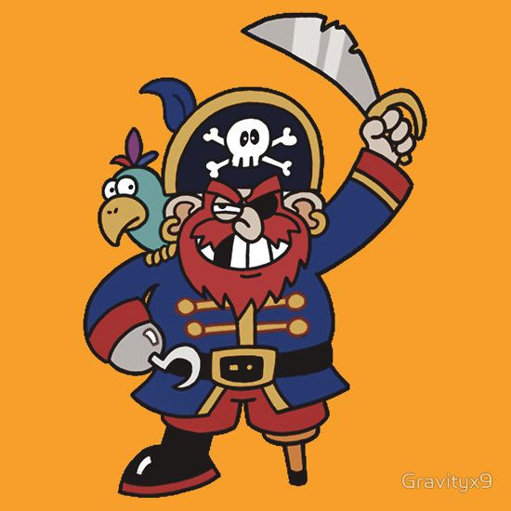
telescope
peg-leg
hook
hat

- Next, use the template below to help you structure your writing.
- Please write in full sentences.
- If you are unable to print, please draw and write your wanted poster on paper. You can also print the template or type straight onto the template.

Name: ___________________________________

What does the pirate look like?
____________________________________________________________________________________________________________________________________________________________________________________________________________________________________________________________________________________________________________________________________________________________________________________________________________

