Home Learning
English
Year 1 and 2:
Today we are going to continue looking at rhyming words and then learn about how to write a shape poem.
Activity 1:
Please look at the treasure map below:
- You are the pirate at the top.
- Each object you come to has a word behind it.
- Please collect all of the words and put them in their rhyming pairs (on the page underneath).
- Once you have collected them you can see what is behind the treasure chest and collect your prize.
- To collect your treasure, please hand in this assignment once you have completed the treasure hunt.
To complete this activity:
- You can type onto this document – Please download it from teams onto Word for it to work more easily
- You can write your answers on paper.

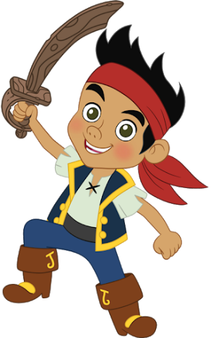
sword
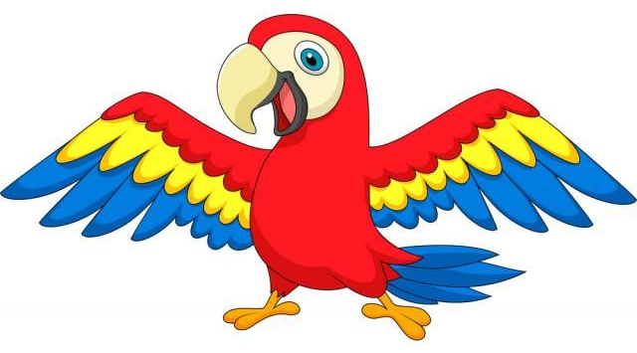
parrot

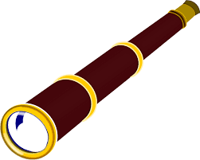
board

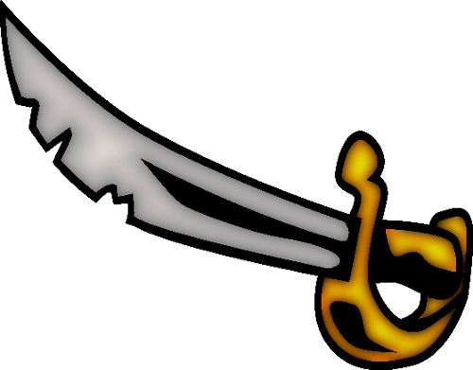

flag
carrot

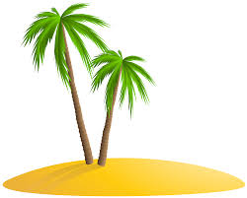
rag
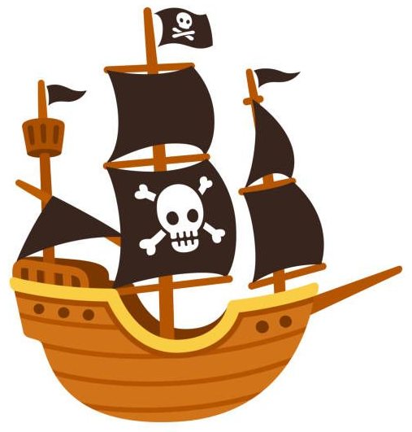
You have 3 dojos.
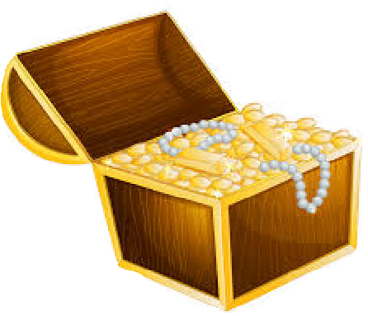
Move the treasure chest to see the prize!
Rhyming Words:

1.

2.

3.

Activity 2:
Year 1:
Using the word’s, you collected above, please have a go at writing a short poem using them. I have put a template below with the rhyming words at the end of each sentence to give some structure to your writing.

_________________________________________ parrot,
_________________________________________ carrot.
_________________________________________ flag,
_________________________________________ rag.
_________________________________________ sword,
_________________________________________ board.
Year 2:
Using the word’s, you collected from the treasure hunt, please have a go at writing a short poem using them. I have put a template below with the rhyming words at the end of each sentence to give some structure to your writing.
Hint: Try and keep on the theme of pirates.

