**Home Learning**

**English**

Year 1 and 2:

Today we are going to write a shape poem about a pirate.

Please watch this video to learn a little more: <https://www.youtube.com/watch?v=pgV738hpu_M>

**Shape Poem:**

* You write your poem in the shape of the object or thing that you are writing about.
* This means you can write around the outline of the pirate or on the lines in the middle – It is up to you.
* You do not need to make your sentences rhyme.

**Activity:**

Year 1 and 2 – You are going to write a poem about a pirate. Use the picture below to help you with your poem. Please use the template of the pirate underneath it to write your shape poem.

* If you cannot fit your poem in the pirate, you can put the rest underneath or go around the outline of the pirate shape.

Challenge: Can you make the last two sentences rhyme?

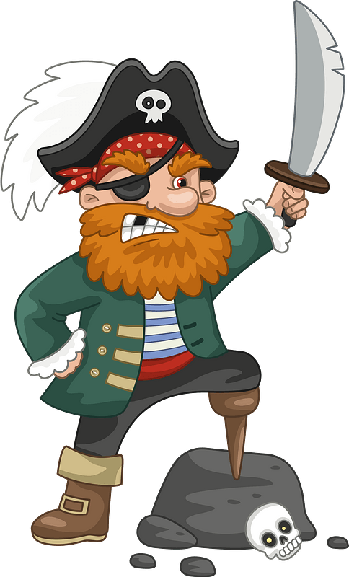Pirate:

Questions to help:

1. What do you like?

2. What is the beard like?

3. Is he short or tall?

4. What clothes are you wearing?

5. What does he have on his head?

6. Are you carrying anything?

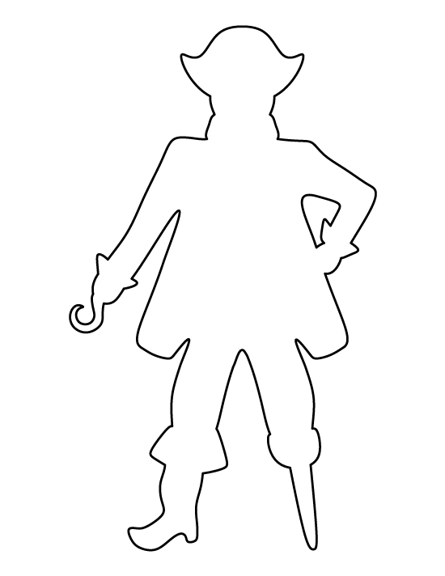Shape Poem: Pirate.