Home Learning
English
Year 1 and 2
This is our final week on our story ‘Pirate’s love underpants.’
Let’s recap what the story was about: https://www.youtube.com/watch?v=Vd8_Y1bEzA8

To complete this work, you can:
- Answer it on this document.
- Print and write your plan.
- Use the document to help you and write your ideas on paper (I have attached this as a PDF to teams so you can see it more easily)
Activity:
Today we are going to be planning our own pirate story. This is going to take 3 days.
First, we need to plan.
- We are going to plan over 2 days and write over 2 days.
- Please look at the template below.
- This is going to help you get your structure for your writing.

Character: Please think of who your main character is going to be.
Answer the questions below and bullet point your ideas.
1. What is their name?
- ________________________________
- ________________________________
- ________________________________
2. What do they look like?
- _______________________________
- _______________________________
- _______________________________

good | bad | funny
frightening | mysterious | evil
cunning | kind | intelligent
3. What is their personality like? (I have put some words to help you)
- ___________________________
- ___________________________
- ___________________________

4. Where do they live?
- ___________________________
- ___________________________
- ___________________________

5. What props do they have?
- ___________________________
- ___________________________
- ___________________________
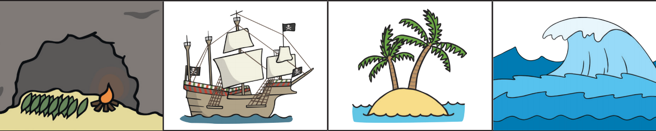
Setting: I have attached some setting ideas for a pirate story. Have a look through and write down where it is going to be set.
desert island
sea
ship
cave

Please choose from above or use any other ideas you might have.
Where is it set?
- __________________________
- __________________________
- __________________________

Ending – Your ending is going to be that your pirate discovers some secret treasure. Today we are going to think about what they find.
What do you want your pirate to find at the end of your story?
- ___________________________
- ___________________________
- ___________________________
Why is it so important? (What is the backstory?)
- ___________________________
- ___________________________
- ___________________________

