Home Learning
English
Year 1 and 2
Really well done for a brilliant week of writing Squirrels, you have written some lovely stories. Today we are going to be writing an alterative ending to our story ‘Pirates love Underpants.’
Let’s just recap the story: https://www.youtube.com/watch?v=Vd8_Y1bEzA8
The ending of this story is:
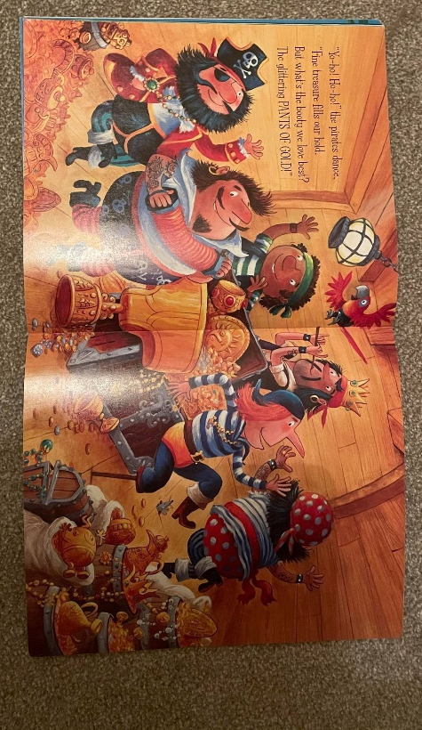
They celebrated and had a party.
They stole the golden underpants and ran away.
They cut the elastic of the other pirates’ underpants.

Activity:
Your challenge is to write an ending from when the pirates see the other group of pirates.
That means you need to write a paragraph which includes:
- How the pirates are going to stop the other pirates from stealing the underpants.
- How they are going to escape.
- What they do at the end once they have the golden underpants.

Please use these sentence starters to help you write each section:

- Once they had seen the other pirates, they had to make a plan. They ______________________________________________
____________________________________________________________________________________________________.

- They did it! They stole the golden underpants. Next, they had to escape, so __________________________________________
____________________________________________________________________________________________________

- Once they were back safely, they _________________________
____________________________________________________________________________________________________

