Home Learning
English
Hello Squirrels!
I hope that you had a lovely Christmas and New Year. Today you are going to writing about your ‘New Years’ Resolution.’
Have a look at this video to help you learn about what a Resolution is and to see some examples:
https://www.youtube.com/watch?v=3687xlRNOdI
- Talk to your adult about what your New Years Resolutions could be.
- Has your adult got one?
Miss MacMillan’s New Years Resolution:
My New Year’s Resolution is to do exercise every day to keep fit and healthy.

Year 1:
Please write 3 sentences of some different New Years Resolutions that you might do for this year.
You can use my example above to help.
Please go through this video to remind you of the alphabet: https://www.youtube.com/watch?v=gbJAHIbL__U
Use the sentence starter below to help you. Please use the template below or write your sentences on paper.
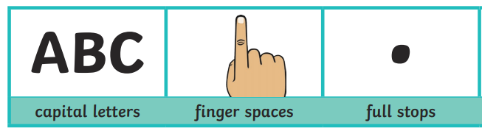
Remember:
Can you give a reason?

My New Year’s Resolution is…
1. ______________________________________________________________________________________________________
2. ______________________________________________________________________________________________________
3.
___________________________________________________
Year 2:
Today we are going to be writing about New Year’s Resolutions.
Use the questions below to help you with your writing. If you are unable to write on the page, please use the questions on the page and answer them on paper.

Remember:
In your answers, please have a go at using ‘because.’
Watch this video to learn about ‘Subordinating Conjunctions.’ This will help you in your work: https://www.youtube.com/watch?v=cWSA2vIMTR0

Year 2 work is on the next page.

