Home Learning
Maths
Year 1: Today we are going to be looking at the numbers 11 – 20.
- Please watch this video and have a go at singing up to 20 and back: https://www.youtube.com/watch?v=_MVzXKfr6e8
Now for your learning: Please watch this video and follow along with it: https://vimeo.com/480769444
Activities:
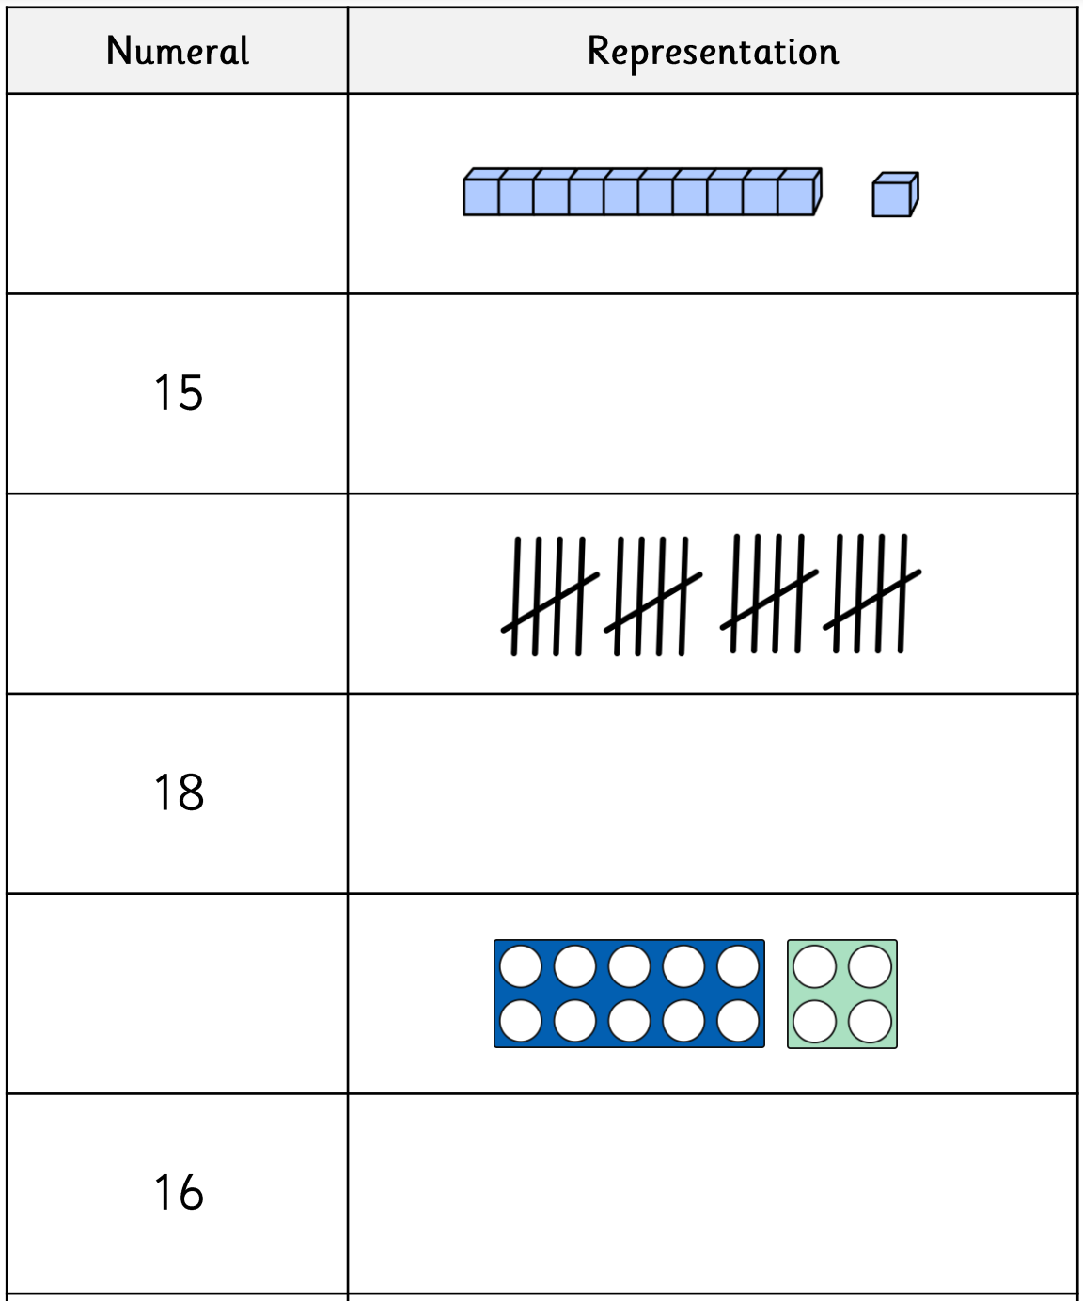
- Look at the numbers and try to draw objects that represent them. There are also questions where you need to count to work out the number.
- Look at the numbers next to the ten frames and make the number in the ten frames.
15

10

17

20

Games:
Please look through the games below and play a few –
https://www.topmarks.co.uk/maths-games/5-7-years/addition-and-subtraction

Year 2: Today, we are going to be adding and subtracting in tens.
- Please watch this video and answer the questions as you go: https://vimeo.com/464192071
- Please complete the questions below by working out what the number is and then working out 10 more and 10 less.
- This link will help you work it out using actual dienes https://mathsbot.com/manipulatives/blocks
10 Less
10 More
10 Less
10 More
10 More
10 Less
12
71
53
10 Less
10 More
10 Less
10 More
10 More
10 Less
10 More
10 Less
10 More
10 Less
10 Less
10 More
43
24
20
62
81
37
Challenges:

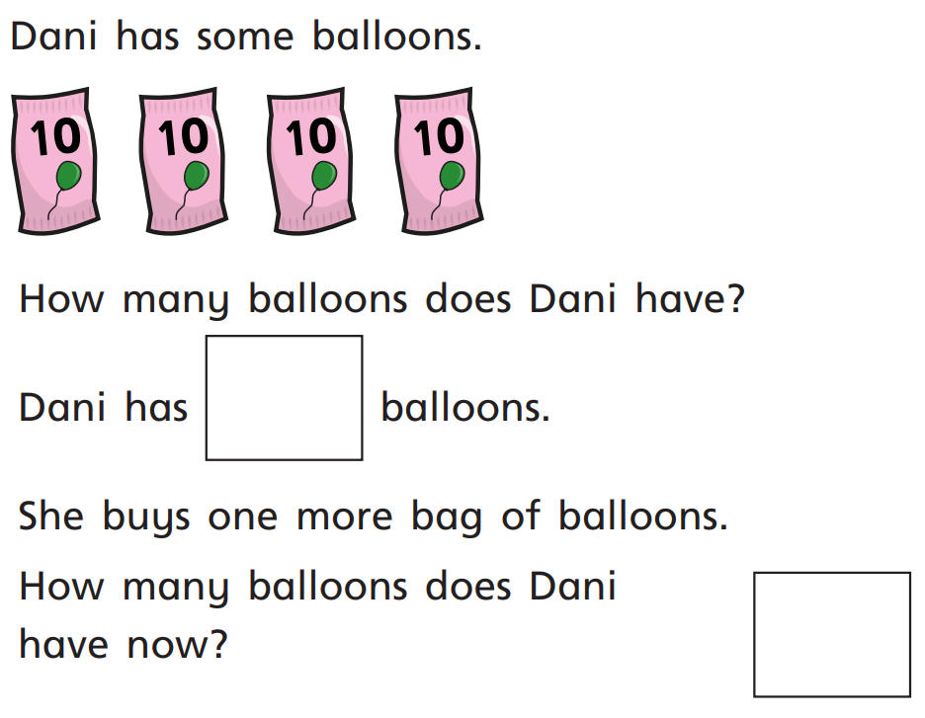
1.

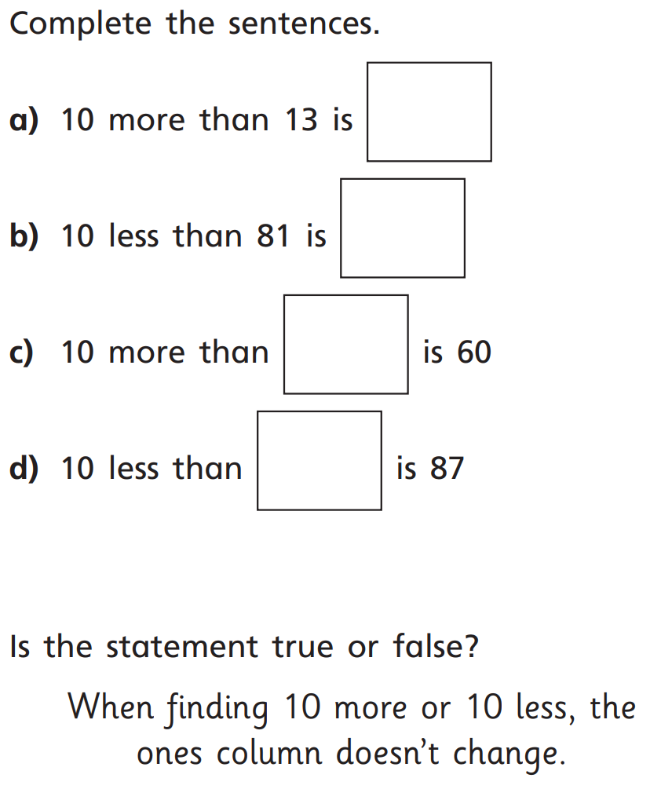
2.

3.

Games:
Choose from any of the games on this link:
https://www.topmarks.co.uk/maths-games/5-7-years/addition-and-subtraction

