**Home Learning**

**Maths**

Year 1:

Today we are going to be recapping tens and ones.

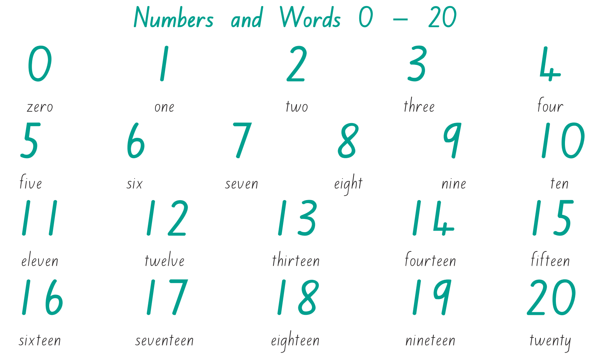Please watch this video and use the ‘Numbers to 20’ word mat below to help you: <https://vimeo.com/480324356>

**Activity 1:**

Circle a the group of ten in each question and then count the rest to find the answer.

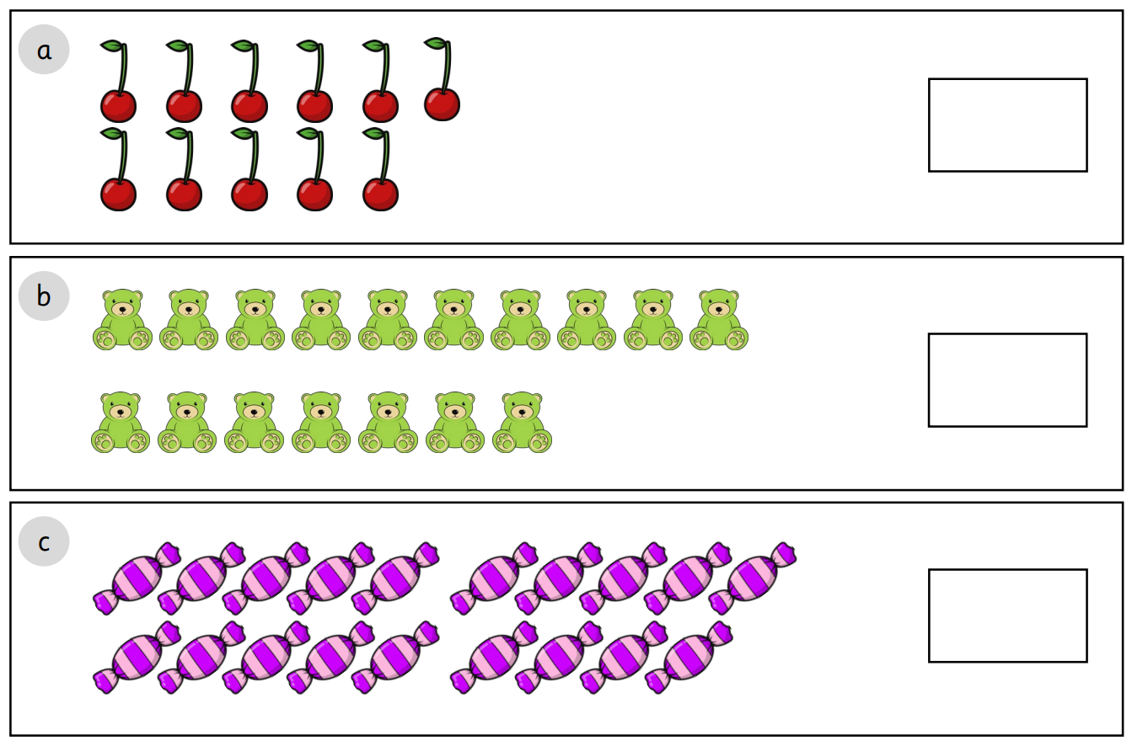**Activity 2:**

Please show each number in the tens frames and write how many tens and ones there are.

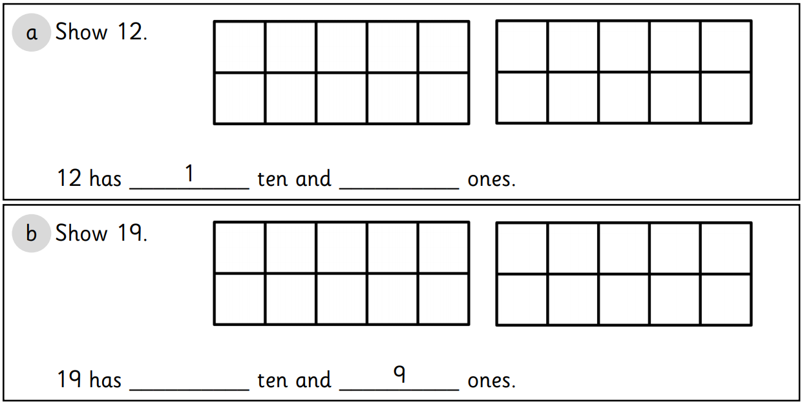

Year 2:

Today we are going to be learning about adding and subtracting tens.

Please watch the video and work through the questions: <https://vimeo.com/464237963>

**Activity:** Below there is a juggler and it is your task to answer the questions below and then colour in each of the juggling balls correctly.

**Questions:**

Red 89 – 10

Blue 22 - 10

Yellow 48 + 10

Green 40 + 10

Purple 43 + 20

Pink 81 – 40

Orange 75 + 20

**Challenge:**

You may have noticed that there are some juggling balls that have not been coloured in.

Can you make up some addition and subtraction number sentences that will make those answers?

Juggling Numbers

95

14

23

79

38

41

61



63

50

12

58