Home Learning
Maths

Year 1: Today we are going to be learning about one more and one less within 20.
First, can you please watch the video on this link (you might have to scroll down to find it) - https://www.bbc.co.uk/bitesize/articles/zht28hv

Now that you are familiar with one more and one less within 10. We are going to have a go at doing it within 20. Below is a number line to 20 to help you if you get stuck.

Remember:
One More – The number gets bigger.
One Less – The number gets smaller.

Activity: Please complete the questions below, on the sheet or on plain paper. There are some challenges and a game below also.
One Less | Number | One More
 | 12
 | 8
 | 3
 | 18
 | 14
 | 11
Challenges:
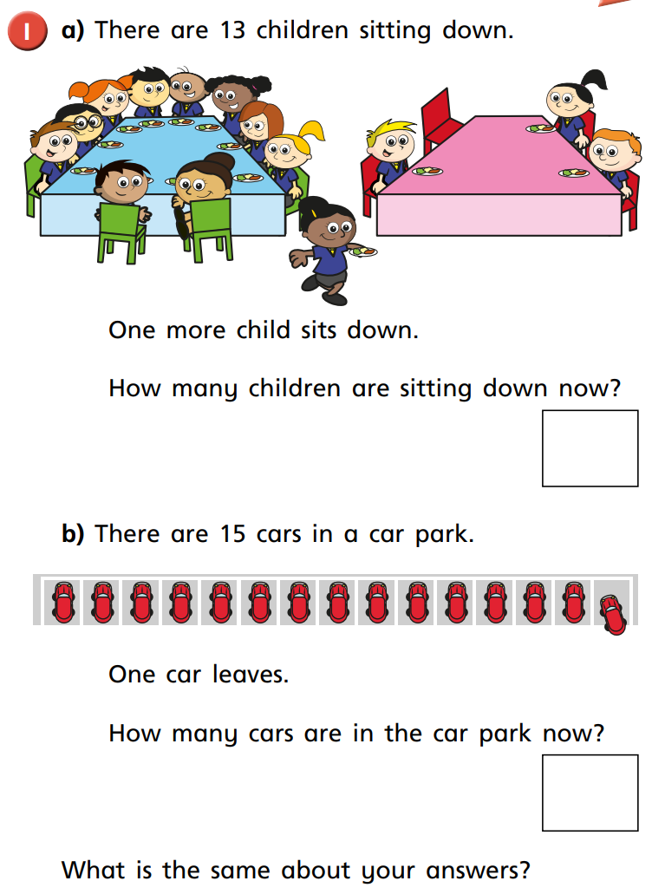

Game: http://www.snappymaths.com/mixed/addsub1w20/interactive/onemorelessw20/onemorelessw20.htm

Year 2:
Today we are going to be learning about ‘Number Bonds to 100.’
Please watch this video to begin with: https://www.youtube.com/watch?v=1DbjJTCUS14

Then please follow this link: https://www.didax.com/apps/ten-frames/
Please follow the instructions below to help you work out your number bonds.
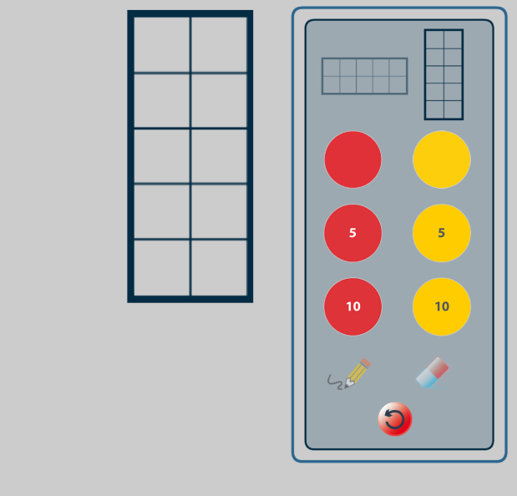
1. Drag a ten frame into the grey space.

2. Look at the red and yellow counters with no numbers on them.
Count in tens and see how many tens are in 100.
Each counter is worth ten.

3. Move one red into the tens square and fill the rest with yellow.
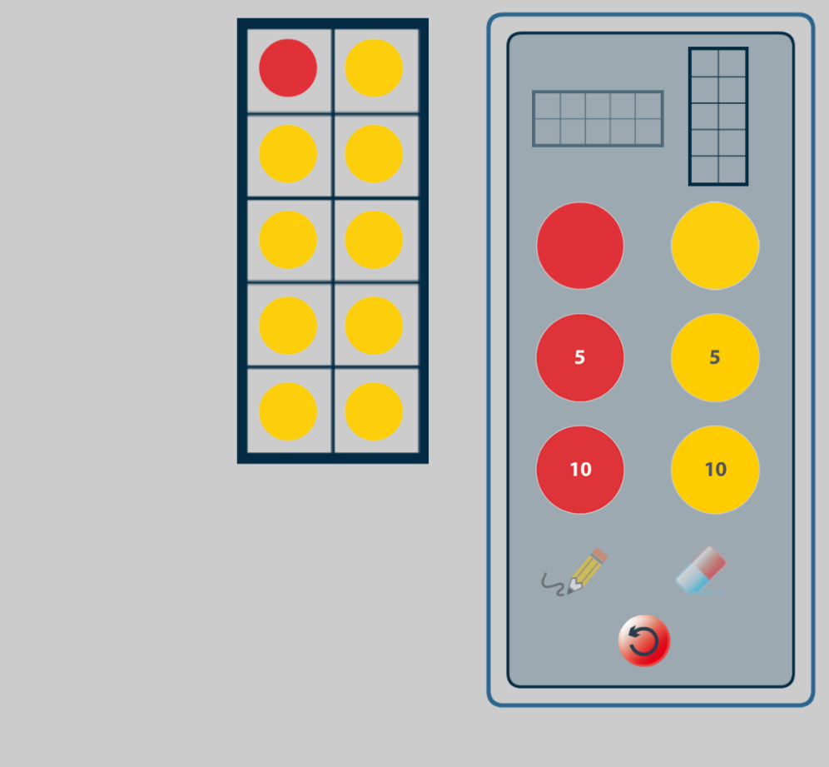

Remember, each counter is worth ten.
How many red counters do you have? 10
How many yellow counters are there? 90
What is my number sentence? 10 + 90 = 100
That is your first number bond to ten. Now let’s work systematically to find all the number bonds to 100.

So, now move 1 yellow away and replace it with 1 more red. What is your number sentence now?
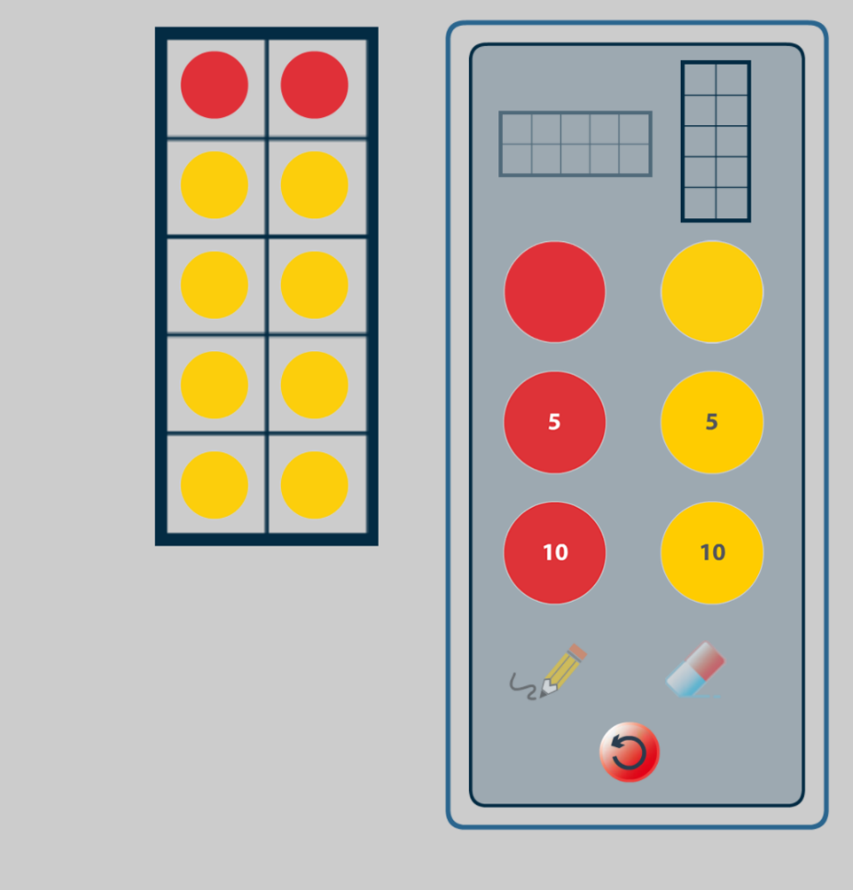

Activity:
Please use this method to find out the different number bonds to 100. The first one is done for you:
1. 10 + 90 = 10
2. 20 + ___ =
3. 30 + ___ =
4. 40 + ___ =
5. 50 + ___ =
6.
7.
8.
9.
10.

Games:
https://www.topmarks.co.uk/addition/robot-addition

