**Home Learning**

**Maths**

Year 1: Today we are learning about comparing objects (within 20).

Please watch this video to begin with: <https://vimeo.com/483168827>

Please complete the maths questions below, either on the sheet or on plain paper.

The children need to count the objects and put in the correct sign.

Remember: What number does the alligator always eat?

1.

|  |  |
| --- | --- |
| C:\Users\Amy\AppData\Local\Microsoft\Windows\Temporary Internet Files\Content.IE5\EK70QLSD\MCj04400420000[1].wmfC:\Users\Amy\AppData\Local\Microsoft\Windows\Temporary Internet Files\Content.IE5\EK70QLSD\MCj04400420000[1].wmfC:\Users\Amy\AppData\Local\Microsoft\Windows\Temporary Internet Files\Content.IE5\EK70QLSD\MCj04400420000[1].wmfC:\Users\Amy\AppData\Local\Microsoft\Windows\Temporary Internet Files\Content.IE5\EK70QLSD\MCj04400420000[1].wmfC:\Users\Amy\AppData\Local\Microsoft\Windows\Temporary Internet Files\Content.IE5\EK70QLSD\MCj04400420000[1].wmf  C:\Users\Amy\AppData\Local\Microsoft\Windows\Temporary Internet Files\Content.IE5\EK70QLSD\MCj04400420000[1].wmfC:\Users\Amy\AppData\Local\Microsoft\Windows\Temporary Internet Files\Content.IE5\EK70QLSD\MCj04400420000[1].wmf  C:\Users\Amy\AppData\Local\Microsoft\Windows\Temporary Internet Files\Content.IE5\EK70QLSD\MCj04400420000[1].wmfC:\Users\Amy\AppData\Local\Microsoft\Windows\Temporary Internet Files\Content.IE5\EK70QLSD\MCj04400420000[1].wmf | C:\Users\Amy\AppData\Local\Microsoft\Windows\Temporary Internet Files\Content.IE5\EK70QLSD\MCj04400420000[1].wmfC:\Users\Amy\AppData\Local\Microsoft\Windows\Temporary Internet Files\Content.IE5\EK70QLSD\MCj04400420000[1].wmfC:\Users\Amy\AppData\Local\Microsoft\Windows\Temporary Internet Files\Content.IE5\EK70QLSD\MCj04400420000[1].wmfC:\Users\Amy\AppData\Local\Microsoft\Windows\Temporary Internet Files\Content.IE5\EK70QLSD\MCj04400420000[1].wmfC:\Users\Amy\AppData\Local\Microsoft\Windows\Temporary Internet Files\Content.IE5\EK70QLSD\MCj04400420000[1].wmfC:\Users\Amy\AppData\Local\Microsoft\Windows\Temporary Internet Files\Content.IE5\EK70QLSD\MCj04400420000[1].wmfC:\Users\Amy\AppData\Local\Microsoft\Windows\Temporary Internet Files\Content.IE5\EK70QLSD\MCj04400420000[1].wmfC:\Users\Amy\AppData\Local\Microsoft\Windows\Temporary Internet Files\Content.IE5\EK70QLSD\MCj04400420000[1].wmfC:\Users\Amy\AppData\Local\Microsoft\Windows\Temporary Internet Files\Content.IE5\EK70QLSD\MCj04400420000[1].wmfC:\Users\Amy\AppData\Local\Microsoft\Windows\Temporary Internet Files\Content.IE5\EK70QLSD\MCj04400420000[1].wmfC:\Users\Amy\AppData\Local\Microsoft\Windows\Temporary Internet Files\Content.IE5\EK70QLSD\MCj04400420000[1].wmf |

2.

|  |  |
| --- | --- |
| C:\Users\Amy\Pictures\Microsoft Clip Organizer\j0434823.pngC:\Users\Amy\Pictures\Microsoft Clip Organizer\j0434823.pngC:\Users\Amy\Pictures\Microsoft Clip Organizer\j0434823.pngC:\Users\Amy\Pictures\Microsoft Clip Organizer\j0434823.pngC:\Users\Amy\Pictures\Microsoft Clip Organizer\j0434823.pngC:\Users\Amy\Pictures\Microsoft Clip Organizer\j0434823.png  C:\Users\Amy\Pictures\Microsoft Clip Organizer\j0434823.pngC:\Users\Amy\Pictures\Microsoft Clip Organizer\j0434823.pngC:\Users\Amy\Pictures\Microsoft Clip Organizer\j0434823.pngC:\Users\Amy\Pictures\Microsoft Clip Organizer\j0434823.pngC:\Users\Amy\Pictures\Microsoft Clip Organizer\j0434823.png  C:\Users\Amy\Pictures\Microsoft Clip Organizer\j0434823.pngC:\Users\Amy\Pictures\Microsoft Clip Organizer\j0434823.pngC:\Users\Amy\Pictures\Microsoft Clip Organizer\j0434823.pngC:\Users\Amy\Pictures\Microsoft Clip Organizer\j0434823.pngC:\Users\Amy\Pictures\Microsoft Clip Organizer\j0434823.png | C:\Users\Amy\Pictures\Microsoft Clip Organizer\j0434823.pngC:\Users\Amy\Pictures\Microsoft Clip Organizer\j0434823.pngC:\Users\Amy\Pictures\Microsoft Clip Organizer\j0434823.pngC:\Users\Amy\Pictures\Microsoft Clip Organizer\j0434823.pngC:\Users\Amy\Pictures\Microsoft Clip Organizer\j0434823.pngC:\Users\Amy\Pictures\Microsoft Clip Organizer\j0434823.pngC:\Users\Amy\Pictures\Microsoft Clip Organizer\j0434823.pngC:\Users\Amy\Pictures\Microsoft Clip Organizer\j0434823.pngC:\Users\Amy\Pictures\Microsoft Clip Organizer\j0434823.pngC:\Users\Amy\Pictures\Microsoft Clip Organizer\j0434823.pngC:\Users\Amy\Pictures\Microsoft Clip Organizer\j0434823.pngC:\Users\Amy\Pictures\Microsoft Clip Organizer\j0434823.pngC:\Users\Amy\Pictures\Microsoft Clip Organizer\j0434823.pngC:\Users\Amy\Pictures\Microsoft Clip Organizer\j0434823.pngC:\Users\Amy\Pictures\Microsoft Clip Organizer\j0434823.pngC:\Users\Amy\Pictures\Microsoft Clip Organizer\j0434823.pngC:\Users\Amy\Pictures\Microsoft Clip Organizer\j0434823.png |

3.

|  |  |
| --- | --- |
| C:\Users\Amy\AppData\Local\Microsoft\Windows\Temporary Internet Files\Content.IE5\JWNB3YVM\MCj04370780000[1].pngC:\Users\Amy\AppData\Local\Microsoft\Windows\Temporary Internet Files\Content.IE5\JWNB3YVM\MCj04370780000[1].pngC:\Users\Amy\AppData\Local\Microsoft\Windows\Temporary Internet Files\Content.IE5\JWNB3YVM\MCj04370780000[1].pngC:\Users\Amy\AppData\Local\Microsoft\Windows\Temporary Internet Files\Content.IE5\JWNB3YVM\MCj04370780000[1].pngC:\Users\Amy\AppData\Local\Microsoft\Windows\Temporary Internet Files\Content.IE5\JWNB3YVM\MCj04370780000[1].pngC:\Users\Amy\AppData\Local\Microsoft\Windows\Temporary Internet Files\Content.IE5\JWNB3YVM\MCj04370780000[1].pngC:\Users\Amy\AppData\Local\Microsoft\Windows\Temporary Internet Files\Content.IE5\JWNB3YVM\MCj04370780000[1].png  C:\Users\Amy\AppData\Local\Microsoft\Windows\Temporary Internet Files\Content.IE5\JWNB3YVM\MCj04370780000[1].pngC:\Users\Amy\AppData\Local\Microsoft\Windows\Temporary Internet Files\Content.IE5\JWNB3YVM\MCj04370780000[1].pngC:\Users\Amy\AppData\Local\Microsoft\Windows\Temporary Internet Files\Content.IE5\JWNB3YVM\MCj04370780000[1].pngC:\Users\Amy\AppData\Local\Microsoft\Windows\Temporary Internet Files\Content.IE5\JWNB3YVM\MCj04370780000[1].pngC:\Users\Amy\AppData\Local\Microsoft\Windows\Temporary Internet Files\Content.IE5\JWNB3YVM\MCj04370780000[1].pngC:\Users\Amy\AppData\Local\Microsoft\Windows\Temporary Internet Files\Content.IE5\JWNB3YVM\MCj04370780000[1].png  C:\Users\Amy\AppData\Local\Microsoft\Windows\Temporary Internet Files\Content.IE5\JWNB3YVM\MCj04370780000[1].pngC:\Users\Amy\AppData\Local\Microsoft\Windows\Temporary Internet Files\Content.IE5\JWNB3YVM\MCj04370780000[1].pngC:\Users\Amy\AppData\Local\Microsoft\Windows\Temporary Internet Files\Content.IE5\JWNB3YVM\MCj04370780000[1].pngC:\Users\Amy\AppData\Local\Microsoft\Windows\Temporary Internet Files\Content.IE5\JWNB3YVM\MCj04370780000[1].pngC:\Users\Amy\AppData\Local\Microsoft\Windows\Temporary Internet Files\Content.IE5\JWNB3YVM\MCj04370780000[1].pngC:\Users\Amy\AppData\Local\Microsoft\Windows\Temporary Internet Files\Content.IE5\JWNB3YVM\MCj04370780000[1].pngC:\Users\Amy\AppData\Local\Microsoft\Windows\Temporary Internet Files\Content.IE5\JWNB3YVM\MCj04370780000[1].pngC:\Users\Amy\AppData\Local\Microsoft\Windows\Temporary Internet Files\Content.IE5\JWNB3YVM\MCj04370780000[1].png | C:\Users\Amy\AppData\Local\Microsoft\Windows\Temporary Internet Files\Content.IE5\JWNB3YVM\MCj04370780000[1].pngC:\Users\Amy\AppData\Local\Microsoft\Windows\Temporary Internet Files\Content.IE5\JWNB3YVM\MCj04370780000[1].pngC:\Users\Amy\AppData\Local\Microsoft\Windows\Temporary Internet Files\Content.IE5\JWNB3YVM\MCj04370780000[1].pngC:\Users\Amy\AppData\Local\Microsoft\Windows\Temporary Internet Files\Content.IE5\JWNB3YVM\MCj04370780000[1].pngC:\Users\Amy\AppData\Local\Microsoft\Windows\Temporary Internet Files\Content.IE5\JWNB3YVM\MCj04370780000[1].pngC:\Users\Amy\AppData\Local\Microsoft\Windows\Temporary Internet Files\Content.IE5\JWNB3YVM\MCj04370780000[1].pngC:\Users\Amy\AppData\Local\Microsoft\Windows\Temporary Internet Files\Content.IE5\JWNB3YVM\MCj04370780000[1].pngC:\Users\Amy\AppData\Local\Microsoft\Windows\Temporary Internet Files\Content.IE5\JWNB3YVM\MCj04370780000[1].pngC:\Users\Amy\AppData\Local\Microsoft\Windows\Temporary Internet Files\Content.IE5\JWNB3YVM\MCj04370780000[1].pngC:\Users\Amy\AppData\Local\Microsoft\Windows\Temporary Internet Files\Content.IE5\JWNB3YVM\MCj04370780000[1].pngC:\Users\Amy\AppData\Local\Microsoft\Windows\Temporary Internet Files\Content.IE5\JWNB3YVM\MCj04370780000[1].pngC:\Users\Amy\AppData\Local\Microsoft\Windows\Temporary Internet Files\Content.IE5\JWNB3YVM\MCj04370780000[1].pngC:\Users\Amy\AppData\Local\Microsoft\Windows\Temporary Internet Files\Content.IE5\JWNB3YVM\MCj04370780000[1].pngC:\Users\Amy\AppData\Local\Microsoft\Windows\Temporary Internet Files\Content.IE5\JWNB3YVM\MCj04370780000[1].pngC:\Users\Amy\AppData\Local\Microsoft\Windows\Temporary Internet Files\Content.IE5\JWNB3YVM\MCj04370780000[1].pngC:\Users\Amy\AppData\Local\Microsoft\Windows\Temporary Internet Files\Content.IE5\JWNB3YVM\MCj04370780000[1].pngC:\Users\Amy\AppData\Local\Microsoft\Windows\Temporary Internet Files\Content.IE5\JWNB3YVM\MCj04370780000[1].pngC:\Users\Amy\AppData\Local\Microsoft\Windows\Temporary Internet Files\Content.IE5\JWNB3YVM\MCj04370780000[1].pngC:\Users\Amy\AppData\Local\Microsoft\Windows\Temporary Internet Files\Content.IE5\JWNB3YVM\MCj04370780000[1].pngC:\Users\Amy\AppData\Local\Microsoft\Windows\Temporary Internet Files\Content.IE5\JWNB3YVM\MCj04370780000[1].png |

4.

|  |  |
| --- | --- |
| C:\Users\Amy\AppData\Local\Microsoft\Windows\Temporary Internet Files\Content.IE5\JOGAO8Q8\MCj04241380000[1].wmfC:\Users\Amy\AppData\Local\Microsoft\Windows\Temporary Internet Files\Content.IE5\JOGAO8Q8\MCj04241380000[1].wmfC:\Users\Amy\AppData\Local\Microsoft\Windows\Temporary Internet Files\Content.IE5\JOGAO8Q8\MCj04241380000[1].wmf  C:\Users\Amy\AppData\Local\Microsoft\Windows\Temporary Internet Files\Content.IE5\JOGAO8Q8\MCj04241380000[1].wmfC:\Users\Amy\AppData\Local\Microsoft\Windows\Temporary Internet Files\Content.IE5\JOGAO8Q8\MCj04241380000[1].wmfC:\Users\Amy\AppData\Local\Microsoft\Windows\Temporary Internet Files\Content.IE5\JOGAO8Q8\MCj04241380000[1].wmf | C:\Users\Amy\AppData\Local\Microsoft\Windows\Temporary Internet Files\Content.IE5\JOGAO8Q8\MCj04241380000[1].wmfC:\Users\Amy\AppData\Local\Microsoft\Windows\Temporary Internet Files\Content.IE5\JOGAO8Q8\MCj04241380000[1].wmfC:\Users\Amy\AppData\Local\Microsoft\Windows\Temporary Internet Files\Content.IE5\JOGAO8Q8\MCj04241380000[1].wmfC:\Users\Amy\AppData\Local\Microsoft\Windows\Temporary Internet Files\Content.IE5\JOGAO8Q8\MCj04241380000[1].wmfC:\Users\Amy\AppData\Local\Microsoft\Windows\Temporary Internet Files\Content.IE5\JOGAO8Q8\MCj04241380000[1].wmfC:\Users\Amy\AppData\Local\Microsoft\Windows\Temporary Internet Files\Content.IE5\JOGAO8Q8\MCj04241380000[1].wmfC:\Users\Amy\AppData\Local\Microsoft\Windows\Temporary Internet Files\Content.IE5\JOGAO8Q8\MCj04241380000[1].wmf |

5.

|  |  |
| --- | --- |
| C:\Users\Amy\AppData\Local\Microsoft\Windows\Temporary Internet Files\Content.IE5\1MIZEL0E\MCj04362080000[1].pngC:\Users\Amy\AppData\Local\Microsoft\Windows\Temporary Internet Files\Content.IE5\1MIZEL0E\MCj04362080000[1].pngC:\Users\Amy\AppData\Local\Microsoft\Windows\Temporary Internet Files\Content.IE5\1MIZEL0E\MCj04362080000[1].pngC:\Users\Amy\AppData\Local\Microsoft\Windows\Temporary Internet Files\Content.IE5\1MIZEL0E\MCj04362080000[1].pngC:\Users\Amy\AppData\Local\Microsoft\Windows\Temporary Internet Files\Content.IE5\1MIZEL0E\MCj04362080000[1].png  C:\Users\Amy\AppData\Local\Microsoft\Windows\Temporary Internet Files\Content.IE5\1MIZEL0E\MCj04362080000[1].pngC:\Users\Amy\AppData\Local\Microsoft\Windows\Temporary Internet Files\Content.IE5\1MIZEL0E\MCj04362080000[1].pngC:\Users\Amy\AppData\Local\Microsoft\Windows\Temporary Internet Files\Content.IE5\1MIZEL0E\MCj04362080000[1].pngC:\Users\Amy\AppData\Local\Microsoft\Windows\Temporary Internet Files\Content.IE5\1MIZEL0E\MCj04362080000[1].png  C:\Users\Amy\AppData\Local\Microsoft\Windows\Temporary Internet Files\Content.IE5\1MIZEL0E\MCj04362080000[1].pngC:\Users\Amy\AppData\Local\Microsoft\Windows\Temporary Internet Files\Content.IE5\1MIZEL0E\MCj04362080000[1].pngC:\Users\Amy\AppData\Local\Microsoft\Windows\Temporary Internet Files\Content.IE5\1MIZEL0E\MCj04362080000[1].pngC:\Users\Amy\AppData\Local\Microsoft\Windows\Temporary Internet Files\Content.IE5\1MIZEL0E\MCj04362080000[1].png | C:\Users\Amy\AppData\Local\Microsoft\Windows\Temporary Internet Files\Content.IE5\1MIZEL0E\MCj04362080000[1].pngC:\Users\Amy\AppData\Local\Microsoft\Windows\Temporary Internet Files\Content.IE5\1MIZEL0E\MCj04362080000[1].pngC:\Users\Amy\AppData\Local\Microsoft\Windows\Temporary Internet Files\Content.IE5\1MIZEL0E\MCj04362080000[1].pngC:\Users\Amy\AppData\Local\Microsoft\Windows\Temporary Internet Files\Content.IE5\1MIZEL0E\MCj04362080000[1].pngC:\Users\Amy\AppData\Local\Microsoft\Windows\Temporary Internet Files\Content.IE5\1MIZEL0E\MCj04362080000[1].pngC:\Users\Amy\AppData\Local\Microsoft\Windows\Temporary Internet Files\Content.IE5\1MIZEL0E\MCj04362080000[1].pngC:\Users\Amy\AppData\Local\Microsoft\Windows\Temporary Internet Files\Content.IE5\1MIZEL0E\MCj04362080000[1].pngC:\Users\Amy\AppData\Local\Microsoft\Windows\Temporary Internet Files\Content.IE5\1MIZEL0E\MCj04362080000[1].pngC:\Users\Amy\AppData\Local\Microsoft\Windows\Temporary Internet Files\Content.IE5\1MIZEL0E\MCj04362080000[1].pngC:\Users\Amy\AppData\Local\Microsoft\Windows\Temporary Internet Files\Content.IE5\1MIZEL0E\MCj04362080000[1].pngC:\Users\Amy\AppData\Local\Microsoft\Windows\Temporary Internet Files\Content.IE5\1MIZEL0E\MCj04362080000[1].png |

Challenge:

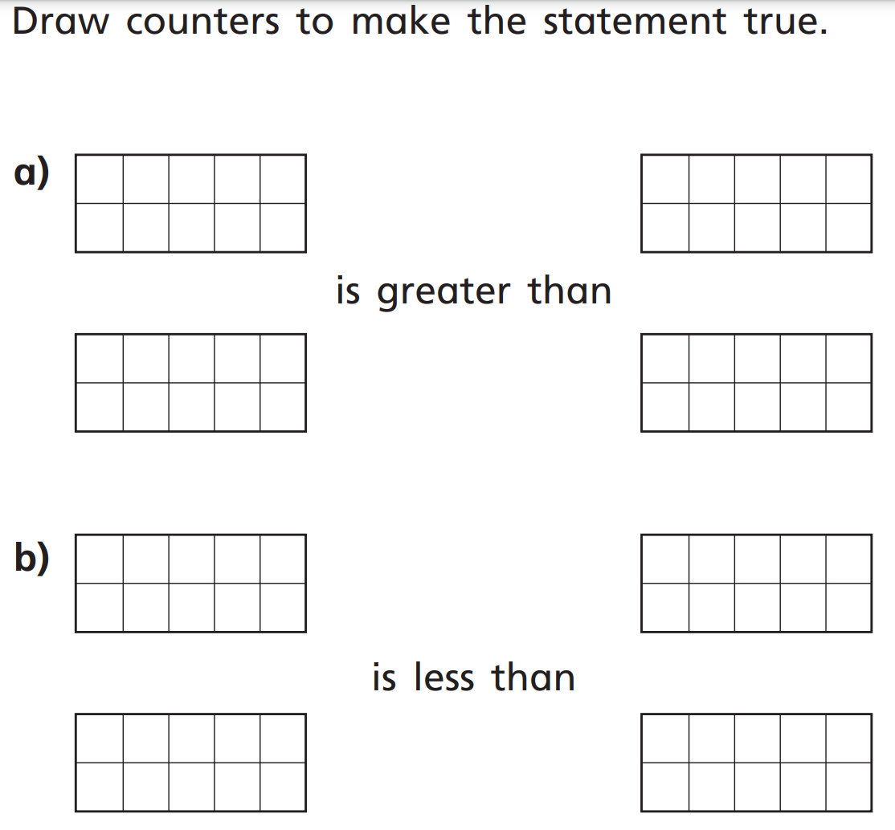

Year 2: Today, we are going to be adding by making ten.

Please watch the video: <https://vimeo.com/464197249>

* You do not need to do question 1 and 2 that it asks you to do.

**Activity:**

This can be done on the word document. Please move the counters to fill one ten frame and write in the number sentence. The first question is done for you.

1. 8 + 6 =

The counters will already be laid out as shown below:

|  |  |  |  |  |
| --- | --- | --- | --- | --- |
|  |  |  |  |  |
|  |  |  |  |  |

|  |  |  |  |  |
| --- | --- | --- | --- | --- |
|  |  |  |  |  |
|  |  |  |  |  |

Then, move the blue counters to make the full ten.

|  |  |  |  |  |
| --- | --- | --- | --- | --- |
|  |  |  |  |  |
|  |  |  |  |  |

|  |  |  |  |  |
| --- | --- | --- | --- | --- |
|  |  |  |  |  |
|  |  |  |  |  |

Now you have 1 ten and 3 ones.

**This means that 8 + 6 = 10 + 3**

Please try the questions below using the same method.

**2. 7 + 5 = 10 + ___**

|  |  |  |  |  |
| --- | --- | --- | --- | --- |
|  |  |  |  |  |
|  |  |  |  |  |

|  |  |  |  |  |
| --- | --- | --- | --- | --- |
|  |  |  |  |  |
|  |  |  |  |  |

**3. 9 + 6 = 10 + ____**

|  |  |  |  |  |
| --- | --- | --- | --- | --- |
|  |  |  |  |  |
|  |  |  |  |  |

|  |  |  |  |  |
| --- | --- | --- | --- | --- |
|  |  |  |  |  |
|  |  |  |  |  |

**4. 6 + 7 = ___ + ____**

|  |  |  |  |  |
| --- | --- | --- | --- | --- |
|  |  |  |  |  |
|  |  |  |  |  |

|  |  |  |  |  |
| --- | --- | --- | --- | --- |
|  |  |  |  |  |
|  |  |  |  |  |

**5. 7 + 9 = ___ + ____**

|  |  |  |  |  |
| --- | --- | --- | --- | --- |
|  |  |  |  |  |
|  |  |  |  |  |

|  |  |  |  |  |
| --- | --- | --- | --- | --- |
|  |  |  |  |  |
|  |  |  |  |  |

**6. 3 + 8 = ___ + ____**

|  |  |  |  |  |
| --- | --- | --- | --- | --- |
|  |  |  |  |  |
|  |  |  |  |  |

|  |  |  |  |  |
| --- | --- | --- | --- | --- |
|  |  |  |  |  |
|  |  |  |  |  |

**Challenge Questions:**

