Home Learning
Maths
Year 1: Today we are going to be doing some new learning. We are learning about counting on to 20.
Please watch this video: https://vimeo.com/490879063
- To complete the activity, please use the instructions and links below.

First, use this number generator to get a number between 1 and 20.
https://www.google.com/search?q=number+generator&oq=number+generator&aqs=chrome.0.69i59i131i433i457j0i433j69i59j0i433j0l2j69i60l2.9459j0j7&sourceid=chrome&ie=UTF-8

Then, use this link to get a dice.
https://www.calculator.net/dice-roller.html

Activity: Please complete 6 questions using the method explained below.
Use the number sentence below to count on to get your answer.
Use the number generator to get your first number.

17 + 3 = 20
Use the dice to get your second number.

Number Line:

Year 2: Today we are going to be doing some new learning. We are learning about making equal groups.
Please watch the video: https://vimeo.com/480211577
- Please go through the video and complete the activities as they ask you.

Activity 1:
Please complete this activity on the word document.
- Can you make 2 equal groups? (Please share the pirates by dragging them into each group equally)

Group 2:
Group 1:

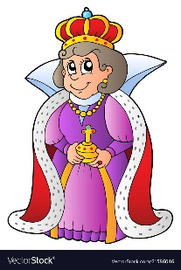
2. Can you make 2 unequal groups? (Please share the pirates by dragging them into each group equally)
Group 1:
Group 2:

Activity 2:
Please go and find 12 objects from around your house.
Can you make 2 equal groups?
Can you make 2 unequal groups?

Please take a picture of your groups and attach this to teams.

Challenge:
Please can you find 16 objects from around your house.
Can you make 2 equal parts?
Can you make 4 equal parts?
Can you make 2 unequal parts?
Can you make 4 unequal parts?

Please take a picture of your groups and attach this to teams.

