Home Learning
Maths
Year 1
Following on from yesterday’s lesson, we are going to carry on looking at adding by counting on. Please complete the activities below.
You can either: edit the document (by clicking on the answer boxes), print the document or write the answers on plain paper
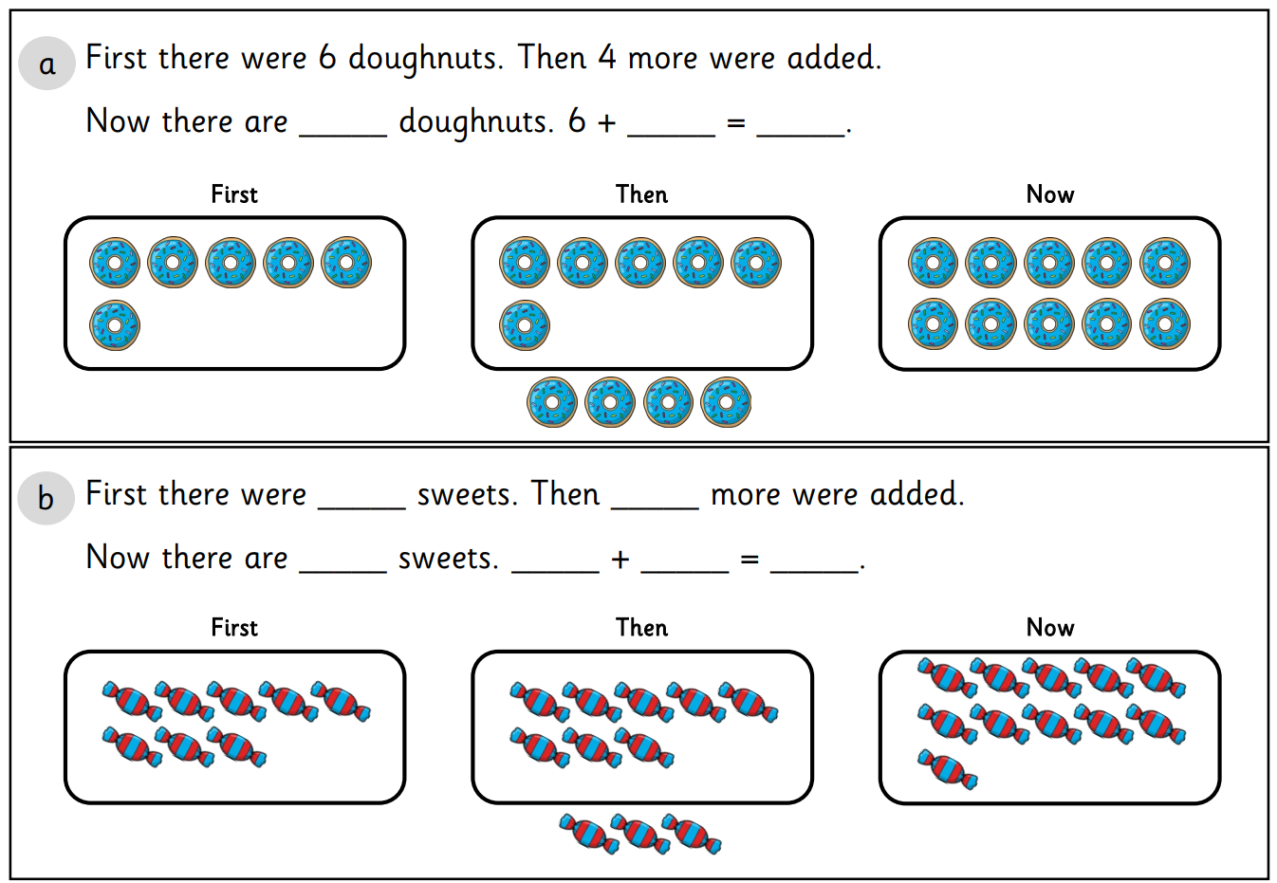
1. These questions show you how to visually add by counting on in 3 steps. Please follow the steps to answer the questions.

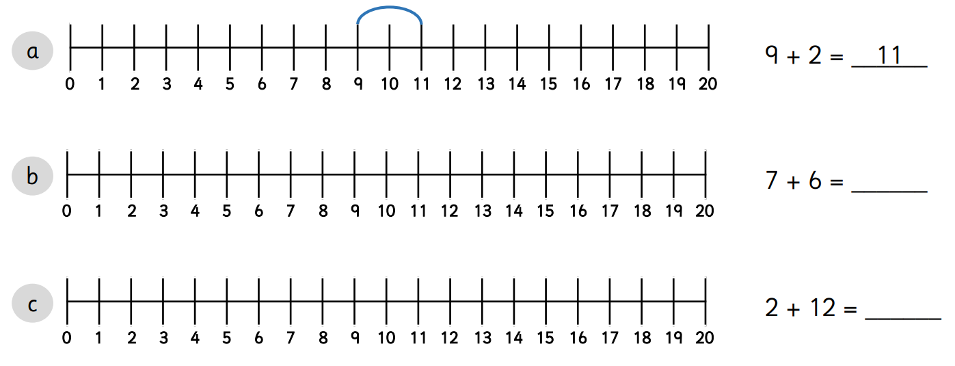
Question 2:

Year 2:
Following on from yesterdays lesson, we are going to be looking at making equal and unequal groups. Please complete the activities below.
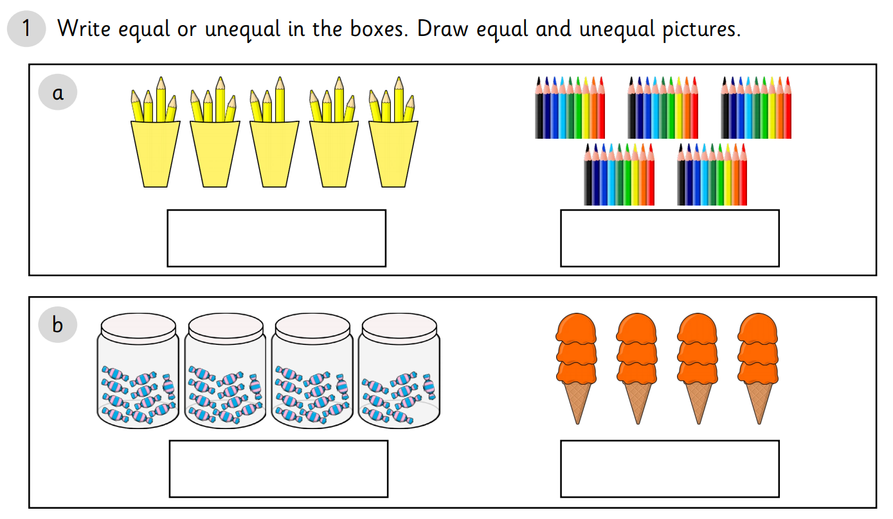
You can either: edit the document (by clicking on the answer boxes), print the document or write the answers on plain paper.

Question 2:
In the question below, have a look at the number of groups and then count how many objects there are in each group.
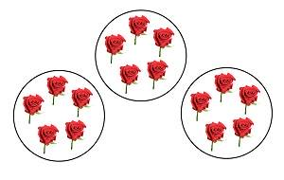
E.g.
There are 3 groups of 5 flowers.

