Home Learning
Maths
Year 1: Today we are going to be learning about adding ones using number bonds.
Please watch the video: https://vimeo.com/490879867

Activity:
Please answer the questions below either on this document, printed or on plain paper.
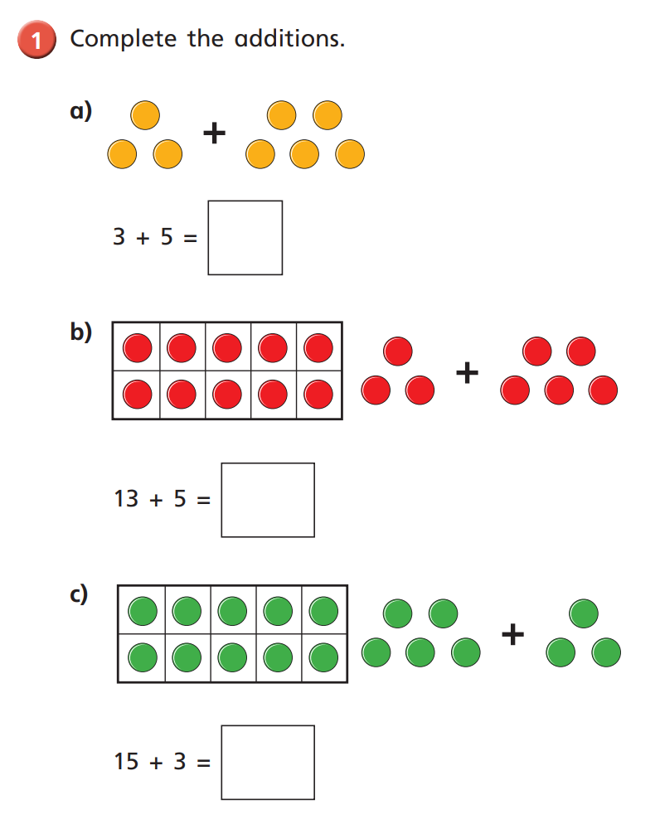

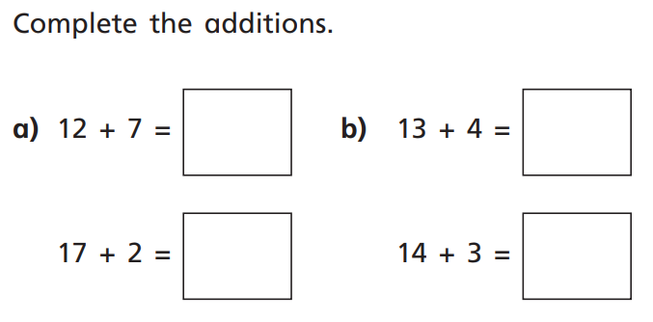

Challenge: Please choose your own calculation to place into the addition. The second number in the number sentence needs to be a number between 10 and 20.
In this second number, you need to split it into tens and ones and then use the number line to help you work it out.

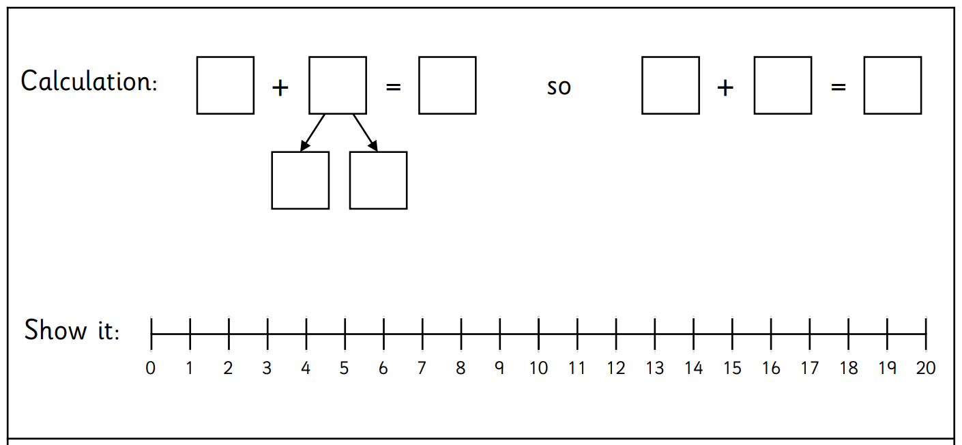

Year 2:
Today we are going to be learning about redistributing from uequal groups to equal groups.
Please watch this video: https://vimeo.com/480212262

Activity 1:
Have a look at these 12 objects. Can you please drag them to create different equal groups?
1. Can you make 6 groups of 2? (Please drag the hats into the circles)

2. Can you make 4 equal groups of 3?

Can you make 4 equal groups of 3?

Can you make 4 equal groups of 3?

3. There are 3 groups. How many pirate’s hats are in each?

Challenge:
Are there any other amounts which start as unequal groups but make equal groups?

