Home Learning
Maths
Year 1:
Today we are going to be doing some more learning about adding using number bonds.
Please watch this video: https://vimeo.com/490880277
- Please complete the activities this video asks you to do.

Activity: These can be answered on this document, printed or on paper.
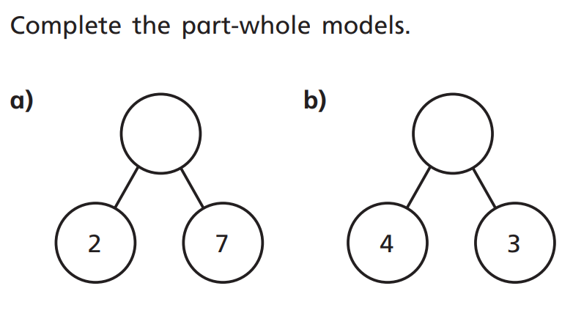
1.

2.

3. To complete the questions below, please use the number line to help you.
First look at the number sentence. Take the number that you have been given and find it on the number line and then count on until you get to the answer.
E.g. For question 1, I would find the number 5 on my number line and then count on until I get to 9 so the missing number would be 4.

Year 2:
Today we are going to be adding equal groups.
Please watch the video below: https://vimeo.com/480212584
- Please complete the activities this video asks you to do.

Activity:
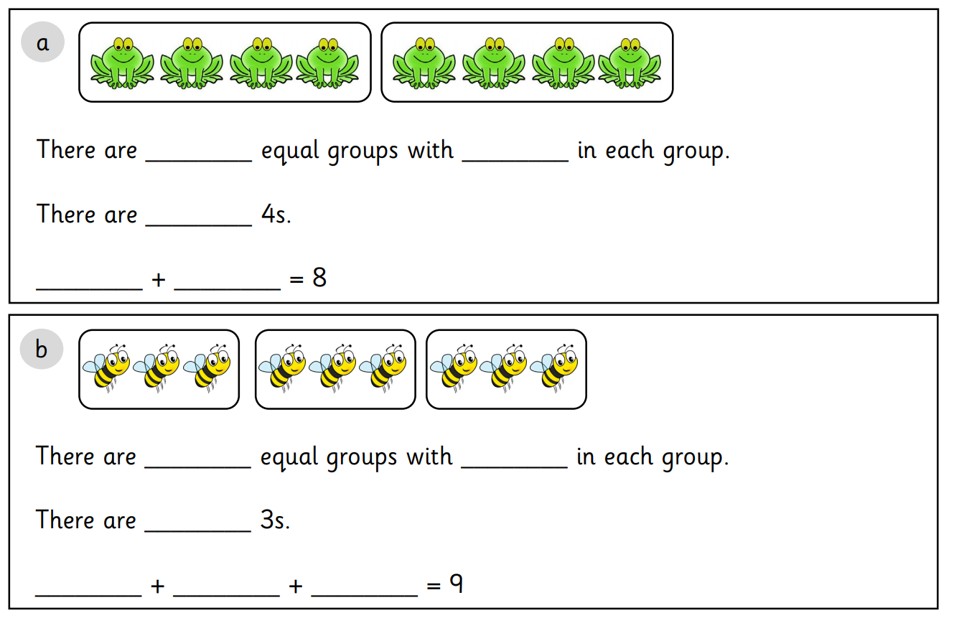
1.

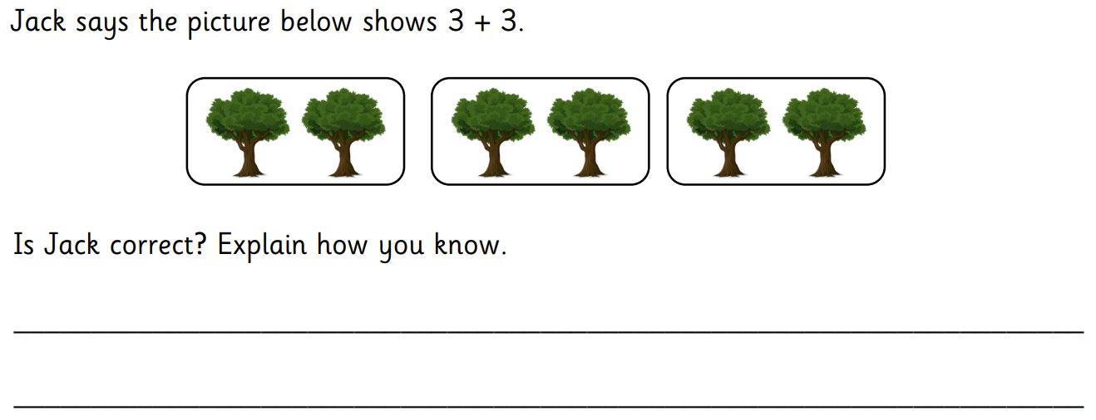
2.

Question 3 Example:
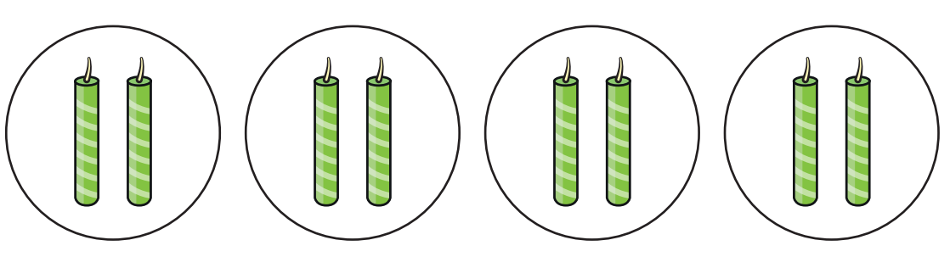
In the next question, you will be given number sentences (just as you worked out above). The example below will help you:

There are 4 groups of 2 here:
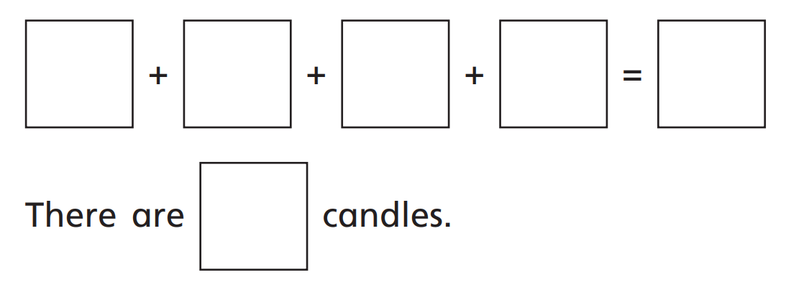
This means we need to add 2, 4 times (as shown below).
8
8
2
2
2
2

2. Please match the number sentences to the pictures.
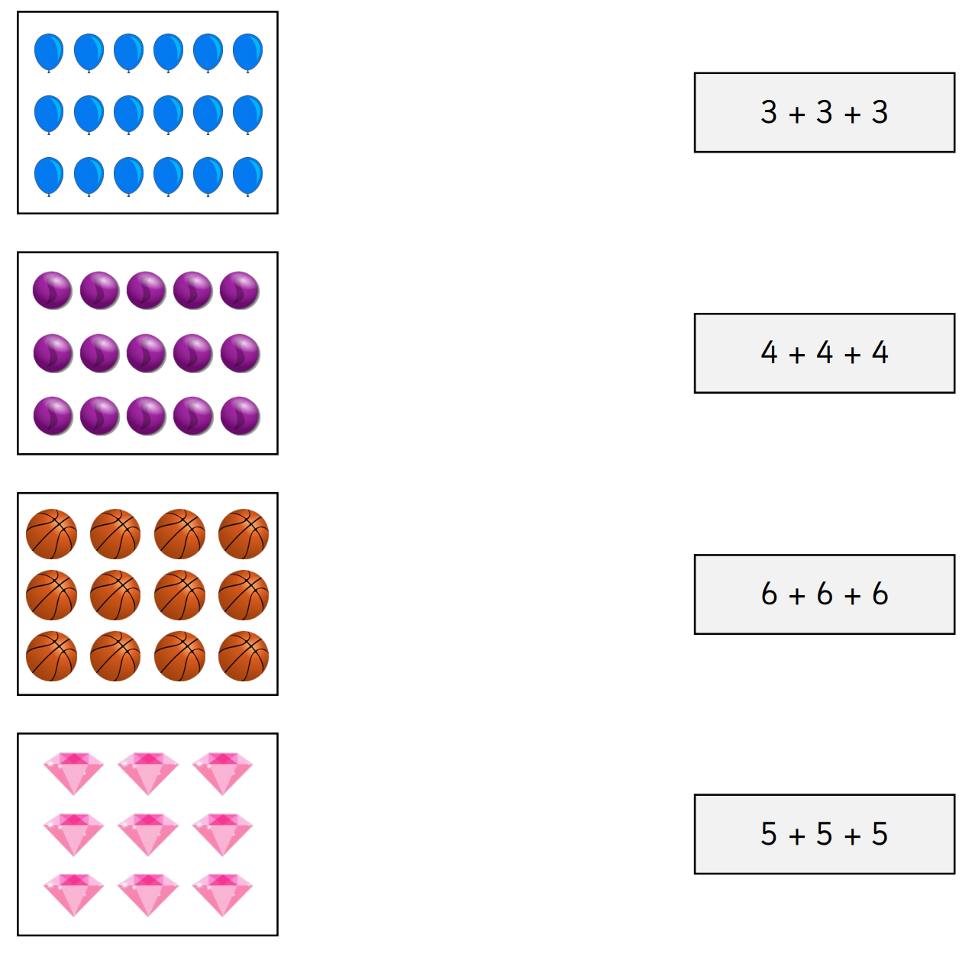
For example, for 4 + 4 + 4, you need to find 3 groups/rows with 4 objects in each row.
Which could it be?

