Home Learning
Maths
Year 1:
Today we are going to be learning about ‘Finding and making number bonds.’
Please watch this video: https://vimeo.com/490882337
- Please answer the questions throughout the video.

Activity:
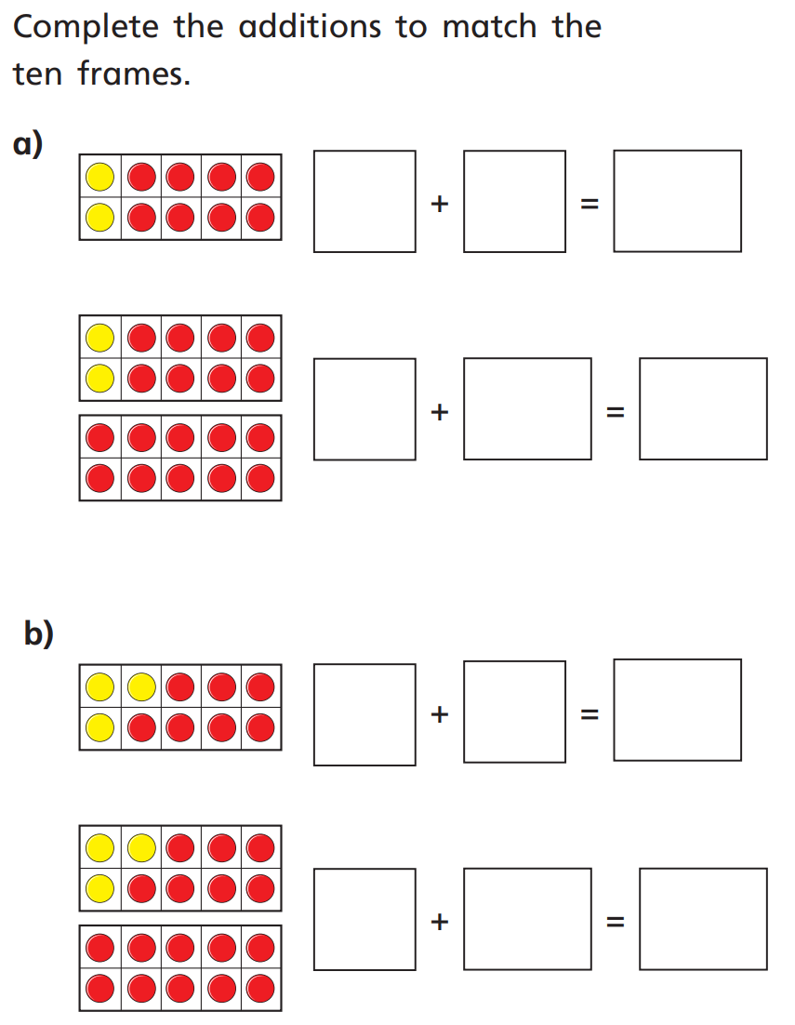
1.

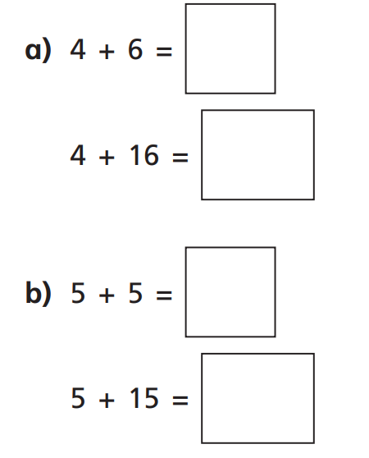
What do you notice?
2.

Hint: Look at the tens and ones.

Challenge:
Use this video to help you complete this challenge: https://www.youtube.com/watch?v=h6udqW6VhWg
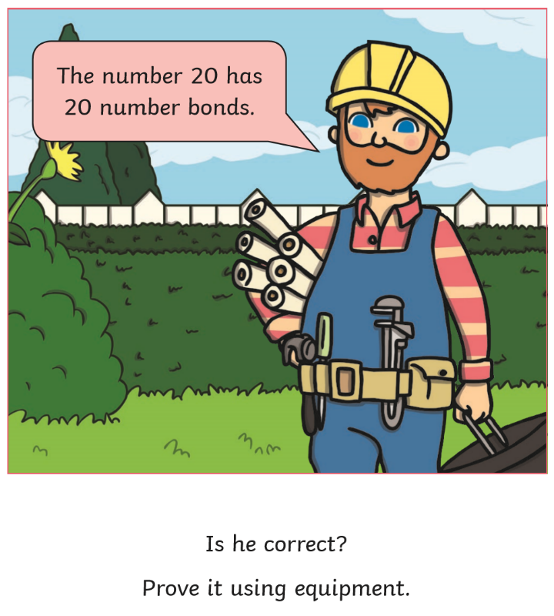

Year 2:
Today we are going to be learning about how to make ‘Arrays.’
Please watch this video: https://vimeo.com/480212725

Activity:
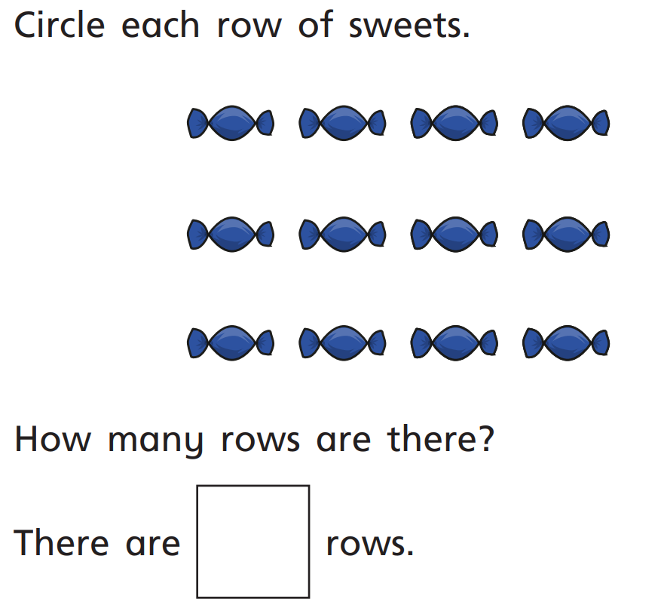
1.

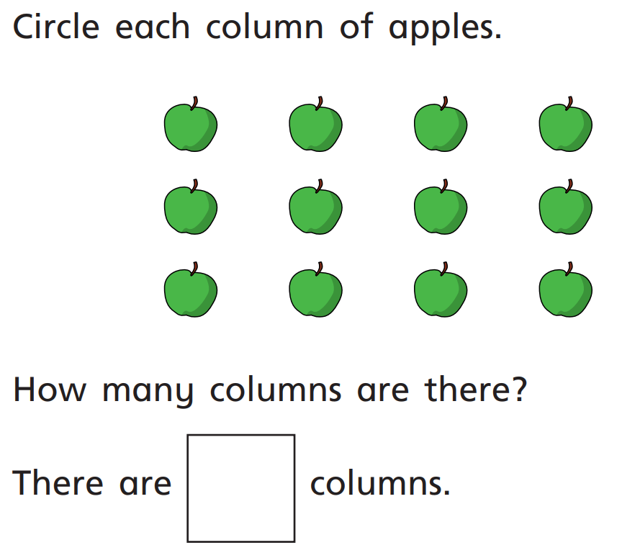
2.

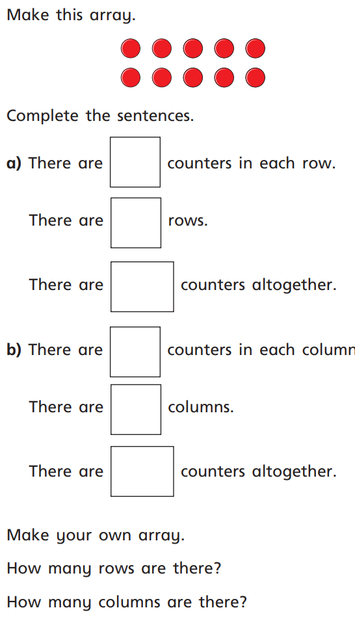
3.

Challenge:
Please take a photo of your array that you make and attach it to teams:

