Home Learning
Maths
Year 1:
Hello Squirrels. Today you are going to be learning about ‘Adding by making 10.’
Please start by watching this video: https://vimeo.com/492195041

Activity 1:
Please write down your number bonds to 10 by using the rainbow below to help you.
Hint: Each arch of the rainbow has a number bond.
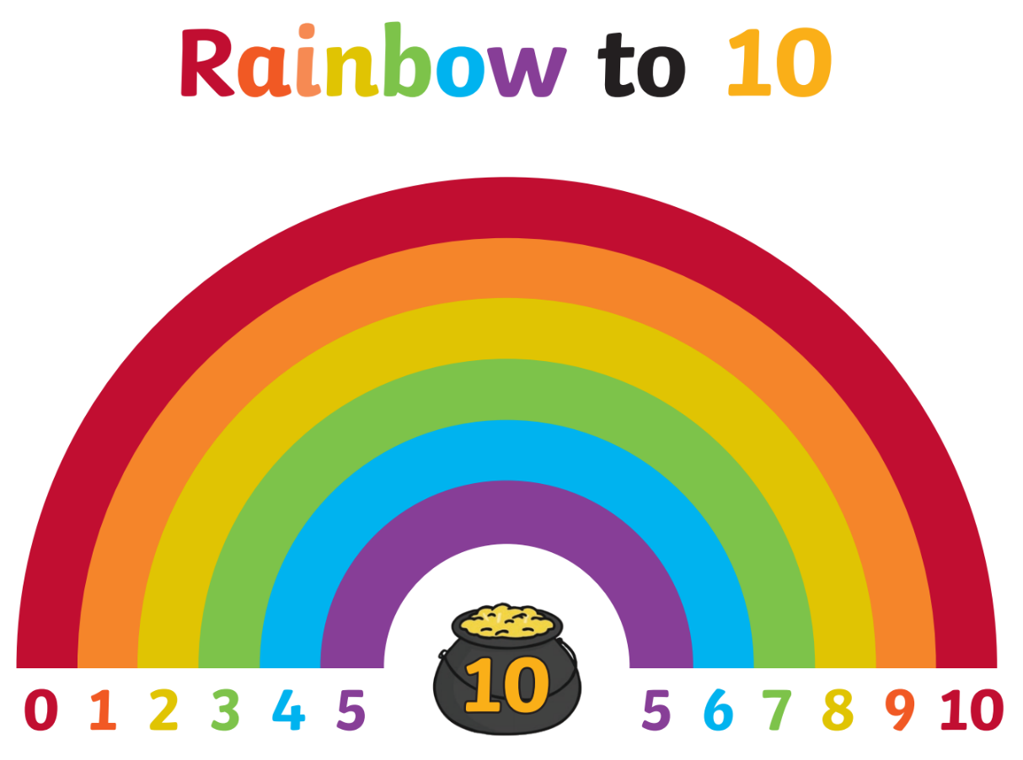

Activity 2:
Please add on by making 10 using the tens frames below to help you. The first one is done for you.
You can complete this on the document, on paper or printed.
1.

+

+ =

2.
+

+ =

3.
+

+ =
Remember to make 10.

4.
+

+ =

Year 2:
Hello Squirrels. Today you are going to be learning about ‘Recognising equal groups.’
Please start by watching this video: https://vimeo.com/488106597

Activity:
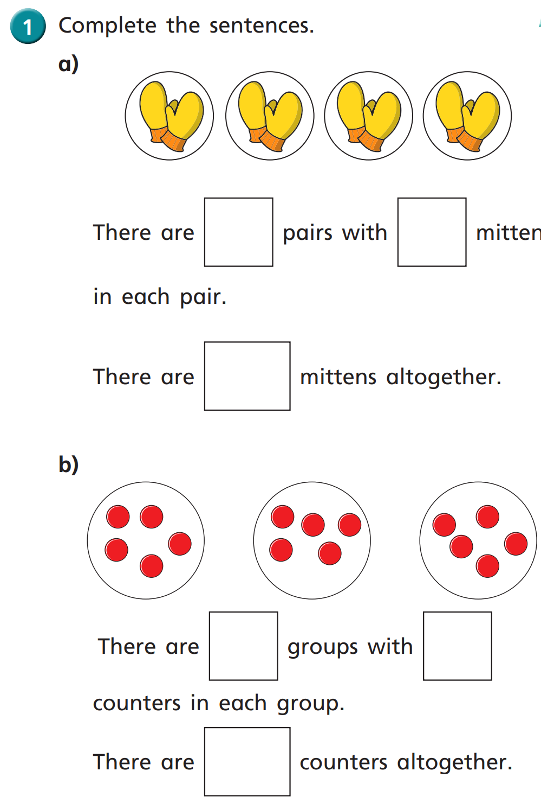
1.

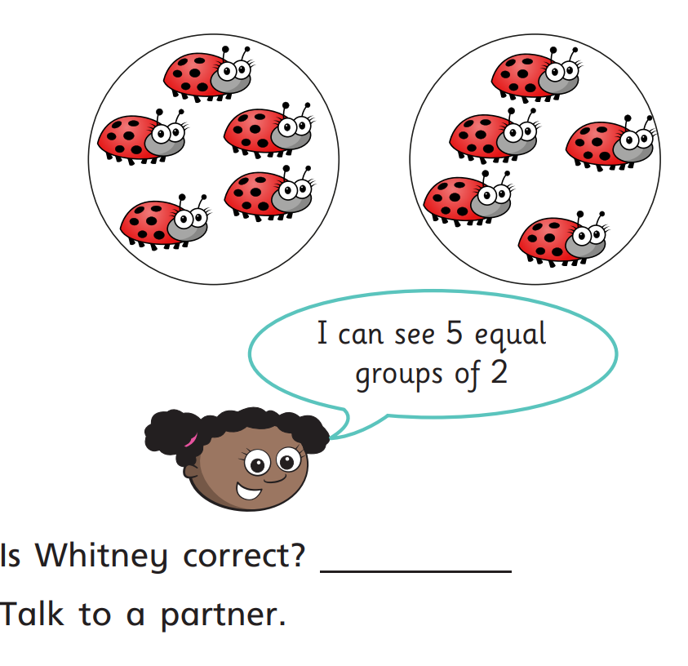
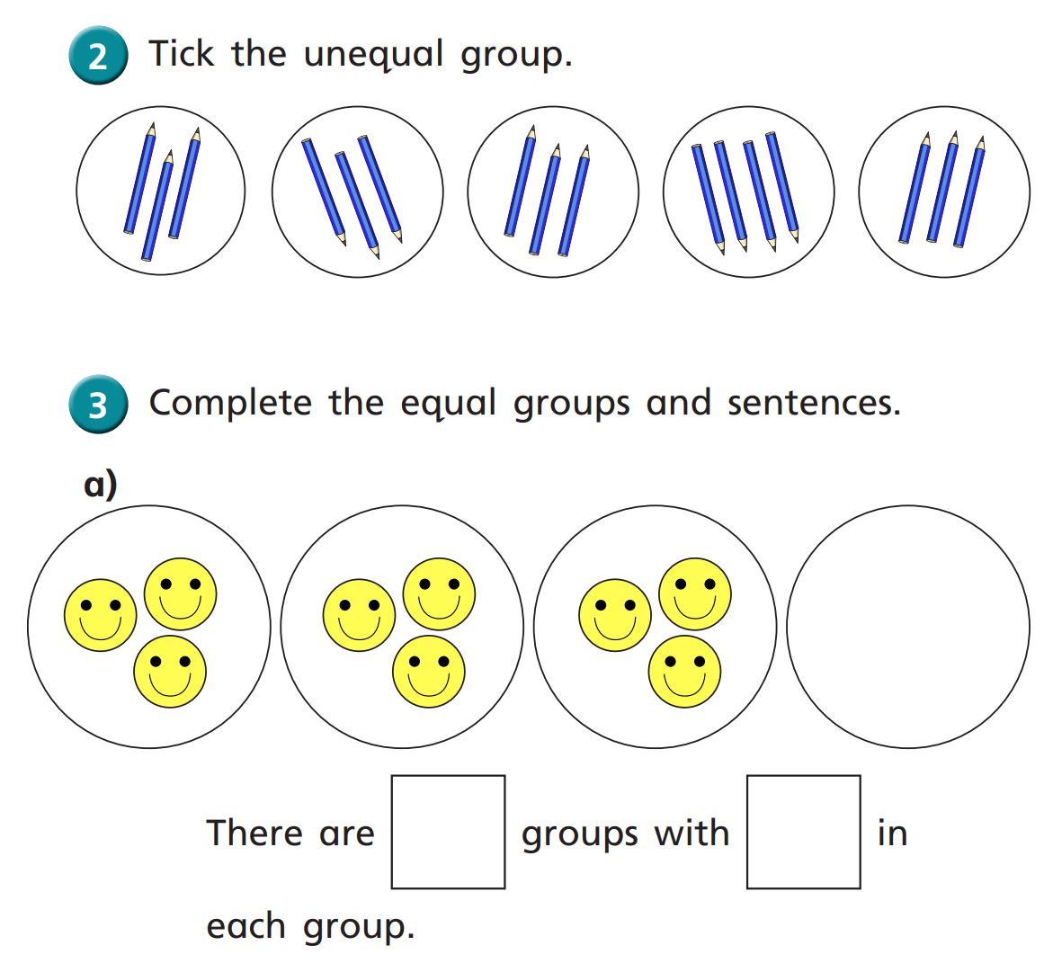

Challenge:

