Home Learning
Maths
Year 1:
Today we are going to be learning more about ‘Adding by making 10.’
Please watch the video: https://vimeo.com/492195871

Activity:
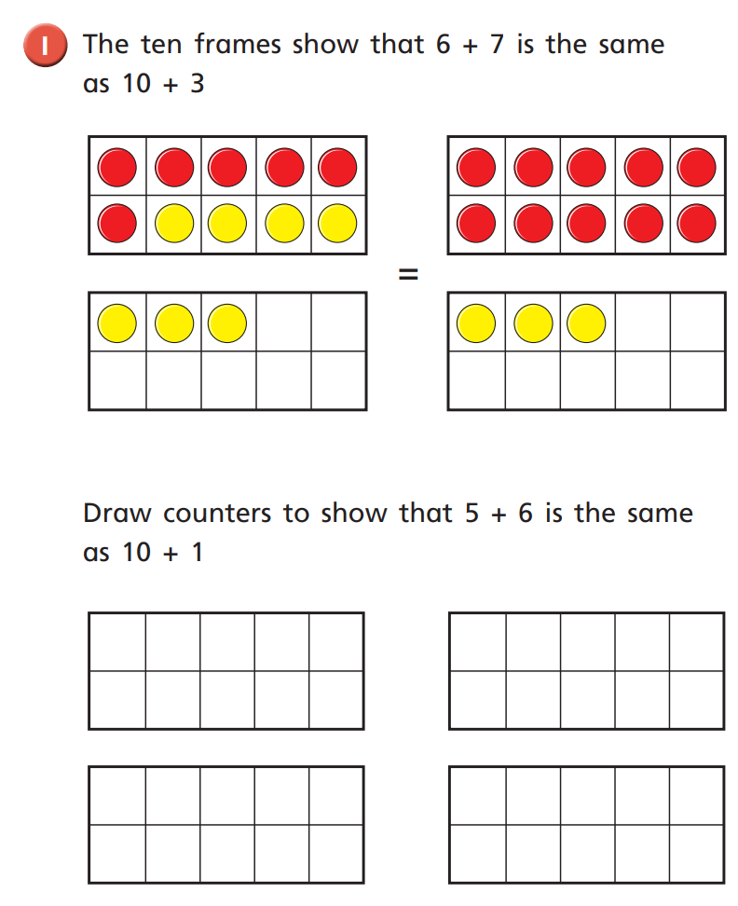

Use these counters to show that 5+6 is the same as 10 + 1.

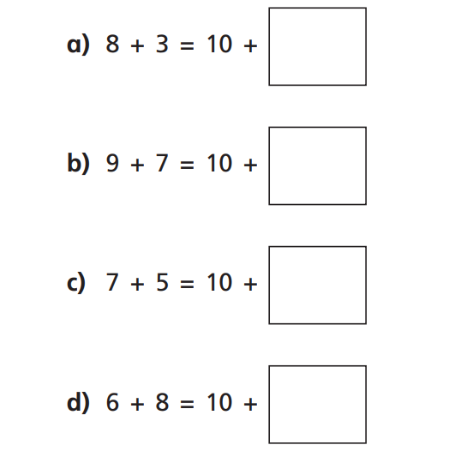
Using the tens frames below. Please have a go at finding the equal number sentence by making ten.

Year 2:
Today we are going to be learning how to make equal groups.
Please watch this video: https://vimeo.com/488108584

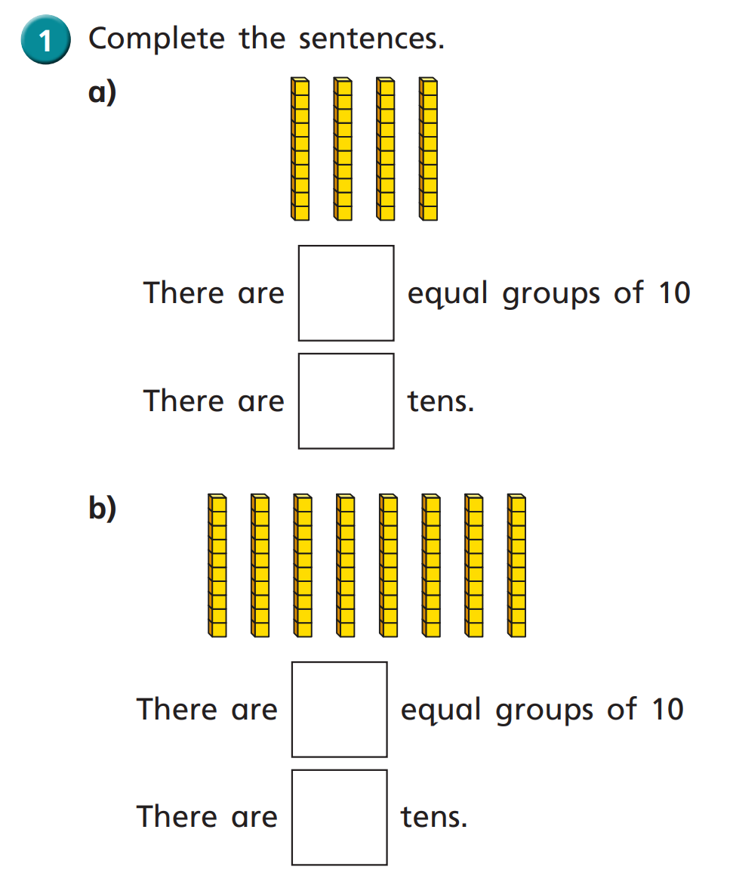
Activity:

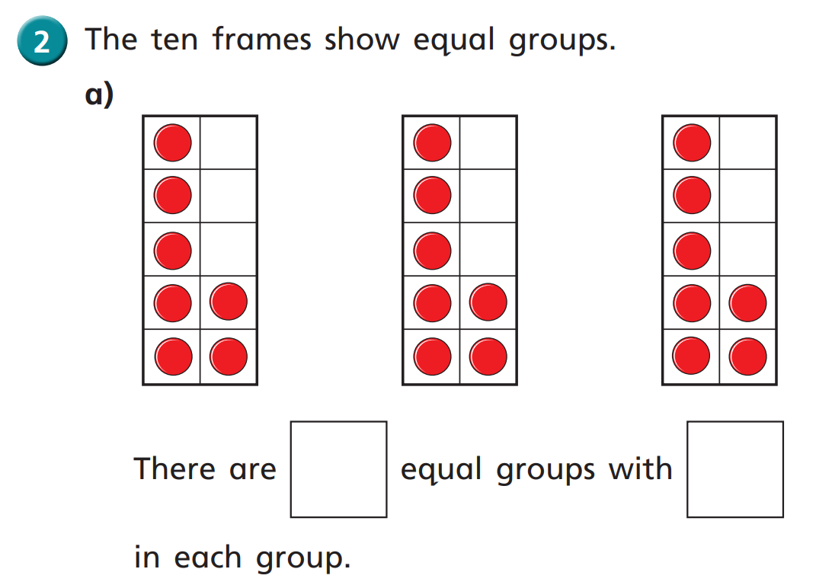

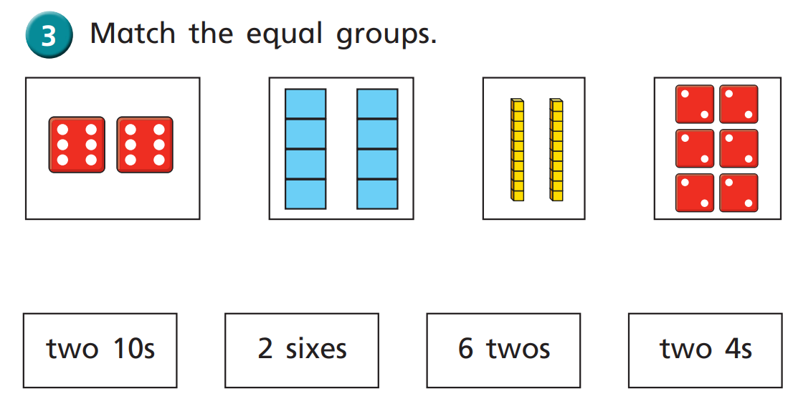

Challenge:
Can you make these groups using circles and spots?
