Home Learning
Maths
Year 1:
Today we are going to be learning about subtracting, not crossing ten.
Please watch this video: https://vimeo.com/492197096
- Have a go at the activities that they ask you to do.
Activity:
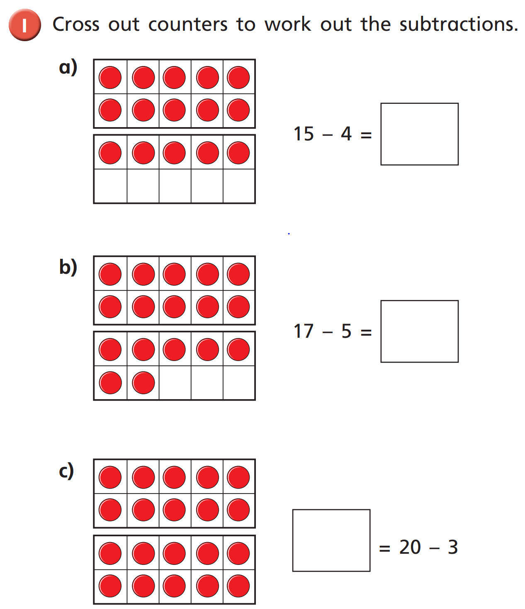

Please use the number line to work out these subtraction number sentences:

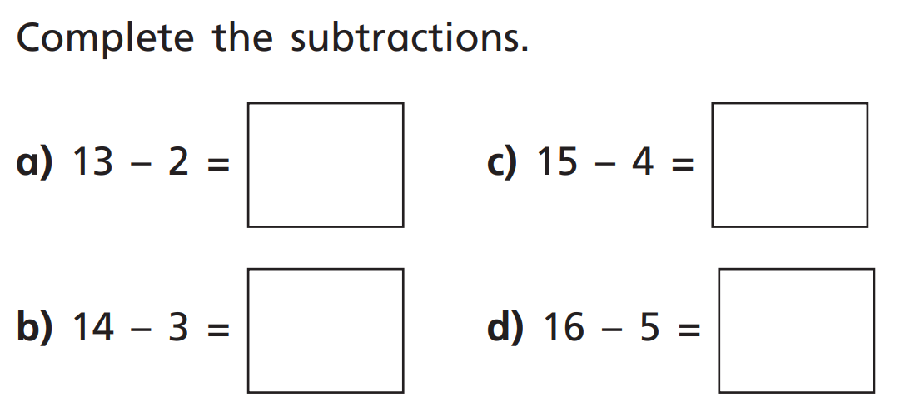

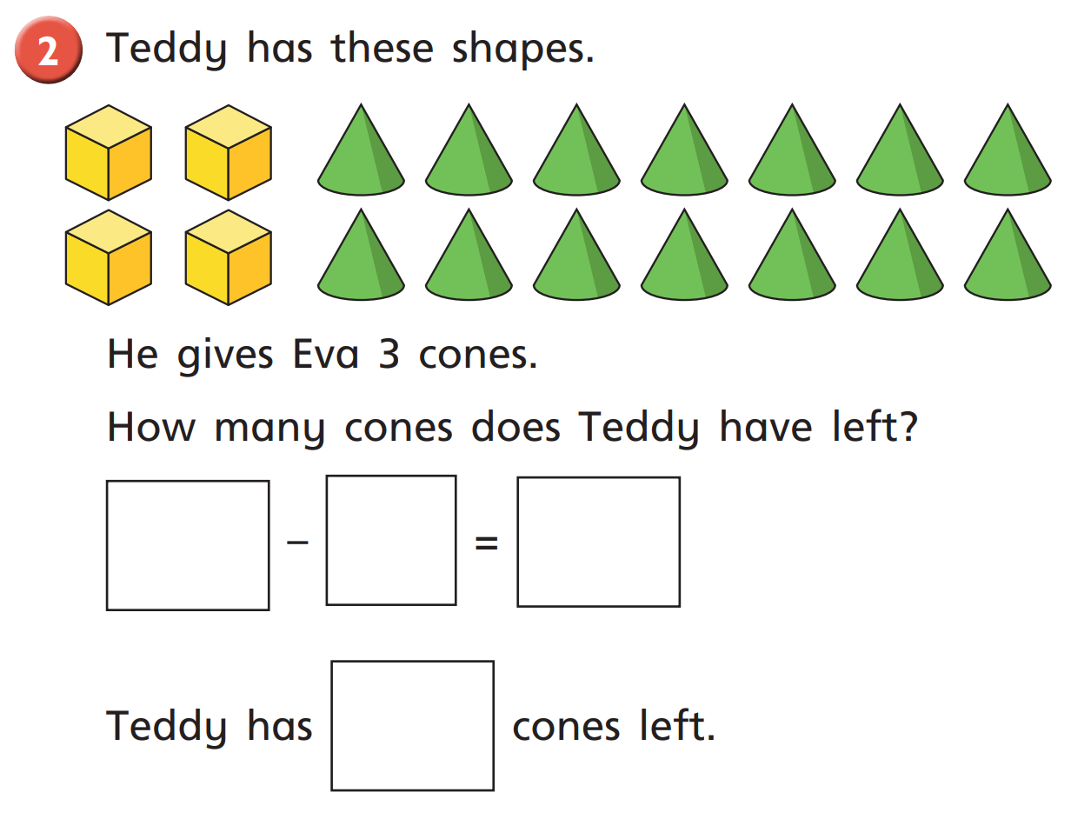
Challenge:

Year 2:
Today we are going to learn about adding equal groups.
Please watch this video: https://vimeo.com/488110327
- Have a go at the activities that they ask you to do.
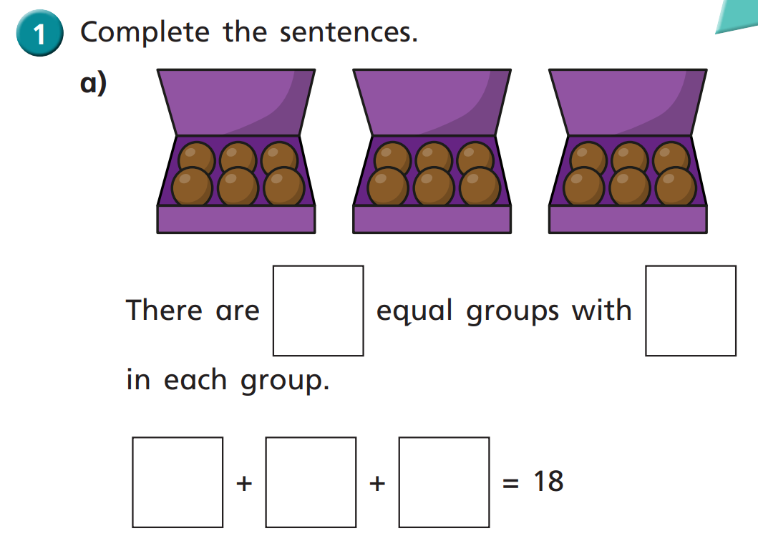
Activity:

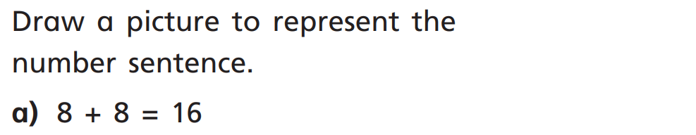
2.

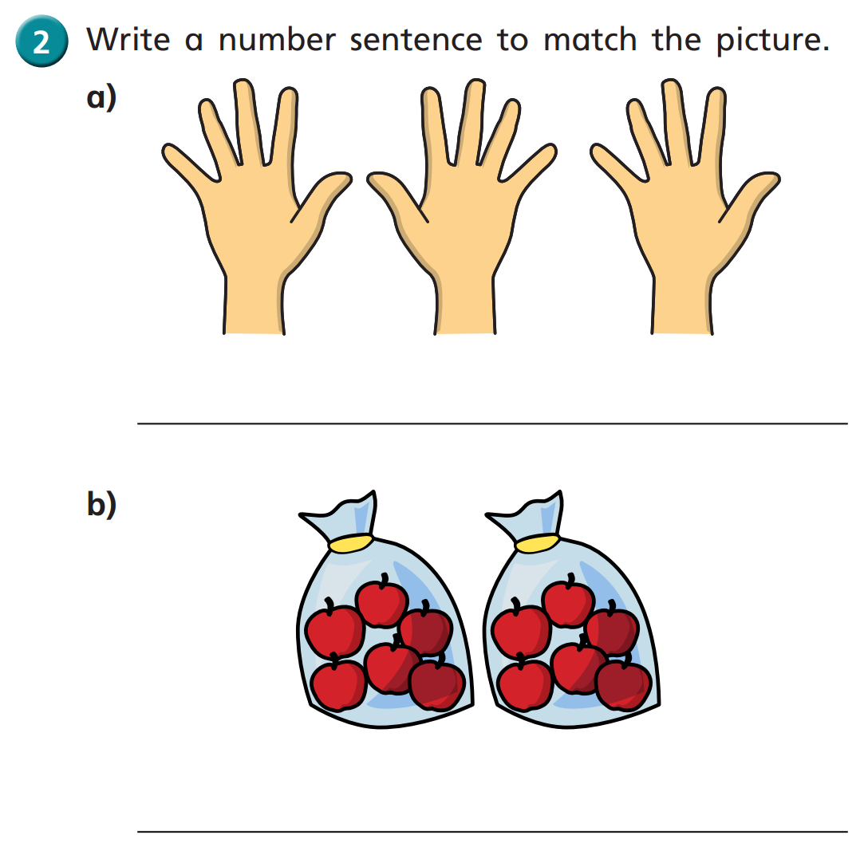

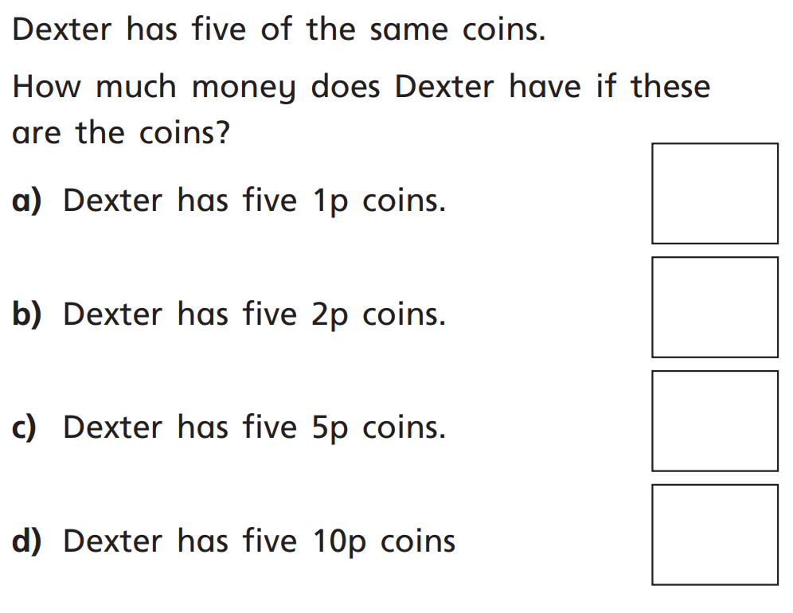
Challenge:

