Home Learning
Maths
Year 1:
Today we are going to be learning about subtracting (not crossing ten) by counting back.
Please follow this link to watch the video: https://vimeo.com/492198226
Activity:
First of all, I would like you to make your own number line to 20.
- You can use card and number each one to 20.
- You can use objects and number them.

Then I would like you to find a toy or teddy to be your partner.

There are some subtraction number sentences below. I would like you to use your teddy or toy to jump down your number line to find the answers to these questions.
1. 17 – 6
2. 20 – 10
3. 15 – 7
4. 12 – 3
5. 17 – 7
6. 19 – 6
Please email or put a picture on teams of you completing these activities.
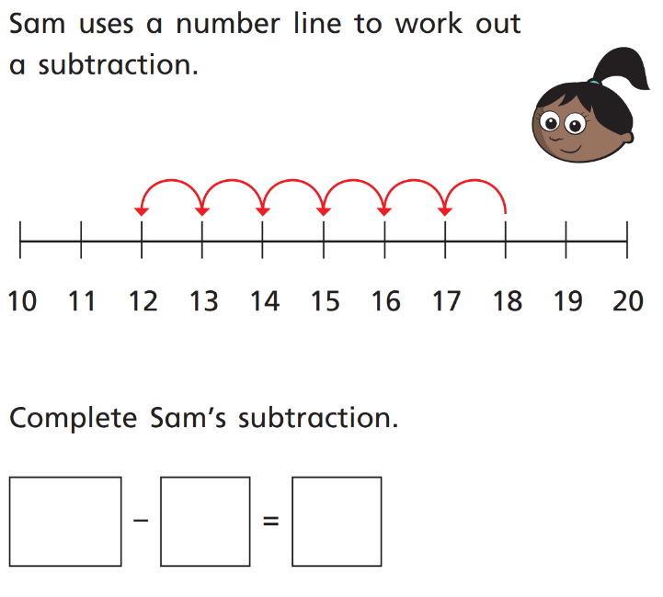
Challenge:

Year 2:
Today we are going to be learning about the multiplication symbol.
Challenge:
Click on this link https://www.topmarks.co.uk/maths-games/daily10, it will take you to a page that will help practise your times tables. You may need an adult to help you set it up. Click play game and then change the drop down arrows at the top of the page to these settings: Level 2 > Multiplication > Mixed tables 2, 5, 10.
You can also change the speed of the questions too, if you wish to have a time limit you can, but to start off with I would choose manual. You can either say the answers or you can write them down and have an adult check them.

Activity:
Please watch this video and then complete the activities below - https://vimeo.com/488111269

- Complete the sentences to describe the equal groups.

_______ + _______ + _______ = 15

_______ X _______ = 15

There are _______ equal groups that have _______ in each group.

There are three _______s.

- Complete the sentences to describe the equal groups.

_______ + _______ + _______ + _______ = 8

_______ X _______ = 8

There are _______ equal groups that have _______ in each group.

There are four _______s.

- Complete the sentences to describe the equal groups.

_______ + _______ + _______ = 30

_______ X _______ = 30

There are _______ equal groups that have _______ in each group.

There are three _______s.

Complete the table below.
Addition | Multiplication
5 + 5 + 5 + 5

 | 3 X 2
10 + 10 + 10 + 10 + 10

 | 6 X 5

Challenge:
Tam says,
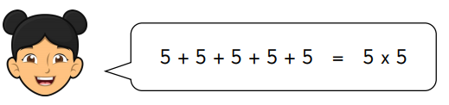

Is Tam correct? Explain how you know.
______________________________________________________________________________________________________________________________________________________________________________________________________________________________________________________

