Home Learning
Maths
Year 1:
Today we are going to be subtracting (crossing ten) by counting back.
Please watch this video: https://vimeo.com/497563367

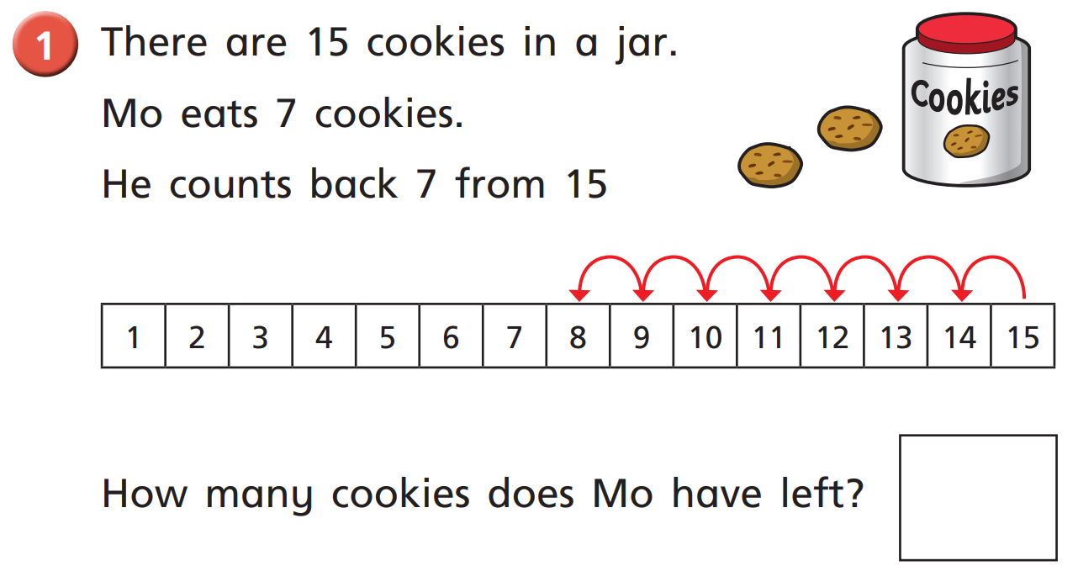
Activity:

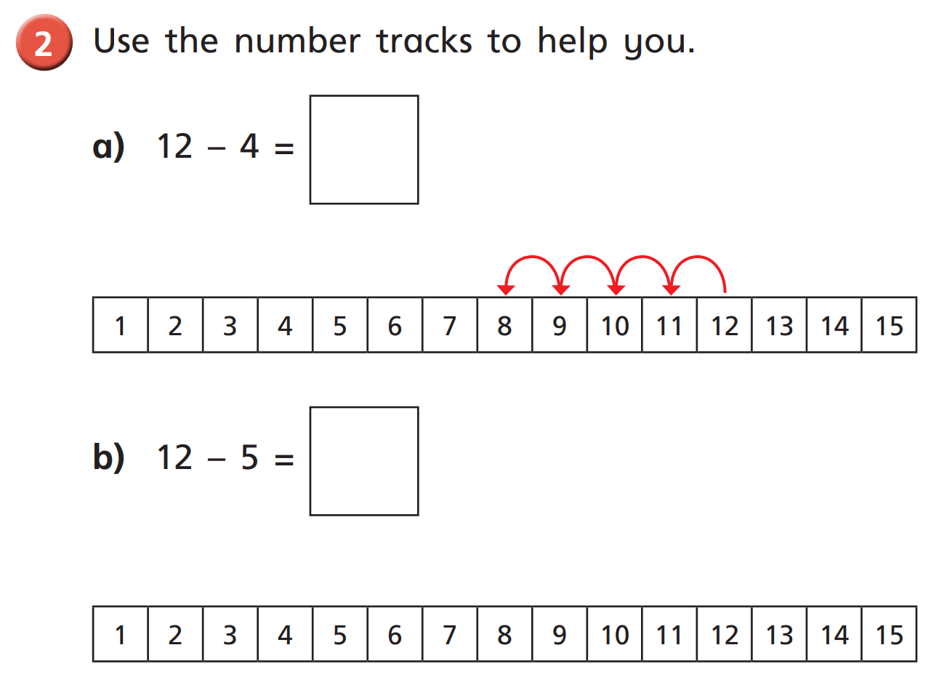

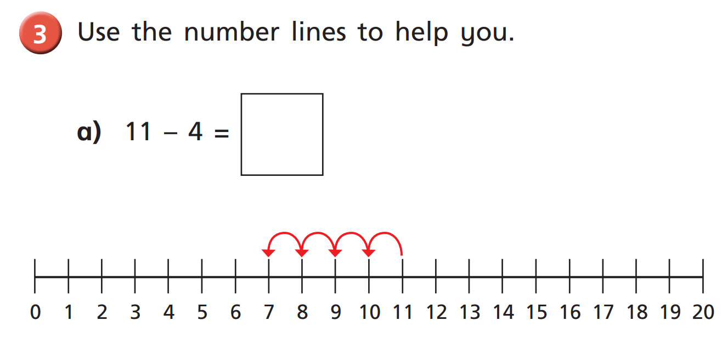

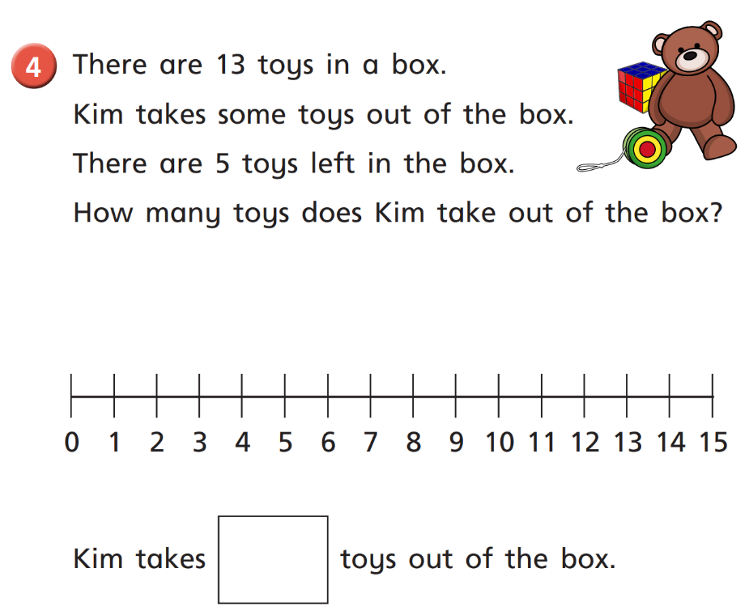
Challenge:

Year 2:
Today we are going to multiplying using pictures.
First, please complete this question as a warm up:

There are groups of flowers.

+
=

+

What is the Multiplication number sentence?

=

x

Activity:
Please watch this video to help you in the next activity: https://vimeo.com/488113679

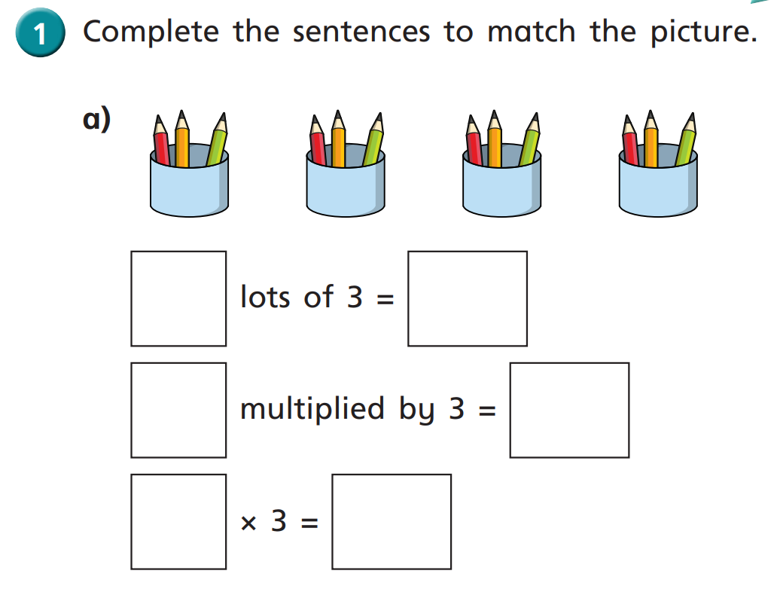

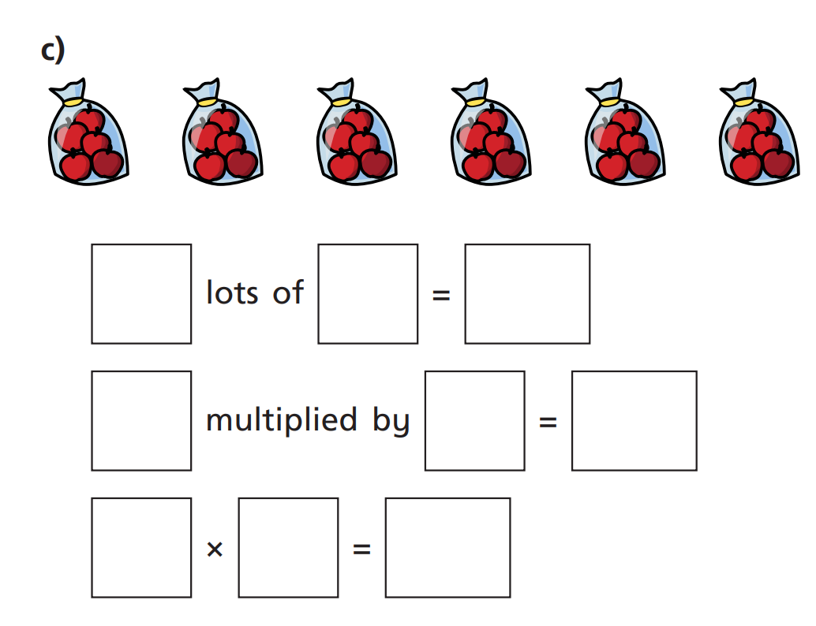
b)

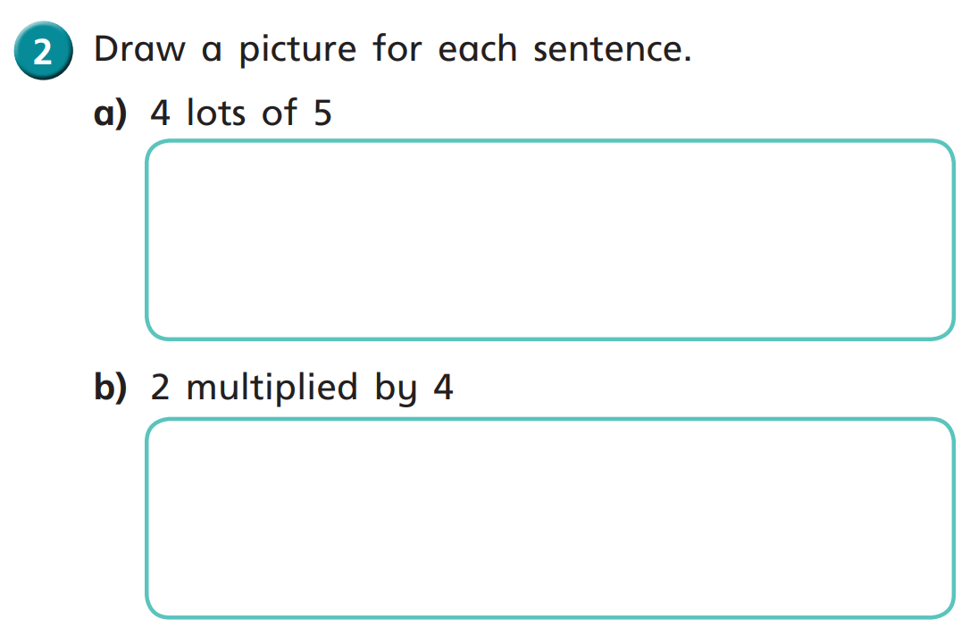
Challenge:

