Home Learning
Maths
Year 1:
Today we are going to be learning about subtracting crossing ten.
Please watch this video: https://vimeo.com/497919464
Activity:

Please have a go at these subtraction questions using the number line to help you:

3. 12 – 6 =

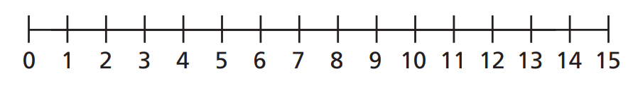
4. 15 – 8 =

5. 14 – 9 =
Challenge:
I think that 16 – 7 = 9
Have a look at the speech bubbles below.
Who is correct and why?
I think that 16 – 7 = 10

Year 2:
Today we are going to be learning how to use arrays.
Please watch this video: https://vimeo.com/490417143
Remember:

Activity: - Please use objects at home to help you answer these questions.
1.
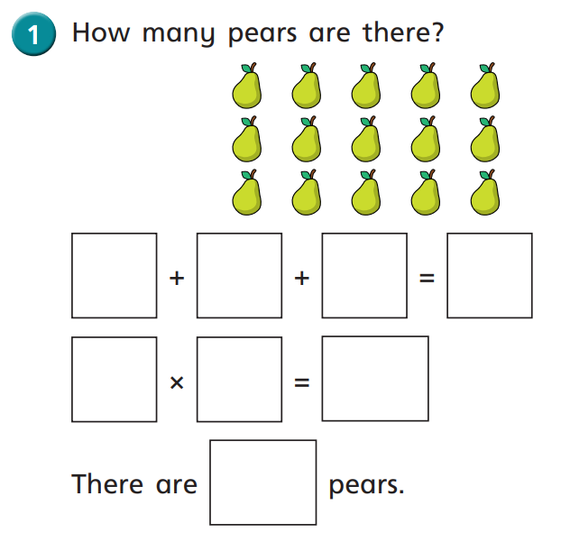

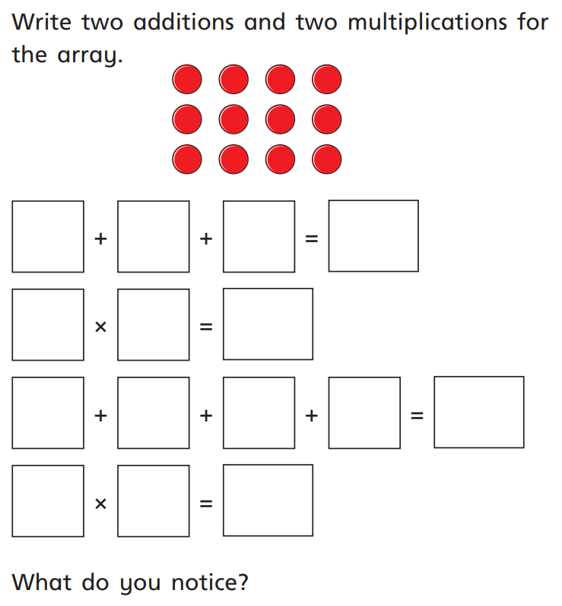
2.

a)

b)

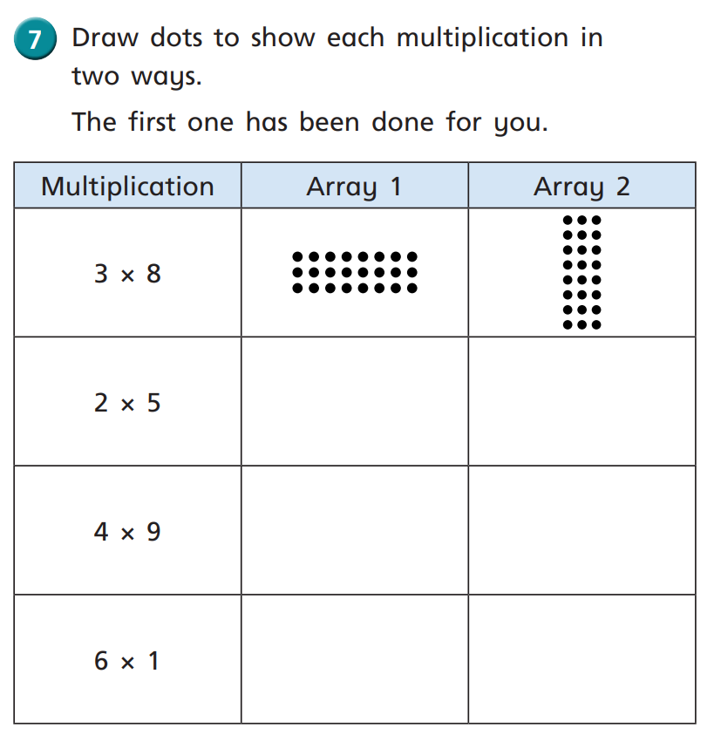
3.

Challenge:
