Home Learning
Maths
Year 1:
Today we are going to be learning some more about subtracting by crossing ten.
Please watch this video: https://vimeo.com/497919984

Activity 1:
We have been learning how to subtract by jumping to the previous ten. Have a go at doing this using these number lines.

1. 15 – 7 =

2. 16 – 8 =

3. 14 – 5 =

Activity 2:

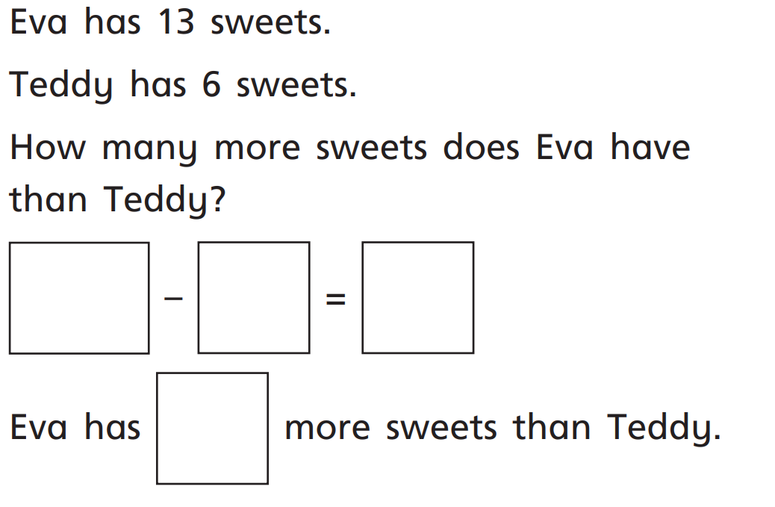
1.

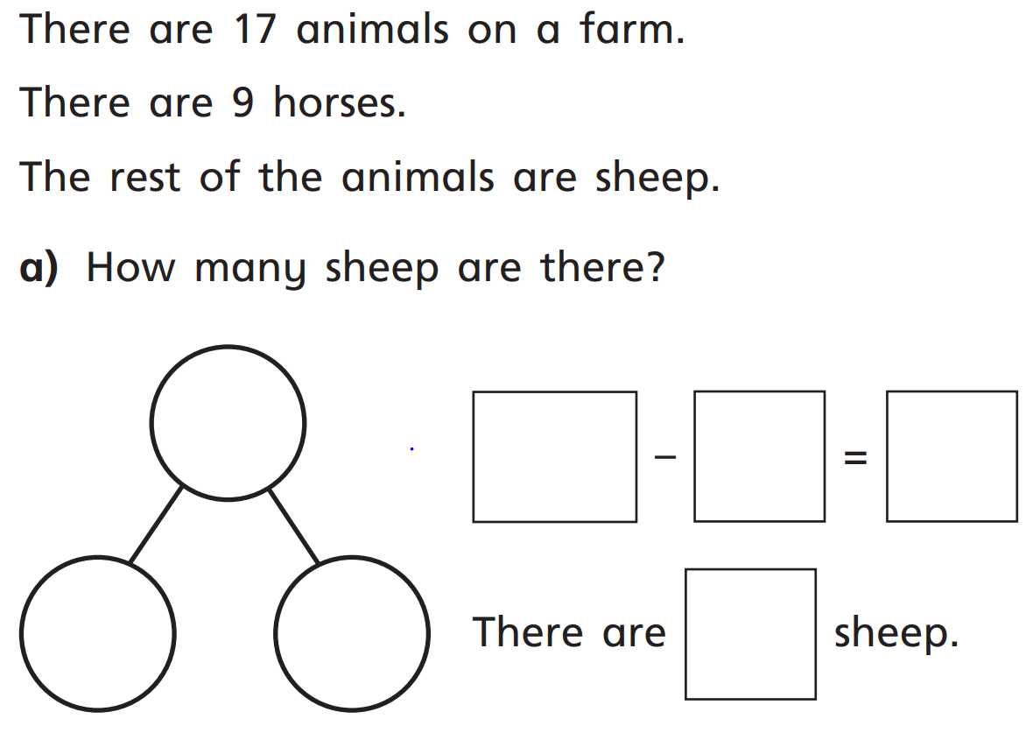
2.

Challenge:

How many subtractions can you make using these cards?
Year 2
Today we are going to learn about doubling.
Please watch this video https://vimeo.com/490420115

Remember, when we double, we are adding the same amount again.
So, 3 acorns doubled.
Is 3 acorns add 3 acorns.
+
Which makes 6 acorns.

So, double 3 is 6.

Activity:
1. Complete the sentences:

Double 2 is __________

Double 5 is __________

Double 7 is __________
2. Double the following amounts, fill in the spaces.

Double __________ is __________

Double __________ is __________

Double __________ is __________

Challenge:
The man could usually chop 11 trees down every day. On Wednesday, he chopped down double his usual amount. How many trees did he chop down on Wednesday?
Please show your working.

