Home Learning
Maths
Year 1:
Today we are going to learn about comparing number sentences.
Please watch this video: https://vimeo.com/497920660
Activity:
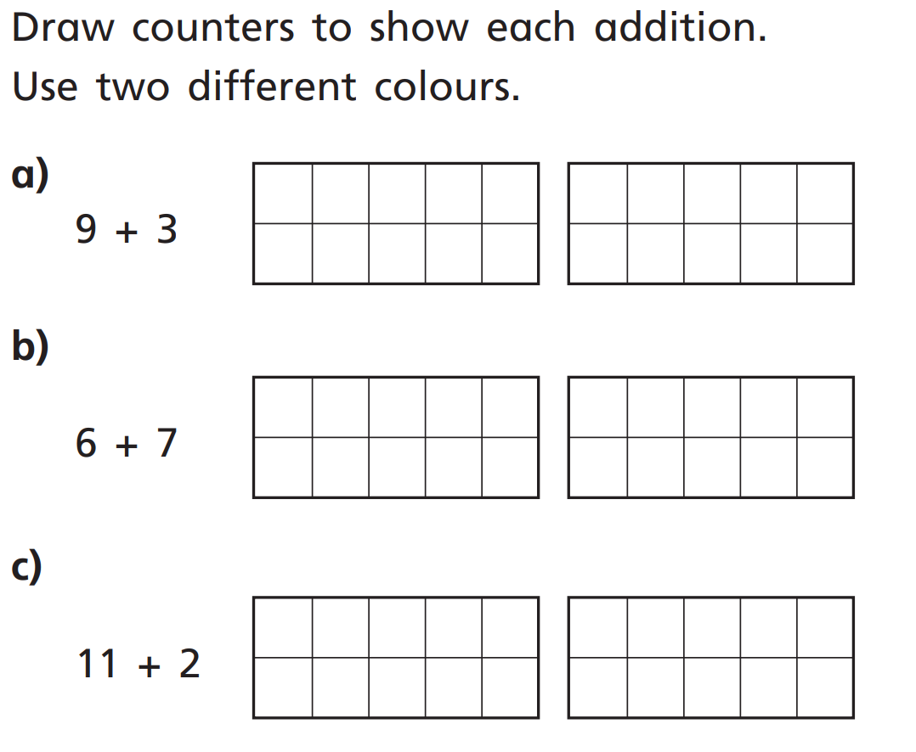
1.
Choose a colour for each number.

2. Work out each question and fill in the gap with the correct phrase.
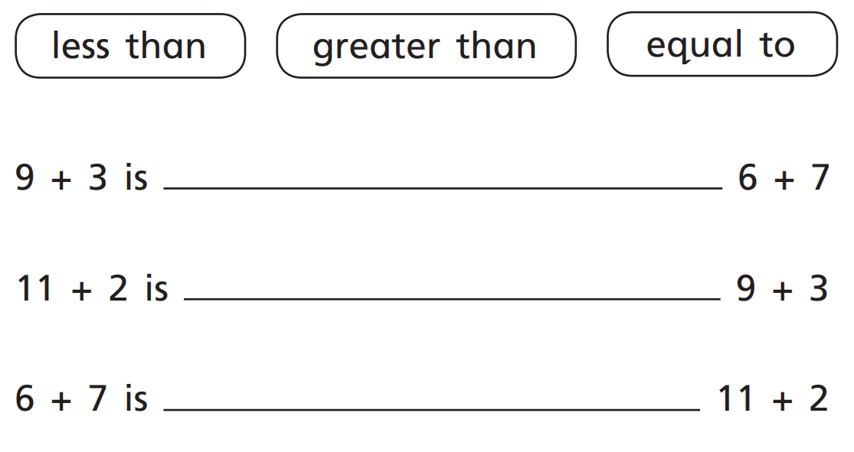

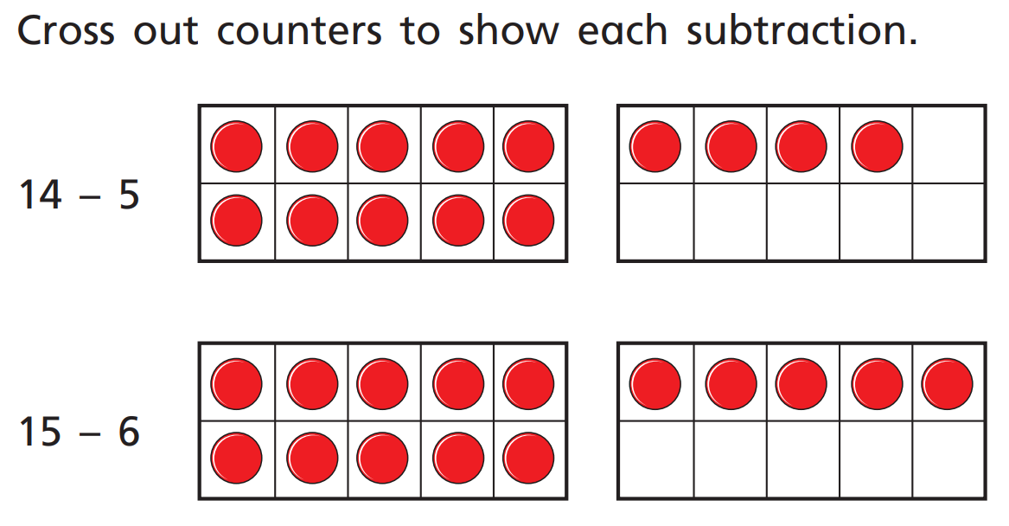
3.

4. Remember your gator signs for this question – The gator always eats the biggest answer.
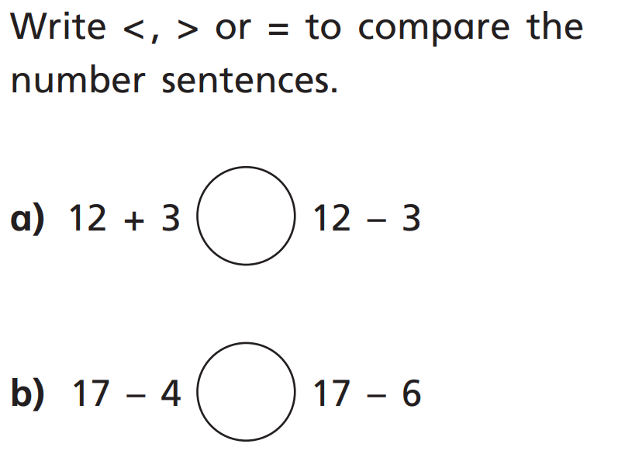

Year 2:
Please watch the video below.
https://vimeo.com/490421314
1. Write the multiplication number sentence to show how many cubes are in each question. Remember to think about how many towers, and how many cubes in each tower.
Challenge: each number sentence can be written two ways. Can you write both ways?
a.
____________________________
b.
____________________________
c.
____________________________

2. Work out the answers to these multiplication sentences.
Remember: ‘x’ is the same as ‘groups of’ so you can draw the multiplication number sentences as groups if you need to.
- 4 x 5 =
- 5 x 7 =
- 5 x 11 =
- ___ x 5 = 25
- 5 x _____ = 15
- 10 = 5 x ____
Challenge:
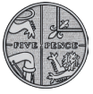
3. This coin is worth 5p.

- How much money is shown here:

Write the multiplication calculation. ________________________

- How many 5p coins would you need to make 60p?

2. Have a go at working through this word problem: 