Home Learning
Maths
Year 1: Today we are going to be going to be recapping everything we have learnt over these last few weeks. Please answer the questions below.

1. There are 7 birds in a tree.

5 more fly into the tree.
How many birds are there now?

There are birds now.

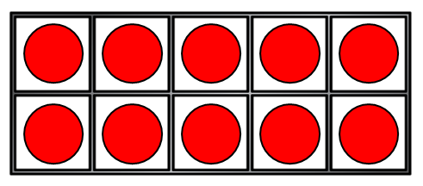
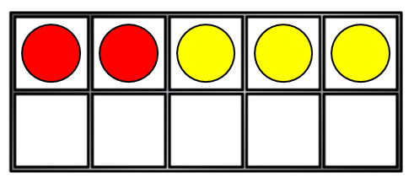
2. Please complete the number sentence:

12 + 3 = =

3. Please complete this number sentence:
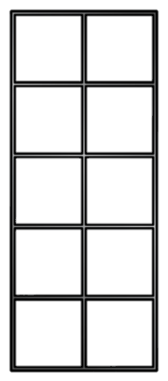

15 – 4 =

9 + 10
11 + 5
13 + 5
15 + 3
10 + 9
12 + 4
4. Please join then umber sentences which have the same answer:

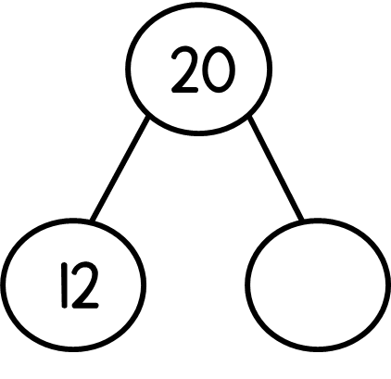
5. Please complete part whole model:
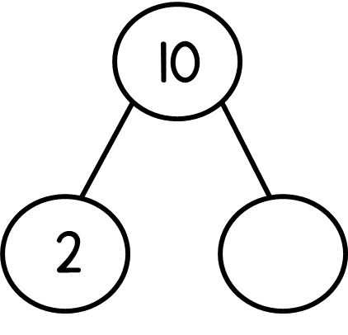

10 = 2 + __________ 20 = 12 + ___________

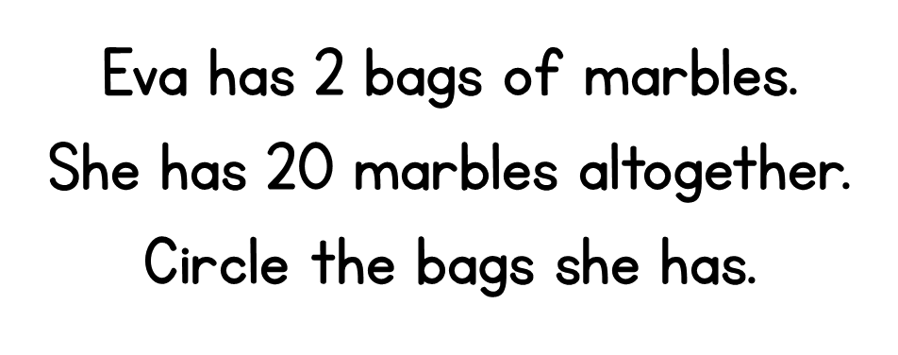
Challenge:
13
20
17
7

Year 2:
You have done so well with your times tables this week. Today we are going to learn how to do our ten times tables.
Please watch the video below: https://vimeo.com/490421912

1. Fill in the spaces in the table below.
Multiplication sentence | How many tens? | Whole number
3 x 10 | 3 tens | 30
4 x 10 |  | 40
5 x 10 | 5 tens
 | 6 tens | 60
7 x 10
 | 8 tens
 |  | 90

2. Complete the bar models and fill in the multiplication sentence.
10 | 10 | 10 | 10 | 10
a)

______ X _______ = _________
70
b)

______ X _______ = _________

10 | 10 | 10 | 10 | 10 | 10 | 10 | 10 | 10 | 10
c)

______ X _______ = _________

Challenge:
3. Draw a bar model to represent 6 x 10. Make sure to use a ruler for straight lines.

