Home Learning
Maths
Year 1:
Today you are going to be counting forwards and backwards to 20. Please watch the video and answer the questions. You will need some paper and a pencil.
Video: https://vimeo.com/480768128
Before we start, have a go at this game to warm up:
https://www.topmarks.co.uk/learning-to-count/underwater-counting

Below there is a ‘Numbers to 20’ word mat. Use this to complete the table below.
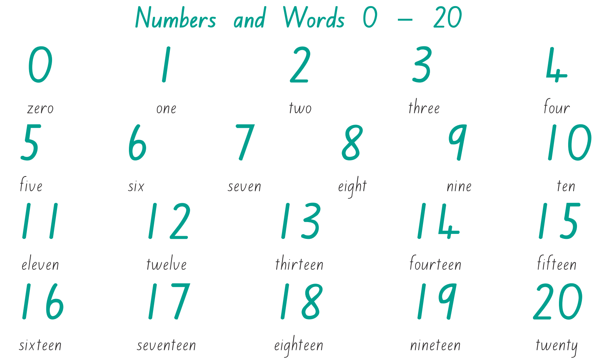

Table: If you are unable to print this off, please just write the number of objects and write the word of the number on paper.

How many? | Write the Numeral: | Write the word:

Well done for all your hard work! Please choose from the games below to have a go at:

Ordering forwards to 20: https://www.topmarks.co.uk/ordering-and-sequencing/caterpillar-ordering

Ordering backwards from 20: https://www.topmarks.co.uk/ordering-and-sequencing/caterpillar-ordering

Year 2:
Today, we are going to be recapping addition and subtraction.
First, look below and write what numbers are created in tens and ones.
Now for a Game!
Please follow this link: https://www.topmarks.co.uk/ordering-and-sequencing/coconut-ordering
Please click
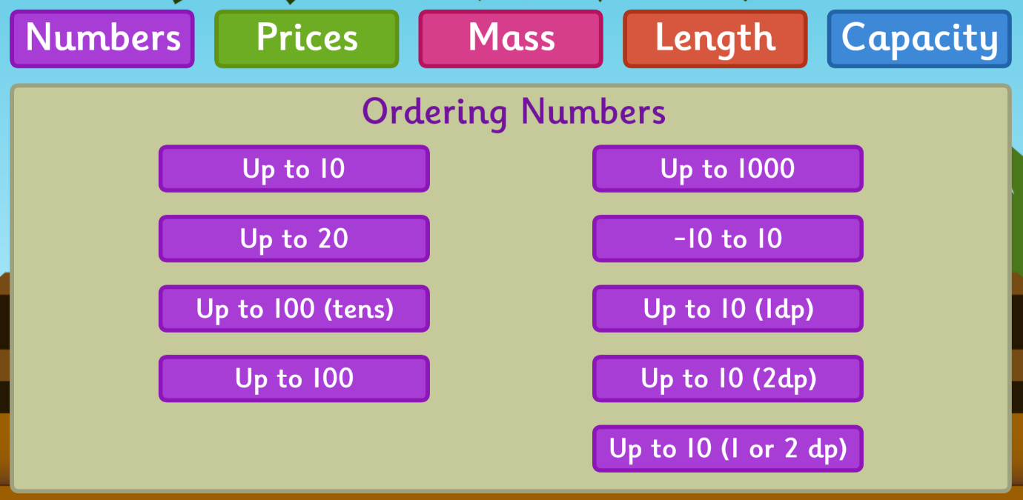
You should come to a page like this:

Today we are going to learn about adding and subtracting ones:
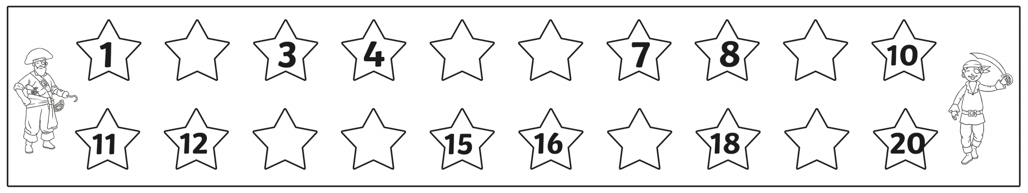
Please complete this missing number line:

Now for our learning:
- Please watch this video to recap this learning and answer any questions on paper: https://vimeo.com/463031310
- Using the interactive number line, please work out the different addition and subtraction number sentences.
- Number Line: https://content.connect.collins.co.uk/Content/Live/ES/Primary/complete/Resources/Busy_Ant_Tools-Games/10_IMT_NumberLine_RC1/index.html
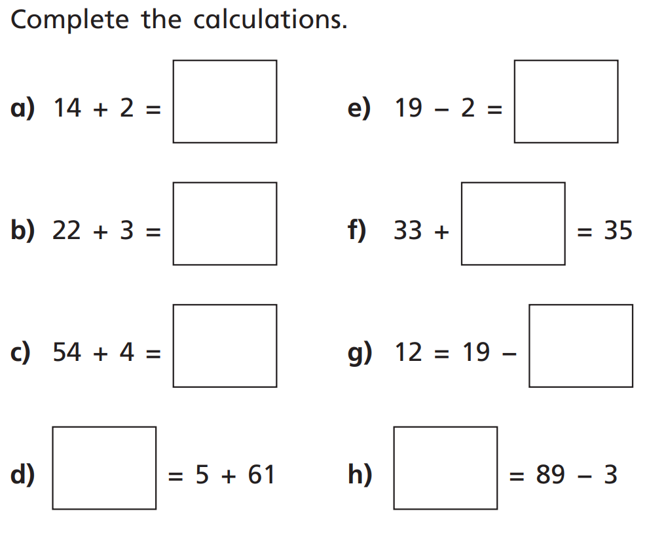

Challenges:
1.
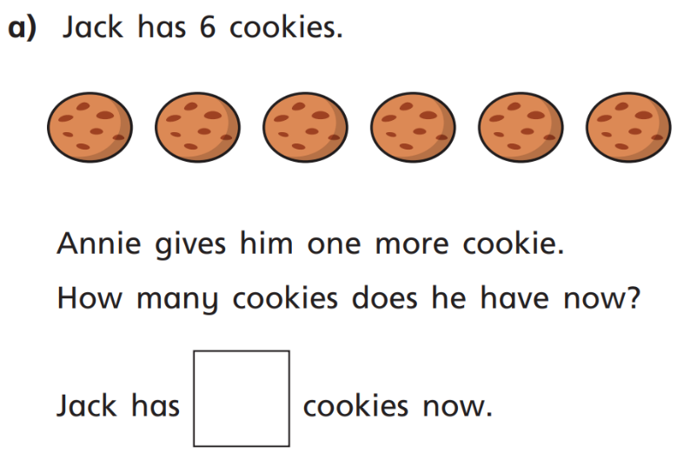

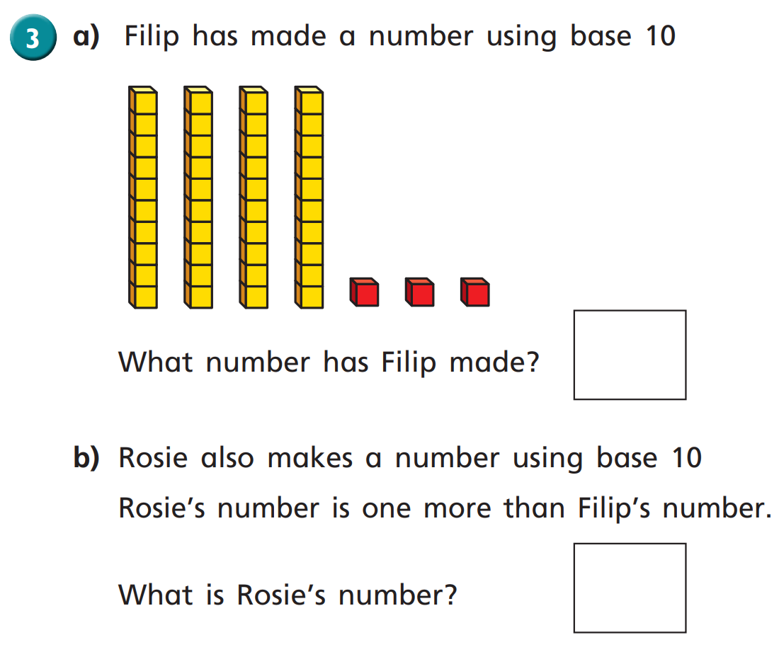
2.

Now for some fun! Choose a game from below!
Ordering Numbers to 10: http://ictgames.com/rangeArranger/
Finding Numbers: https://www.topmarks.co.uk/learning-to-count/helicopter-rescue
Addition and Subtraction: https://www.topmarks.co.uk/addition/robot-addition

