Home Learning
PE
Hello Squirrels,
Below there are some PE that you can do at home.
First of all lets…
https://www.youtube.com/watch?v=oe_HDfdmnaM

Now let’s get onto the main session:

PE: Try any one of these PE challenges!
Challenge 1: https://youtu.be/c9lm8Y7koqE
Challenge 2: https://youtu.be/JfSl3G0p4u0
Challenge 3: https://youtu.be/LmaIiYTYQiw

Alternatively, here are the challenges explained below:

Challenge 1 (around the sock): This challenge will test the upper body and core strength. Arrange 4 socks as shown here. Set up a time for 20 seconds. When the timer starts push up and use your hands to walk your body in a circle like a hand clock.
How many quarter turns can you complete in 20 seconds?
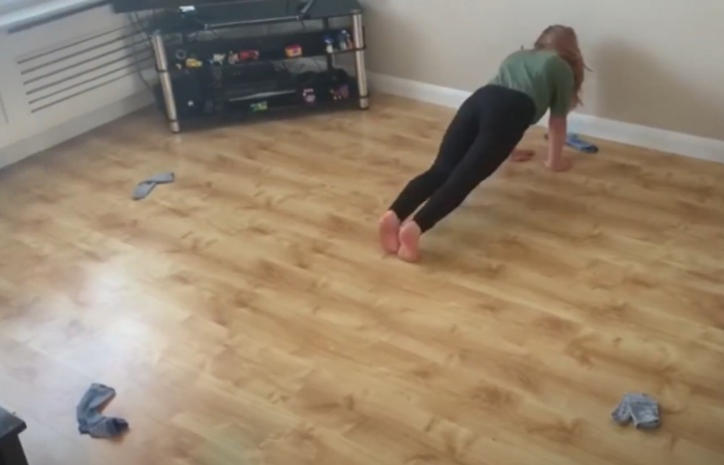

Challenge 2 (sock throw roll): Build a stack of 4 toilet rolls as a target. Stand at a distance from the target – with your feet, measure a distance equal to your age. For example if you are 6 years old stand at least 6 foot lengths from the target. Using a pair of socks try and knock down the toilet roll tower.
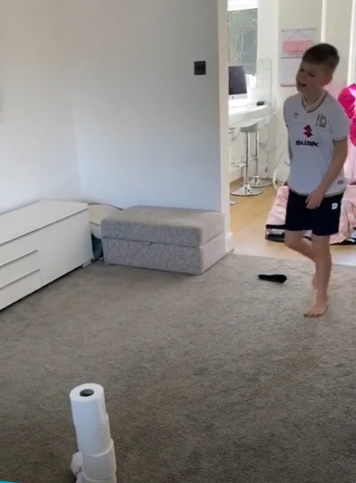

Challenge 3 (baby shark): Lay on your back, keep your legs straight, lift your feet about 15 – 20cm off the ground. Open your legs until your feet are a least shoulder width apart and then bring them together again – Remember try to keep your legs straight throughout this exercise.
How many of these can you manage in 10 seconds?
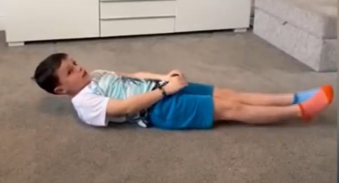

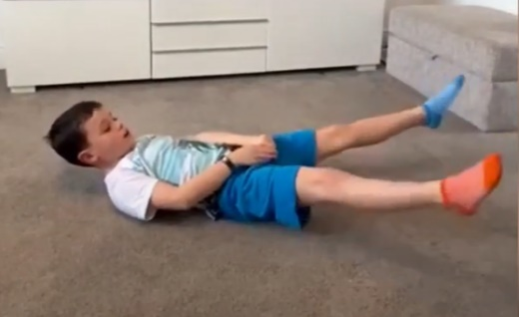

EXTENSION: Can you come up with your own PE challenge, maybe you can try it out on someone at home!

