Home Learning
PE
Ahoy Squirrels!
For PE this week we are going to do some pirate themed yoga.
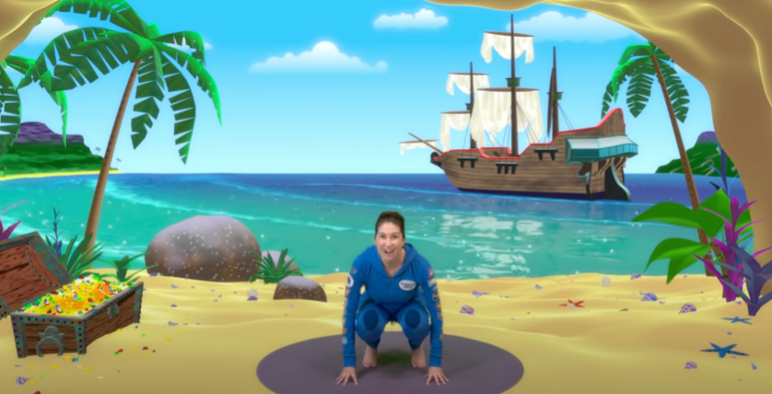
https://www.youtube.com/watch?v=T_0P5grVoyg&t=154s

For this you will need to make sure you give yourself enough space to do it safely.
Once you have done the session have a think about what was your favourite pose, and get someone to take a picture of you doing the pose and send it to us.
Good luck to all you pirate Squirrels!

