Home Learning
Reading Comprehension
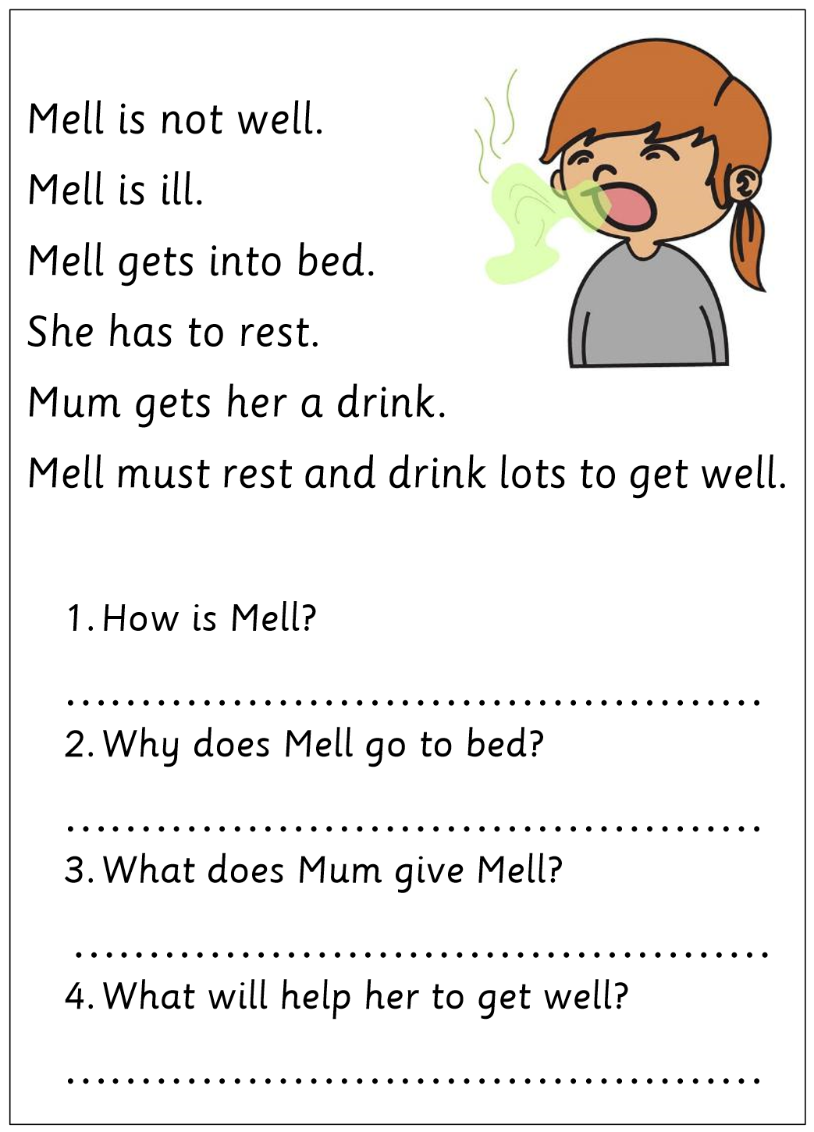
Mrs Hammond’s Group:
Mrs Golden and Miss MacMillan’s Group
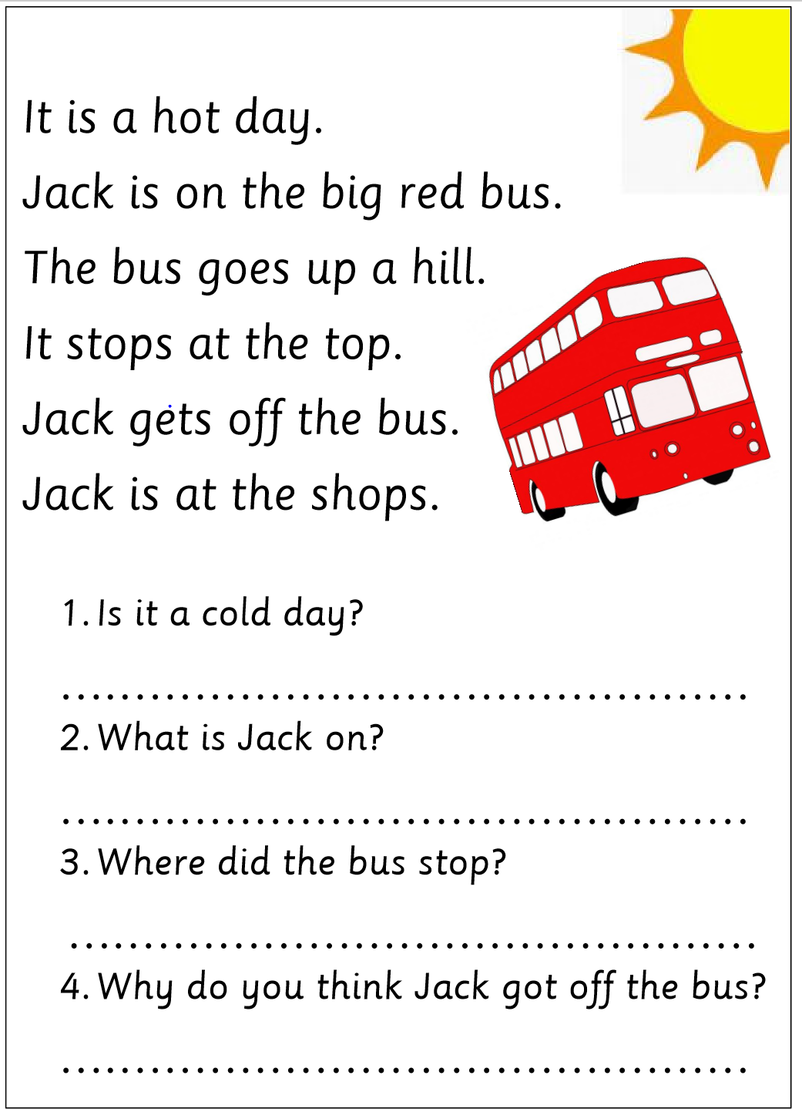
Mrs Young’s and Mrs Dyson’s Group
