Home Learning
Science
Year 1 and 2
Today we are going to be learning about the seasons and focusing on Winter.
Activity 1:
Please watch this video: https://www.bbc.co.uk/bitesize/topics/zkvv4wx/articles/zcx3gk7

Use the video to help you complete the sheet below. I have already labelled one of the seasons.
You need to:
- Label the seasons in the correct order.
- Look at the word bank and think about which words fit which season.
- Then write the words into the correct sections (Hint: Some might fit into more than one season)

Summer | Autumn | Winter | sunny
rainy | dry | windy | warm
mild | cold | wet | snowy
frosty
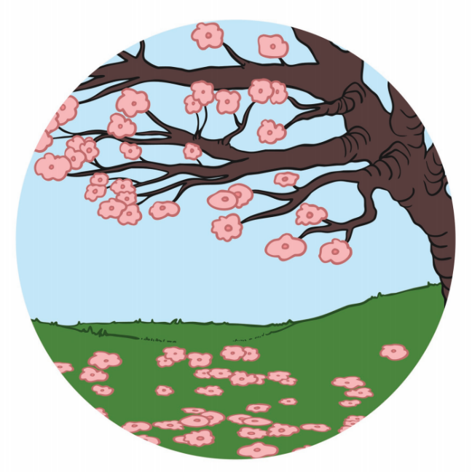  1. Spring: |  | 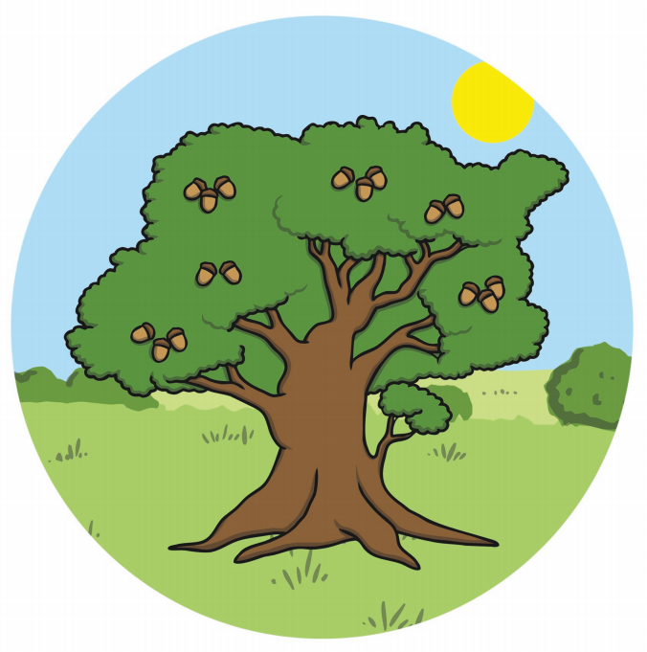  2.S_____________
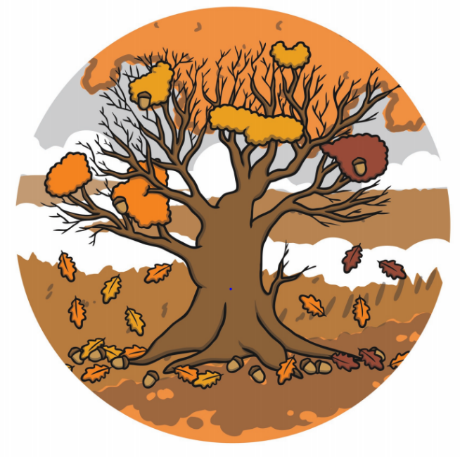  4.W____________ |  | 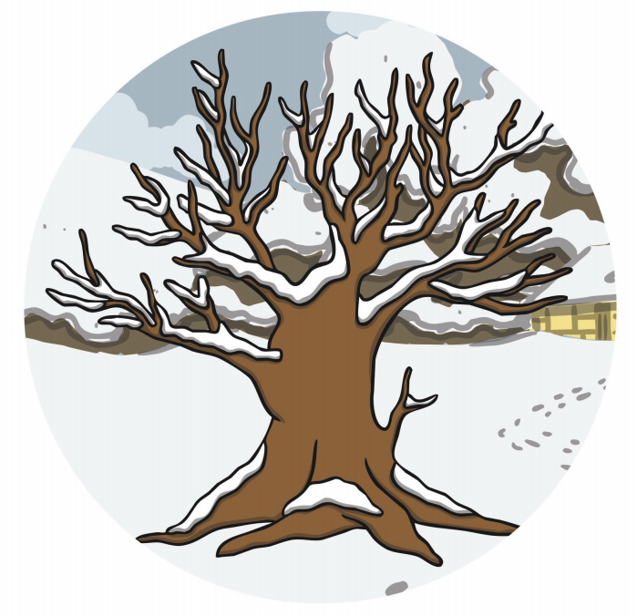  3.A_____________
Activity 2:
Please go outside and have a look at the weather. In the space below, please draw pictures of the weather that is showing outside and label them using the word mat below to help you.
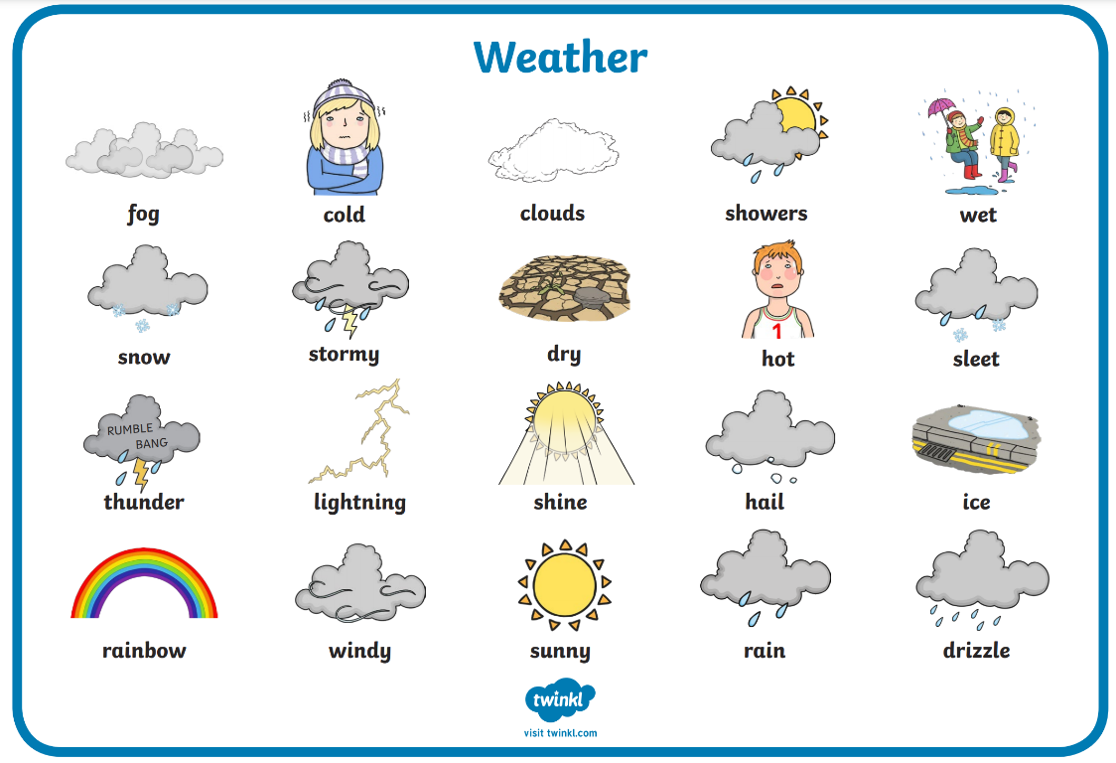

Activity 3:
We are going to focus on Winter.
Think about:
- What clothing do you wear in winter?
- Why do you wear warm clothing?
Please draw a picture of yourself and draw on the clothing that you would wear to keep yourself warm during winter. Use the word mat below to help with labelling.

hat | scarf | gloves | boots | Jacket
earmuffs | fluffy socks | woolly jumper | trousers

