Home Learning
Topic
Year 1 and 2
Last week we learnt about:
- What we know about pirates already.
- Ordering dates.
- Facts about Pirates – Are they true or false?

Today we are going to be recapping:
- Ordering dates.
- Physical and Human Features.
- Naming the parts of the oceans.

Activity 1:

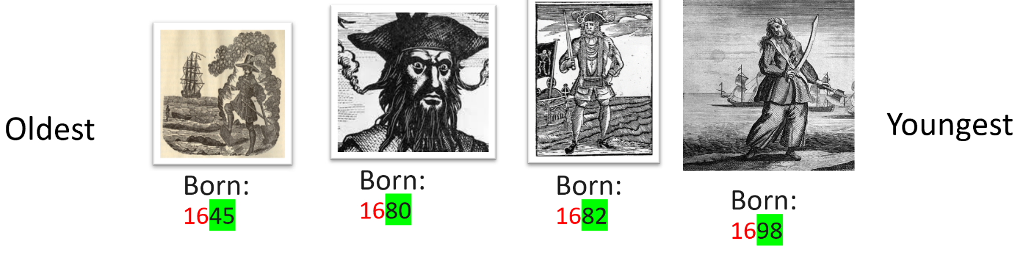
Ordering Dates – Last week we ordered the pirates by when they were born.

We are going to order them by when they died.
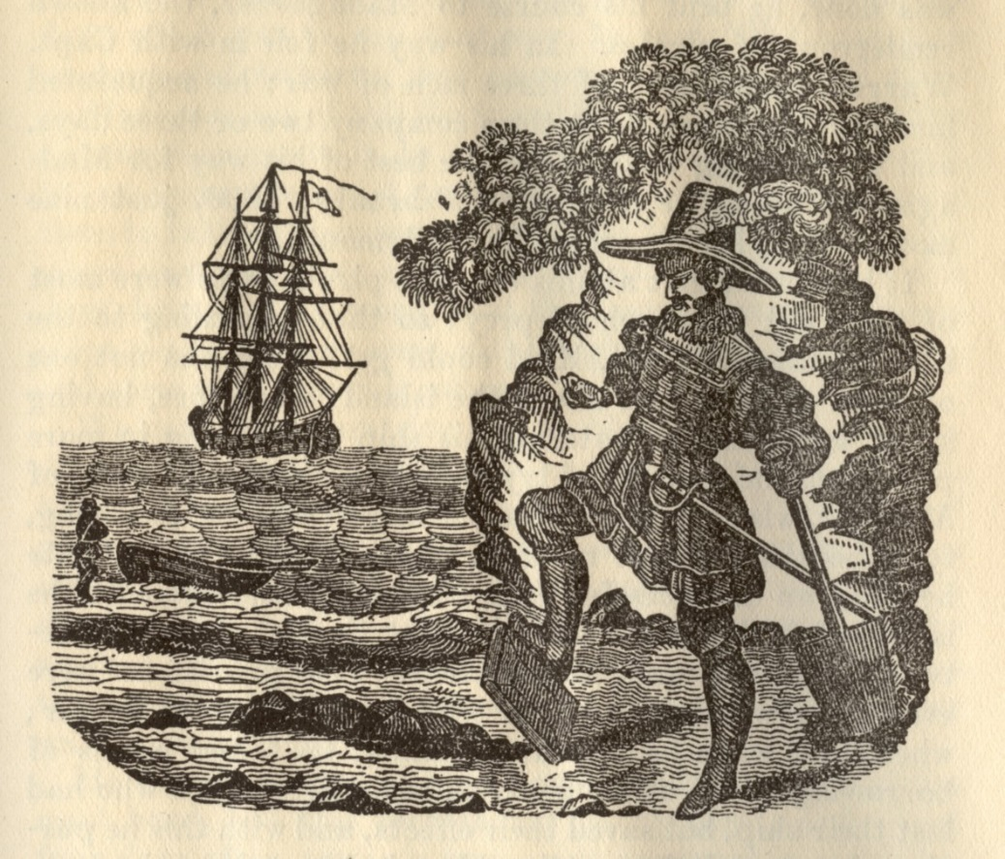
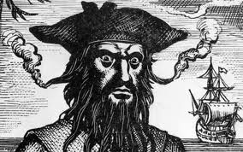
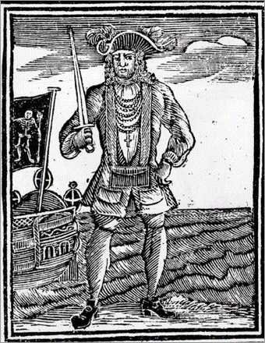
William Kidd
Died:
1701
Anne Bonny
Died:
1782
Blackbeard
Died:
1718
Black Bart
Died:
1722

To order these dates, we need to check:
- Is the red number the same?
- If it is, we don’t need to worry about it as they were all born in the same Century.
- We need to look for the smallest green number.
- This is the pirate that died first.
- We now need to look for the biggest green number.
- This is the pirate that died most recently.
- Now, looking at the pirates that are left – order them from smallest to biggest.

Have a go at ordering these pirates from the first pirate to die to the last pirate to die.

Activity 2:
We are going to recap what ‘Human’ and ‘Physical’ features are.
Let’s recap: https://www.bbc.co.uk/bitesize/topics/zqj3n9q/articles/zr8q7nb#:~:text=Human%20and%20physical%20features%20are,mountains%20and%20rivers%20are%20natural.&text=Human%20features%20like%20houses%2C%20roads,have%20been%20built%20by%20people.

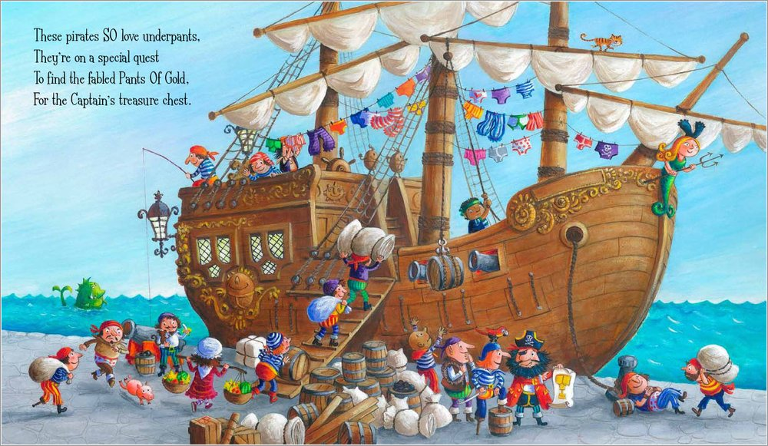
Have a look at this picture and see if you can label the different human and physical features in this picture:

Activity 3:
Following on from the last activity, what do Pirates sail on?
That’s right – Ocean.
Watch this video to learn about the different oceans: https://www.youtube.com/watch?v=X6BE4VcYngQ

Please complete the activity on the next page.

Please look at the map below and have a go at naming the oceans using the video:

5.
4.
3.
2.
1.

