14.01.21 Maths

Long multiplication.
To complete these calculations you need to use the longer method of multiplication we learnt when multiplying by a single digit. It is important that you complete these calculations neatly with each digit in its own square and all space value columns are aligned correctly. First you multiply the top number by the number in the ones column in the bottom. So question A1 below shows 16x15.

Step 1: Partition the bottom number in to 10s and 1s. So for this calculation we will think of 16x5 and 6x10.

Step 2: complete 16x5. 6x5 = 30, so write the 0 in the 1’s column and carry the 3 (neatly and in small writing) in to the 10s column.

Step 3: complete 5x10. This =5 tens (50), add our 3 tens and we have 8 tens. Altogether we have 80. The 0 in the ones column from the previous calculation.

Step 4: We are now multiplying by 10s, so write a 0 in the ones column to remind you of the place value and multiply 16 by 1. The total is 160.

Step 5: Add both the multiplications together to get your total. 240.

Just ask if you’ve any questions. My email is hhorsford@charing.kent.sch.uk or join one of the teams sessions. 10.10 – 11.10 or 12.45 – 1.45 to chat to me.

Good luck!

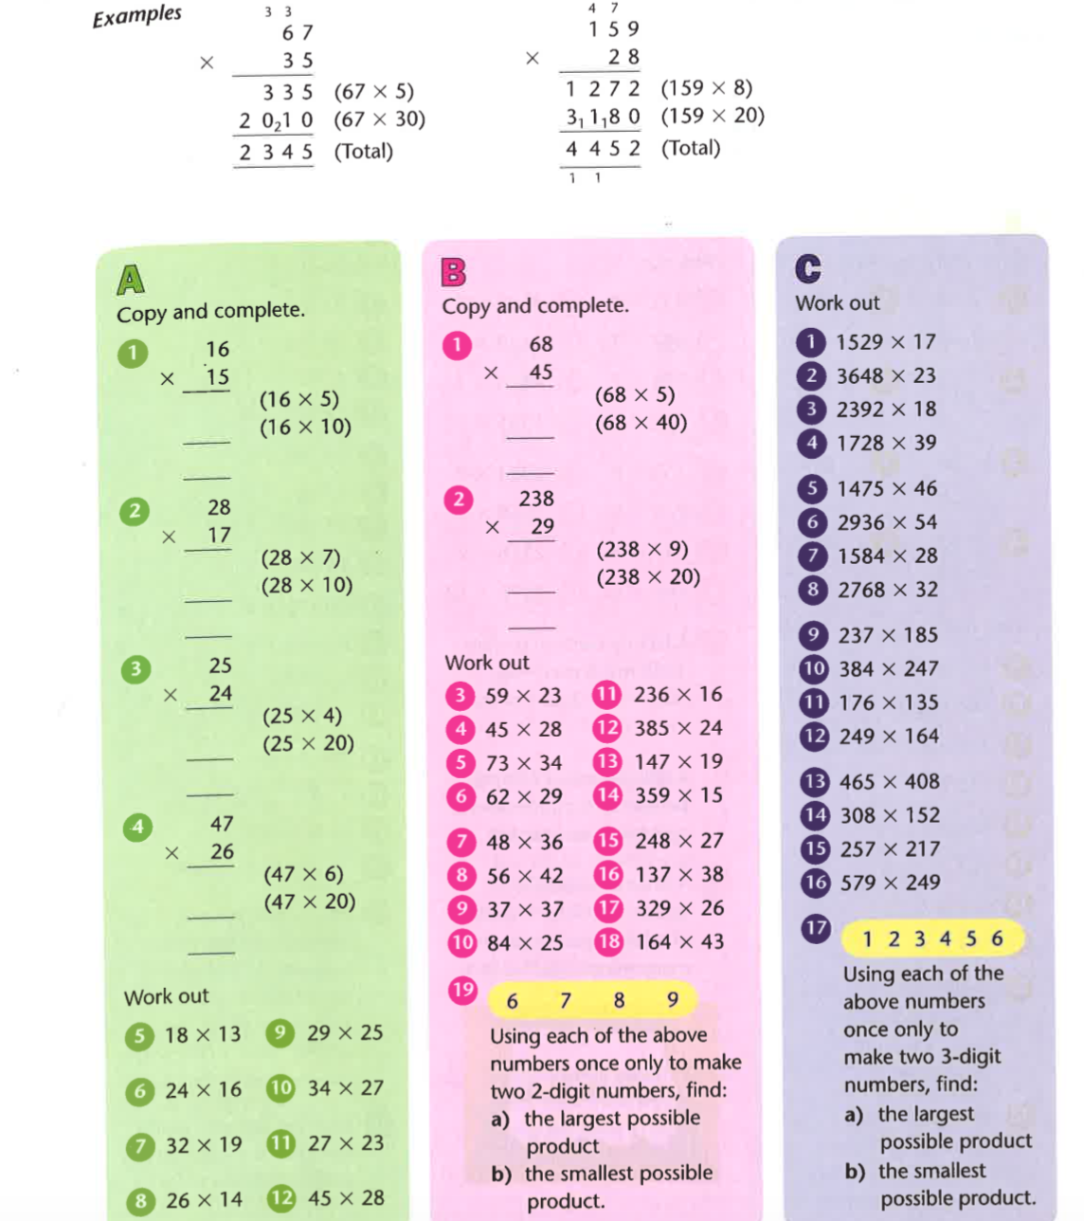

Challenges

