21.01.21

Maths Worksheet

Yesterday we have learnt about the bus stop method of division. Use your knowledge to answer the questions below.

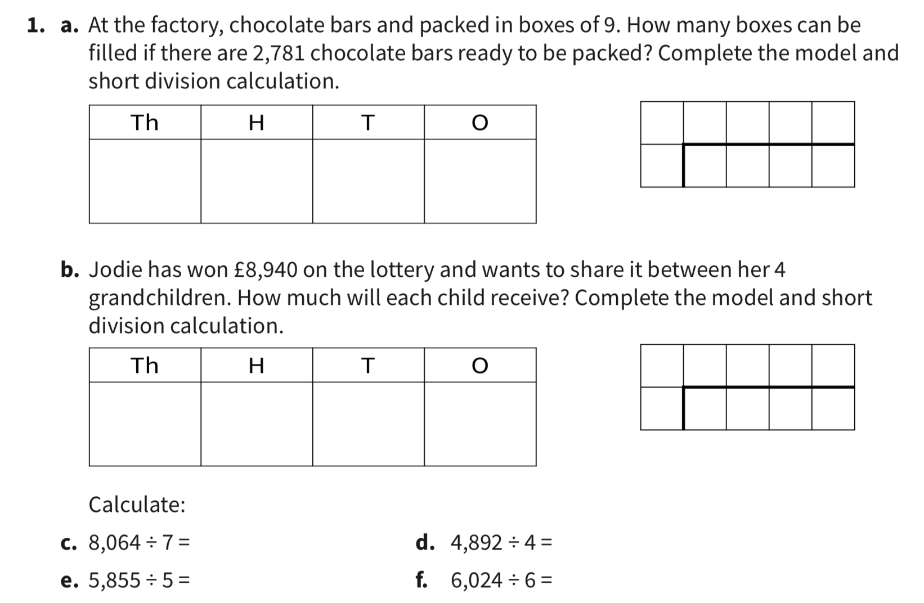

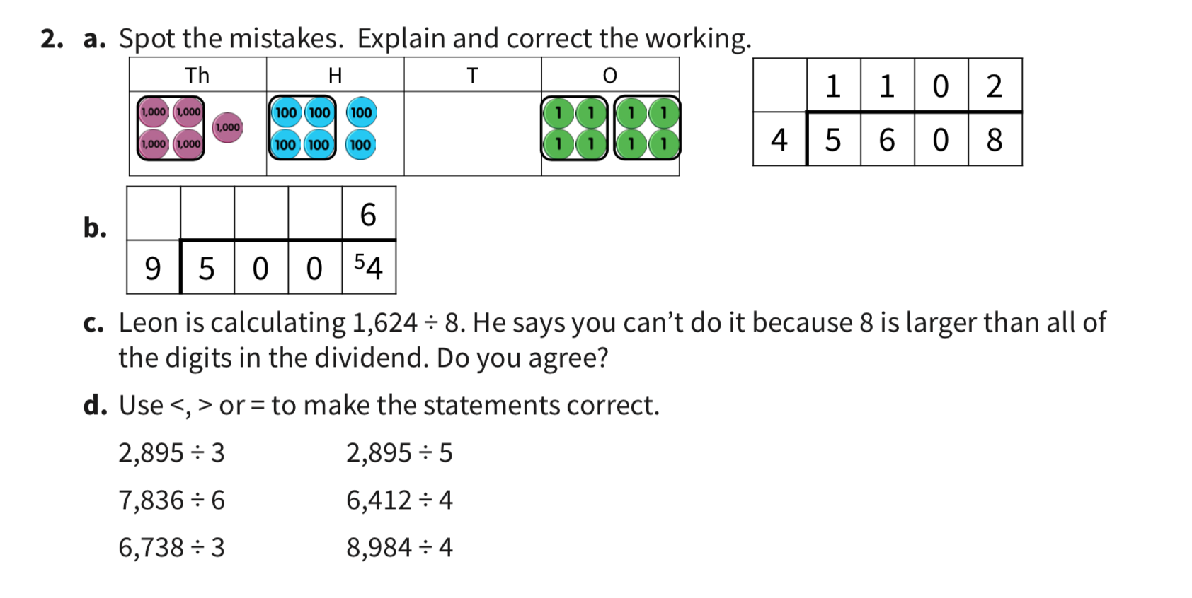

**Challenge**

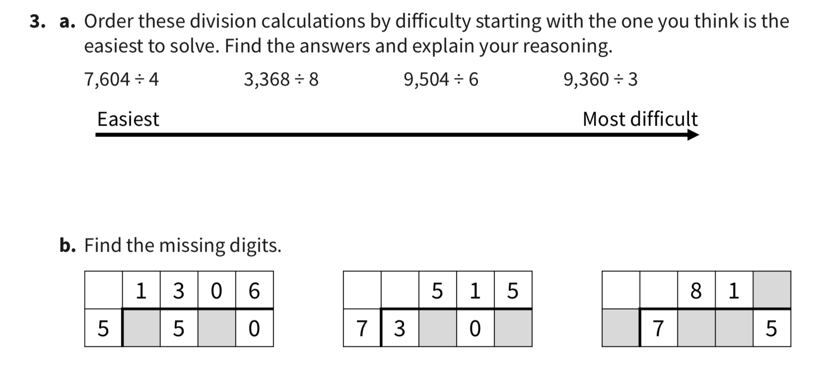

ANSWERS

