Thursday 7th January 2021 – SpaG

Have a go at Mat 1 OR mat 2. Mat 2 is the more challenging.

Mat 1
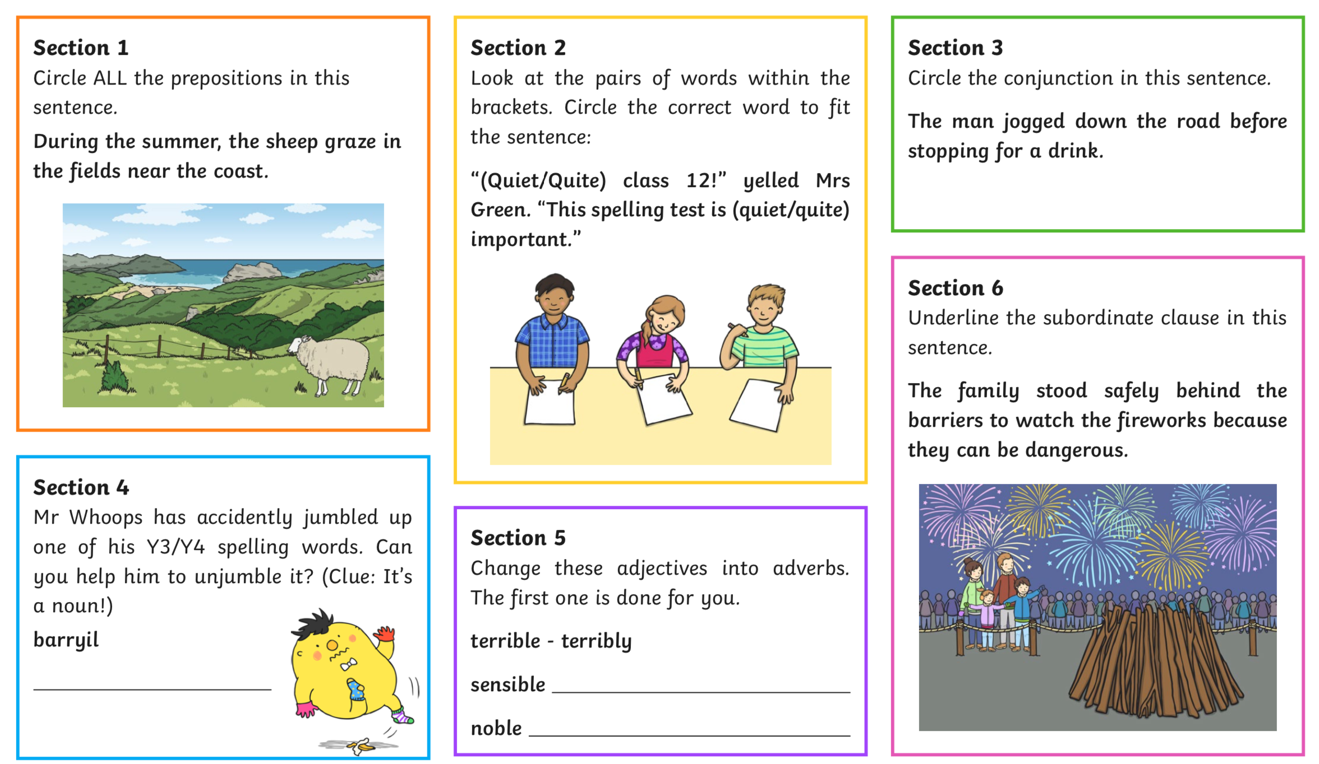

Mat 2

