11.01.21
Have a go at filling in 1 of the grids. You can either time yourself to see how long it takes and see if you can beat your time next go or complete it how we do at school and see how far you can get in 5 minutes. There is a challenging grid on the next page if you want to use it.

Times Table Grid 1

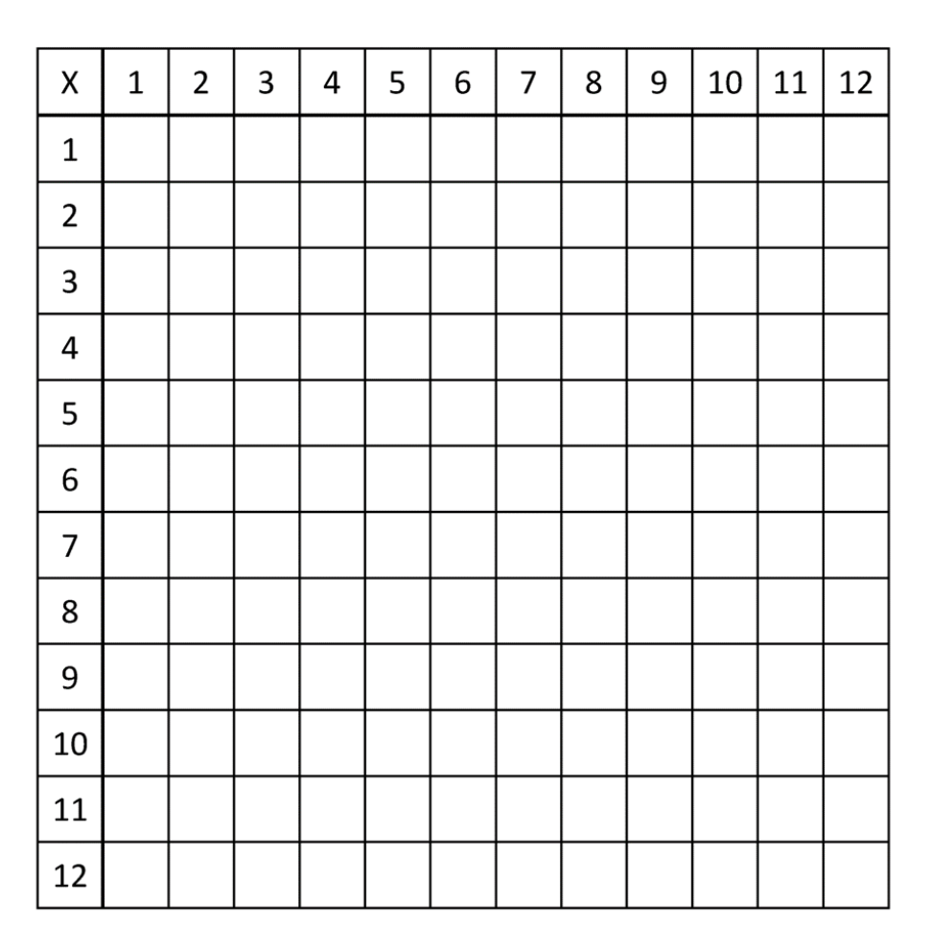

Challenge Grid

